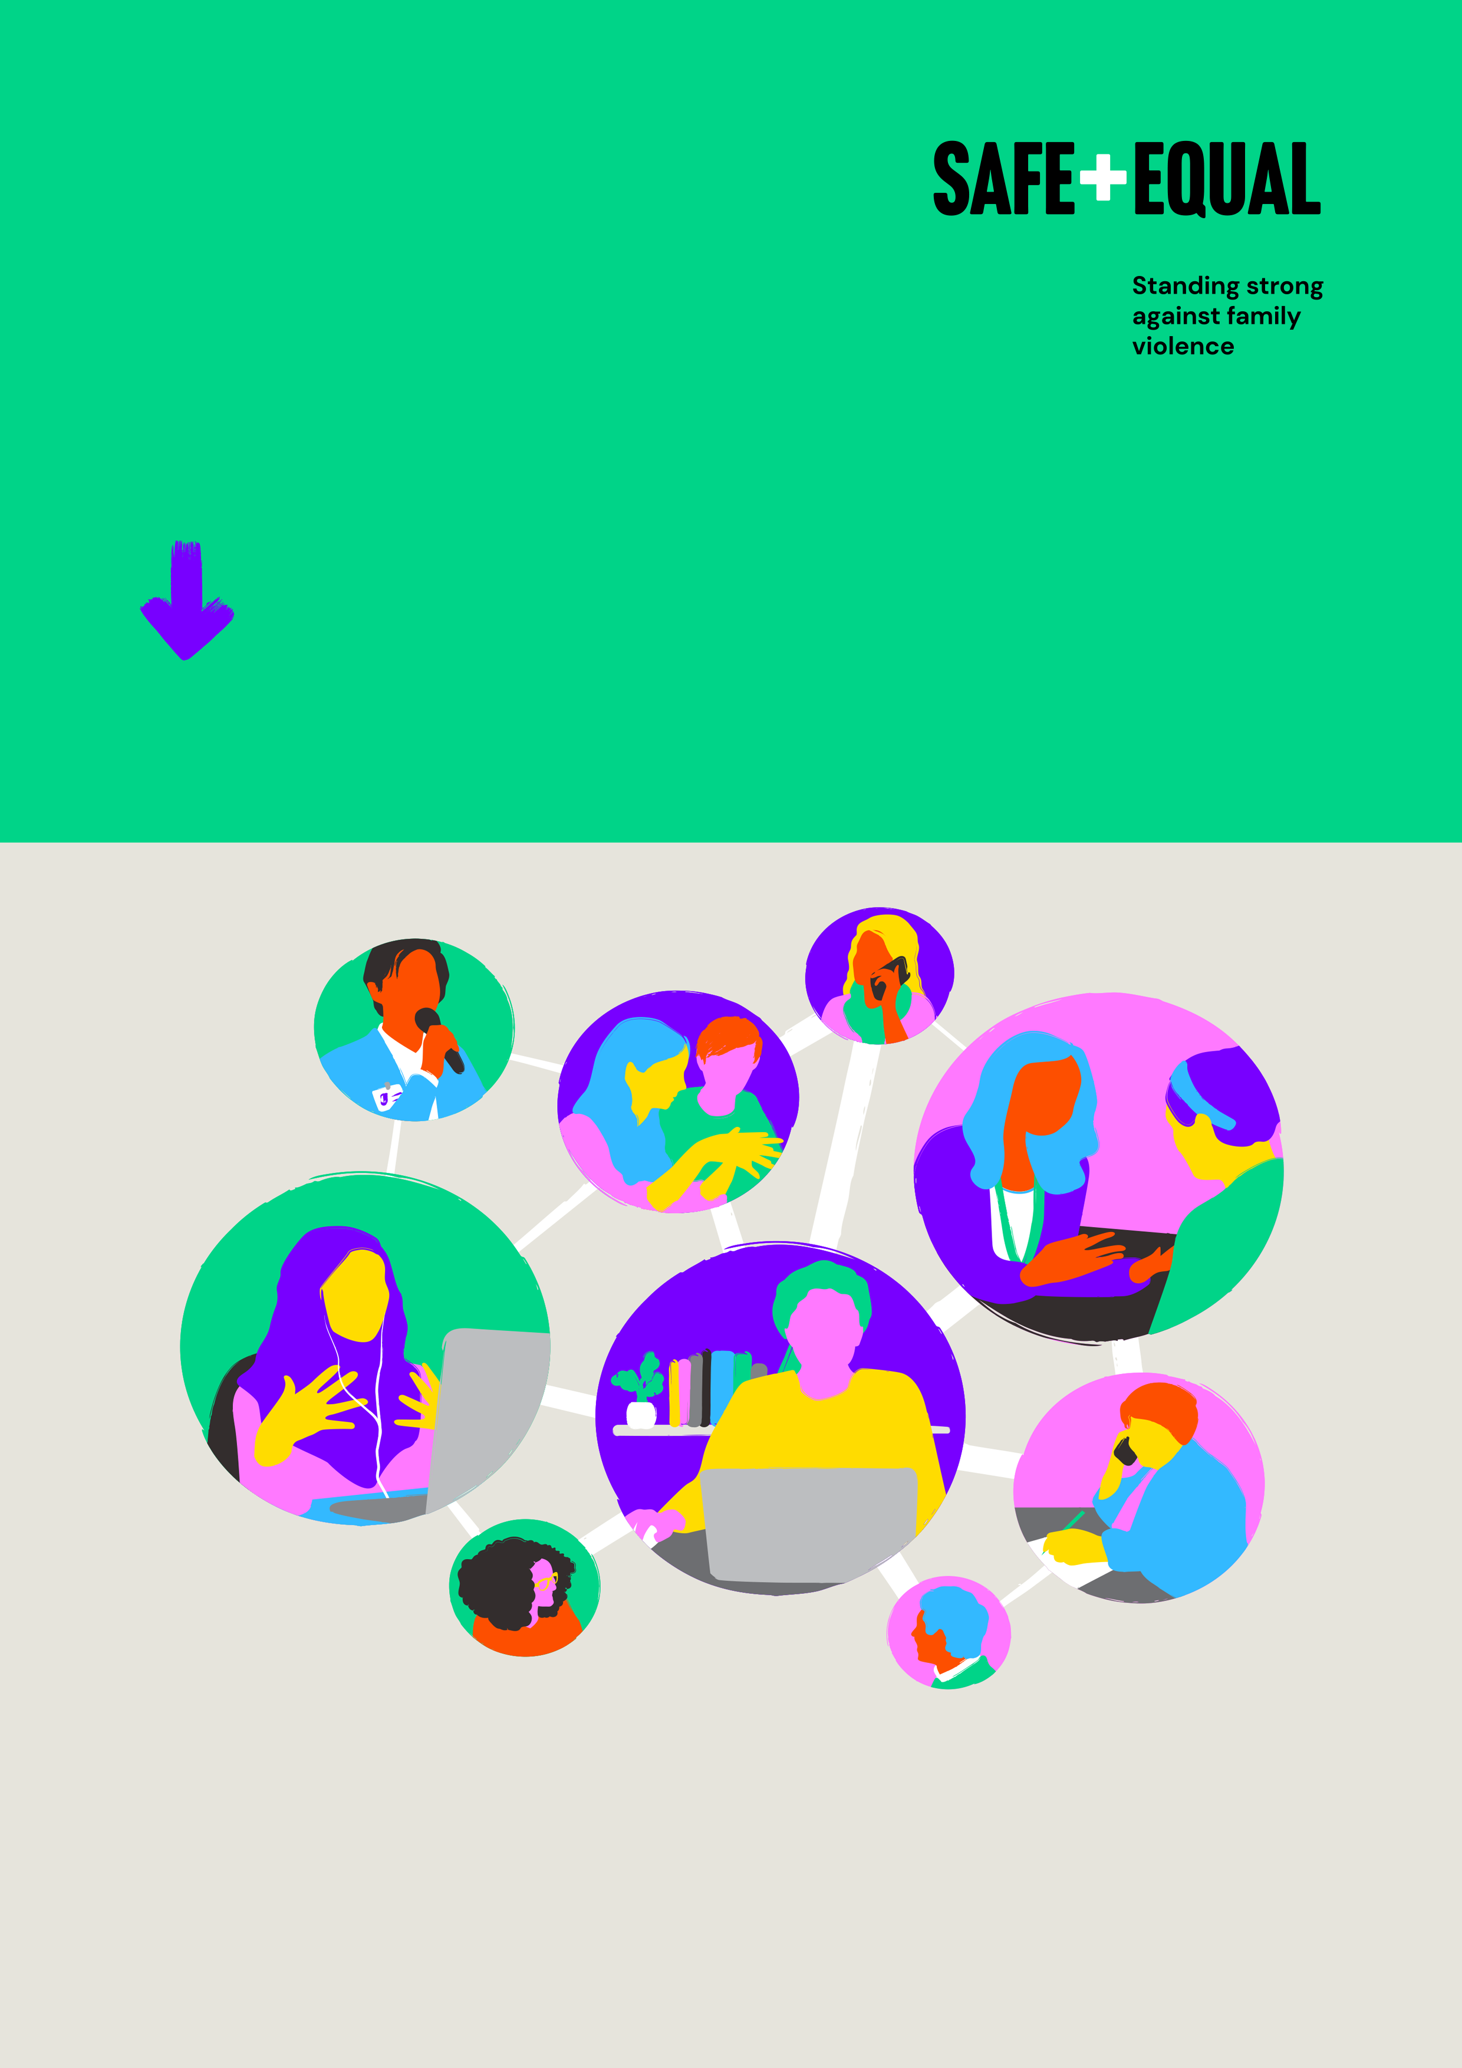

What is primary prevention?

Connecting across the continuum from prevention to response

Safe and Equal acknowledges Aboriginal and Torres Strait Islander peoples as the traditional and ongoing custodians of the lands on which we live and work. We pay respects to Elders past and present. Sovereignty has never been ceded.

Safe and Equal is the peak body for specialist family violence services that provide support to victim survivors in Victoria. Our vision is a world beyond family and gender-based violence, where women, children and people from marginalised communities are safe, thriving and respected.

To support this, we aim to grow our leadership role in representing and developing the primary prevention workforce, and building and sharing innovative practice expertise.

Prepared by: Marina Carman, Meghan Cooper and Amelia Ditcham[1]

Contents

Introduction 4

The prevention continuum 4

Prevention – or primary prevention 4

Early intervention – or secondary prevention 6

Response and recovery – or tertiary prevention 7

Connection across the continuum 8

Conclusion 9

# Introduction

A key feature of policies and frameworks around family and gendered violence at both state and national level is an understanding of a continuum of work required across primary prevention, early intervention, response and recovery. This includes the national framework for prevention of violence against women, [Change the Story](https://www.ourwatch.org.au/change-the-story/), and the Victorian strategy for preventing family violence and all forms of violence against women, [Free from Violence](https://www.vic.gov.au/free-violence-victorias-strategy-prevent-family-violence). It is also a feature of the [National Plan to End Violence against Women and Children](https://www.dss.gov.au/ending-violence).

Addressing the needs of victim-survivors and ultimately ending family and gender-based violence will require specialised and complementary activities undertaken by a range of practitioners, programs and organisations.

This resource aims to promote understanding of work across the continuum from prevention to response, as well as provide practical suggestions to improve connection.

# The prevention continuum

Ending family and gender-based violence is long-term work that must occur at all levels and all settings across the community. This continuum of interconnected and concurrent activities is often grouped into three broad categories:

* **prevention – or primary prevention**
* **early intervention – or secondary prevention**
* **response and recovery – or tertiary prevention**

Initiatives focused on each of these areas are important and reinforce each other.

## Prevention – or primary prevention

Primary prevention describes work done across communities, organisations and society in settings where people live, learn, work, socialise and play to stop violence from happening in the first place.

The national framework for the prevention of violence against women, [Change the Story](https://www.ourwatch.org.au/change-the-story/), explains a primary prevention approach as follows:

A primary prevention approach works to change the underlying social conditions that produce and drive violence against women, and that excuse, justify or even promote it. It works across the whole population to address the attitudes, norms, practices, structures and power imbalances that drive violence against women.[2]

[Change the Story](https://www.ourwatch.org.au/change-the-story/) has established that men’s violence against women is driven by:

1. Condoning of violence against women
2. Men’s control of decision-making and limits to women’s independence in public and private life
3. Rigid gender stereotyping and dominant forms of masculinity
4. Male peer relations and cultures of masculinity that emphasise aggression, dominance and control [3]

The socio-ecological model in [Change the Story](https://www.ourwatch.org.au/change-the-story/) is used widely to show how these drivers of violence operate at different levels – individual and relationship, community and organisational, system and institutional, societal.

The gendered drivers of men’s violence against women are well-recognised and described, but preventing all family and gender-based violence means looking at other drivers of violence as well. These include inequality, stigma, discrimination and marginalisation experienced by Aboriginal and Torres Strait Islander people, people from migrant and refugee communities, people of colour, LGBTIQ+ communities, and people with disability, amongst others. A number of other complementary frameworks address these issues directly, such as [Changing the Picture](https://www.ourwatch.org.au/resource/changing-the-picture/), [Changing the Landscape](https://www.ourwatch.org.au/resource/changing-the-landscape/), [Pride in Prevention](https://rainbowhealthaustralia.org.au/news/launch-pride-in-prevention-evidence-guide) and [Intersectionality Matters](https://www.mcwh.com.au/intersectionality-matters-a-new-resource-for-preventing-violence-against-women/).

**Primary prevention work is undertaken by (and within) a range of different organisations:**

* organisations dedicated specifically to primary prevention
* organisations with a significant focus on prevention (within a broader remit of work on gender equality, women’s health or family and sexual violence service delivery)
* organisations with expertise and community connection related to Aboriginal and Torres Strait Islander communities, multicultural communities, LGBTIQ+ communities and women with disabilities
* organisations supporting the work of practitioners in key settings, such as schools, universities, councils, health and community services, community and sporting organisations
* organisations specialising in content-specific workforce capability building and workforce development in areas such as masculinities or consent

**Some examples of what primary prevention work looks like are:**

* Implementing whole-of-school initiatives and curricula that promote respectful relationships
* Developing campaigns that aim to break down gender stereotypes and challenge ideas about violence and disrespect being acceptable or excusable
* Building partnerships with community organisations to deliver targeted initiatives aimed at changing gender norms and promoting equality in relationships
* Working with men and boys to support healthy relationships, and challenge dominant forms of masculinity that emphasize aggression and control
* Supporting sports clubs to develop policies and procedures that ensure women have equal access to resources and appropriate facilities to support their participation
* Implementing workplace initiatives that take a whole-of-organisation approach to addressing inequality in workplace policies, processes, leadership and workplace culture
* Working with media outlets to challenge discriminatory depictions of women, and promote content that creates positive change
* Advocating to improve legal, policy and funding support for primary prevention across all relevant government departments and portfolios

Primary prevention also includes efforts to promote women’s financial independence and control of decision-making, as part of changing the drivers of gendered violence. As such, it is closely related to broader efforts to promote and achieve gender equality, but also distinct from these. Improving legal and workforce equality, for instance, does not automatically change the ideas and social structures that drive violence against women. This requires specific and coordinated effort.

Primary prevention will only ultimately be effective when working in complementary ways across the continuum, and in solidarity with broader efforts to improve gender equality and work against other forms of social inequality, stigma and discrimination.

### Complementary work across the continuum

While it has different goals, primary prevention complements and enhances early intervention, response and recovery activity by helping reduce recurrent perpetration of violence, and by shifting attitudes and practices within the justice and support service systems that may inadvertently tolerate, justify or excuse violence against women, as well as addressing the inequalities within other settings that may create additional hurdles and disadvantages for women on their recovery journey.

(Change the Story, 2021)[4]

## Early intervention – or secondary prevention

Early intervention describes initiatives designed to stop early signs of abuse from escalating, and targeted interventions to shift attitudes and behaviours in ways that minimise immediate and long-term risk.

This can involve working with groups or individuals who may be at higher risk of perpetrating or experiencing violence, focusing efforts where there are signs that violence is more likely to occur, and working more broadly across communities and society to improve approaches to recognising and responding to signs of violence.

**Some examples of early intervention work include:**

* Developing resources to support people to understand family violence and recognise if they or someone they know are experiencing it
* Providing information and training about family violence, legal rights and support services to people who are at higher risk of experiencing violence or professionals who work with them
* Working with boys who have shown early signs of using violence to stop them from continuing to use violence as adults
* Delivering education sessions at sports clubs about sexual assault and the legal consequences after women have reported experiencing sexual harassment

## Response and recovery – or tertiary prevention

Response and recovery describe initiatives that involve supporting victim survivors during and after their experiences of violence, and intervening to stop violence from reoccurring.

This may include supporting victim survivors when they are still experiencing abuse, planning to leave or have already left. This work can take a variety of forms including crisis response, case management and specialist counselling. Recovery from violence can take a long time, and there is a need to focus on ongoing holistic support for victim survivors to sustainably regain their health and wellbeing.

Specialist family violence services provide frontline support for those experiencing family violence. They place the needs of victim survivors at the centre of their practice.

Importantly, tertiary prevention also includes holding perpetrators accountable in ways that aim to stop violence from happening in future.

**Some examples of response work include:**

* Talking to victim survivors about their experiences of violence and assessing their level of risk
* Working with victim survivors if they choose to leave or to stay in their relationship, to help them to remain safe
* Arranging crisis accommodation, supporting victim survivors to secure housing, advocating for victim survivors navigating the legal system, and providing referrals and support
* Responding to incidents through a police presence and supporting victim survivors with intervention orders
* Delivering men’s behaviour change programs that help to reduce repeated perpetration

# Connection across the continuum

As efforts to prevent family and gender-based violence grow and become more comprehensive, a bigger and increasingly specialised workforce will be required. While some organisations and practitioners work across multiple parts of the continuum, in most cases they will work predominantly in one or the other – due to specific expertise, networks and connections, and funding streams.

Specialisation enhances a comprehensive approach to family and gendered violence. Nevertheless, maintaining and improving connection between and across efforts is important.

**Some ways in which connection is useful include:**

* An understanding of the drivers of violence against women and other drivers of family violence is important foundational knowledge for all organisations and practitioners working in family and gendered violence. This understanding helps to create hope both for practitioners and clients in a service setting, putting their experiences in context and allowing them to see themselves as part of broader movements for social change.
* Prevention practitioners should be aware of their obligations to respond to individual disclosures of family violence encountered in their work, and seek training and advice to meet these obligations.
* Response practitioners and services work closely with individuals, families and communities to raise awareness about family violence. This is an important precondition for primary prevention, which then seeks to directly shift social norms, structures and practices.
* Primary prevention messaging and campaigns also play a role in raising awareness of family violence. Appropriate links directing people to services must be included in public-facing materials, and pre-briefings should be organised for services that could see increased demand as a result.
* Organisations working across the continuum engage the public through their social media channels, events, partnerships and initiatives. These can be leveraged to share messaging and initiatives produced by others specialising in particular areas.
* Advocacy and policy efforts must include calls for funding of a comprehensive approach across prevention, early intervention, response and recovery. Specific policy recommendations and advocacy points from specialist organisations should be included and promoted.

# Conclusion

There are common threads throughout all work being undertaken across the continuum, particularly in terms of shared efforts to change minds and change ideas, as well as experiences of backlash and resistance to change. Safe and Equal provides training, programs and resources to support the specialist workforces engaged in across prevention and response, and aims to improve understanding and connection in order to achieve our shared vision.

For further information: [www.safeandequal.org.au](http://www.safeandequal.org.au)

Safe and Equal acknowledges the support of the Victorian government.

1. This resource includes content adapted from the resource *‘Where does my work fit? Primary prevention, early intervention and response’*, published by Domestic Violence Resource Centre. It also draws on insights taken from a discussion held at the Safe and Equal Members’ Forum in September 2022 about connecting efforts across prevention and response.
2. Our Watch, *Change the Story: a shared national framework for preventing violence against women and children* (second edition). (2021). Melbourne: Our Watch, p. 8.
3. Our Watch, *Change the Story*, p. 36.
4. Our Watch, *Change the Story*, p. 57.