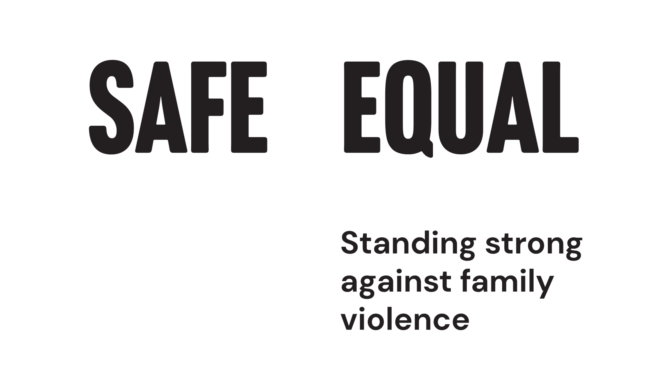

Talking about change

**Learnings from the transition to working online in primary prevention**

Safe and Equal acknowledges Aboriginal and Torres Strait Islander peoples as the traditional and ongoing custodians of the lands on which we live and work. We pay respects to Elders past and present. Sovereignty has never been ceded.

Safe and Equal is the peak body for specialist family violence services that provide support to victim survivors in Victoria.

Learn more - watch [Safe and Equal youtube video: What is Resistance?](https://www.youtube.com/watch?v=tdzxOVkA4-s)

**Contents**

What is resistance? 3

Types of resistance 4

Where to invest your energy 5

Framing strategies 6

Framing a response 8

Example resistance statement response 9

Tips when responding to resistance 10

Worker wellbeing 12

Sustaining worker wellbeing 13

# What is resistance?

Resistance describes the various forms of push back generated by policies, programs and perspectives that aim to create progressive social change. Anyone working to create social change will inevitably experience resistance and backlash.

**The best way to understand resistance is as an indicator of success.** Resistance occurs precisely when existing norms, structures and practices are effectively challenged and threatened.

Resistance can be experienced systemically, organisationally and interpersonally (see examples in the diagram below). This resource focuses on managing and responding to **interpersonal resistance** and offers strategies to help you better target your message and strengthen your influence whilst also maintaining your boundaries.

This guide draws on a range of key resources for managing resistance, bringing together strategies and tips for having supportive and constructive conversations about gender equality and the prevention of gender-based violence.

Primary prevention of gendered violence means stopping the violence *before it starts* by addressing its underlying drivers.[1] Central to prevention is actively challenging all forms of oppression and discrimination, including colonialism, cisnormativity, ageism, racism, homophobia, ableism and sexism While the examples in this guide focus on resistance to gender equality, the strategies and tips explored here can be applied when experiencing resistance to any form of social change.

**Examples of resistance at different levels:**

Resistance occurs at different levels across the socio-ecological model – individually, where it occurs within interpersonal relationships, organisationally where institutions deny the existence or a problem or refuse to take meaningful action, or at a broader systemic level, where deeply embedded norms, structures and attitudes perpetuate and promote practices that enable resistance to change. Examples of resistance at each of these levels look like:

* **Interpersonal:** For example, ‘Don’t be so sensitive, it’s just a joke.’
* **Organisational:** For example, ‘Gender inequality is not a problem here.’
* **Systemic:** For example, ‘Laws are gender blind.’

Key resources that inform this guide include VicHealth’s [*(En)countering resistance: Strategies to respond to resistance to gender equality initiatives (2018)*](https://www.vichealth.vic.gov.au/-/media/ResourceCentre/PublicationsandResources/PVAW/Encountering-Resistance-Gender-Equality.pdf); [Framing gender equality: Message guide (2021)](https://www.vichealth.vic.gov.au/-/media/ResourceCentre/PublicationsandResources/Mental-health/Framing-gender-equality---Message-guide.pdf?la=en&hash=AF111835871BFA3092C1F9DD98B3C8AA0E493295); and [Framing masculinity: Message guide (2020)](https://www.vichealth.vic.gov.au/-/media/ProgramsandProjects/HealthInequalities/VicHealth-Framing-masculinity-message-guide-2020.pdf?la=en&hash=5C7A0577057997705D93D71052E66DCB5F1BC685). VicHealth has generously granted permission to include their work in this resource.

We also recommend Rainbow Health Australia’s [Pride in Prevention Messaging Guide (2021)](https://rainbowhealthaustralia.org.au/news/pride-in-prevention-messaging-guide) for greater understanding of how to respond to resistance in the primary prevention of family violence experienced by LGBTIQ communities.

# Types of resistance

Resistance can manifest in a number of ways, ranging from passive to active. While we are often able to identify the more active forms of resistance, the more passive forms can be harder to identify and therefore decide whether or not to engage with it, and what form of engagement would be most productive. Familiarising yourself with the different forms of resistance is important for determining how we then respond. The table below provides examples of common forms of resistance, what they might look like in practice, and a description of how they each undermine progress.

#### Type of resistance (most active to most passive)

**Backlash**

Example: ‘These feminists deserve all the abuse they get’

Description: Aggressive, attacking response.

**Repression**

Example: ‘We tried that once and women didn’t want to take up the opportunity’

Description: Reversing or dismantling a change initiative.

**Co-option**

Example: ‘What about men’s rights?’

Description: Using the language of progressive frameworks and goals for reactionary ends.

**Appropriation**

Example: ‘Of course we’d appoint more women, if only they were more experienced’

Description: Simulating change while covertly undermining it.

**Appeasement**

Example: ‘Yes, yes, we must do something (one day)’

Description: Efforts to placate or pacify those advocating for change in order to limit its impact.

**Inaction**

Example: ‘We have more urgent priorities right now’

Description: Refusal to implement change initiative.

**Disavowal**

Example: ‘It’s not my job to do something about it’

Description: Refusal to recognise responsibility.

**Denial**

Example: ‘There’s no problem here’

Description: Denial of the problem or the credibility of the case for change. This can include victim blaming.

Source: [VicHealth 2018, *(En)countering resistance: Strategies to respond to resistance to gender equality initiatives*, Victorian Health Promotion Foundation, Melbourne.](https://www.vichealth.vic.gov.au/-/media/ResourceCentre/PublicationsandResources/PVAW/Encountering-Resistance-Gender-Equality.pdf)

# Where to invest your energy

Research shows that the majority (60%) of people in Australia are persuadable on the issue of gender equality. This means that they sit in the ‘moveable middle’ in the spectrum of resistance (see diagram below). Rather than spending vast amounts of time and energy trying to persuade the entrenched opposition (who strongly disagree with taking action towards gender equality), our effort is best spent bringing people over from the moveable middle to the committed end of the spectrum and finding other committed allies to keep our movement strong.

This means that sometimes, we will have to walk away from conversations with the entrenched opposition when we know our time would better be spent elsewhere.

**The spectrum of resistance highlights people’s readiness to commit to an issue:**

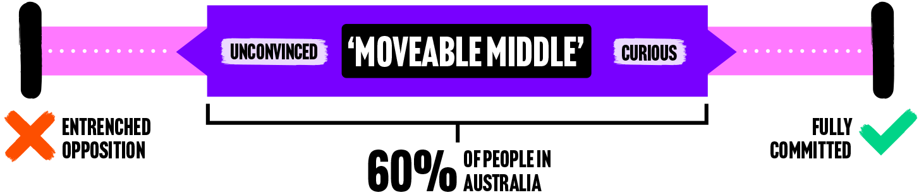

Source: VicHealth. (2021). [*Framing gender equality: Message guide*](https://www.vichealth.vic.gov.au/-/media/ResourceCentre/PublicationsandResources/Mental-health/Framing-gender-equality---Message-guide.pdf?la=en&hash=AF111835871BFA3092C1F9DD98B3C8AA0E493295). Melbourne: Victorian Health Promotion Foundation.

# Framing strategies

Framing is about how you explain why an issue is important. Framing can influence how people think and feel about an issue and ultimately how they might respond to it. VicHealth’s (2020) *Framing Masculinities: Message Guide* provides us with some useful insights on how to effectively frame the issue of gender equality when having a conversation with those in the moveable middle. Framing strategies include:

* Articulate the rationale and benefits for people of all genders; gender equality will benefit **everyone**, not just women.
* Offer compelling accounts of the problem and solutions – real life stories about the change you’ve seen, or that your organisation has influenced, can be very powerful.
* Acknowledge that gender is personal, interpersonal, institutional, and structural, involving unequal power relations. These conversations are about our personal lives and the system.

## Framing tips

### 1. Don’t pander to the vocal minority

Resist the temptation to pander to arguments traditionally put forward by those who excuse or minimise men’s violence against women, or engage in myth-busting. Instead focus on telling your progressive story to the vast majority of people who are persuadable on the issue.

**From:** Men are not naturally violent. They have been taught to use violence.

**To:** Men have been taught to use violence.

### 2. Be solutions focused

Spend more time talking about people’s role in the solution and less time talking about their role in the problem, in order to avoid activating shame and defensiveness.

**From:** All men do things that contribute to a culture of violence against women.

**To:** There are things all men can do to end the culture of violence against women.

### 3. Use the power of social norming

Don’t imply traditional masculine norms are ‘dominant’ or widely accepted. Instead, point out that most people think traditional masculine stereotypes are harmful and believe men should be freed from them.

**From:** Challenging outdated ideas of what it means to be a man is difficult because they are deeply embedded in our culture.

**To:** The vast majority of Australians do not agree with these outdated attitudes and are ready for change.

These tips have been adapted from VicHealth’s [Framing Masculinity Message Guide (2020)](https://www.vichealth.vic.gov.au/-/media/ProgramsandProjects/HealthInequalities/VicHealth-Framing-masculinity-message-guide-2020.pdf). Refer to this guide for more useful tips.

## Case study – Trades Hall Council

This VicHealth case study documents how the Victorian Trades Hall Council successfully responded to resistance by linking gender equality to the existing values of their audience and highlighting the value for the group as a whole.

“In 2016, the Victorian Trades Hall Council launched their Stop Gendered Violence at Work campaign, which positions gendered violence, including sexism and discrimination, as a serious occupational health and safety hazard.

The *We Are Union Women* team has found that framing discussions around shared union values helps people connect with gender equality and makes the case for change.

People are asked ‘what is union to you?’ with common responses including ‘social justice’, ‘standing strong together’, and ‘no one gets left behind’. The consistency of these broader values with gender equality principles provides a relatable point of connection and understanding.”[2]

# Framing a response

IGLA Europe’s *Framing Equality Toolkit* provides us with five steps you can follow when constructing your framed response to resistance:

## 1. Speak to people’s best selves

Be willing to listen and appeal to the emotions and values of people’s better selves – the side that most people want to believe themselves to be on. This can significantly reduce people’s prejudices.

## 2. Create common ground

Find something you agree on and use it as a starting point. People will likely be more supportive if you can express your shared identity and build on common ground.

## 3. Talk about change

Frame your issue in a way that makes change feel possible by using examples of success or evidence of how a particular action will create the desired change. The aim is to present a healthy balance of both positive and negative; problem and solution.

## 4. Make it real

Make your argument human! You will be more successful at changing minds when you embed factual evidence within a broader message that draws on the values and emotions of an audience and tells a story about real people and experiences.

## 5. Avoid reinforcing unhelpful frames

Don’t get too caught up in debunking people’s incorrect arguments, assumptions or biased ‘evidence’. This can often draw you into a messy debate that doesn’t actually serve to further your point or strengthen your frame. Instead, focus on spreading truths, sticking to your evidence and argument.

Adapted from Blackmore & Sanderson. (2017). [*Framing Equality Toolkit*](https://www.ilga-europe.org/communicationsresources/framingequality), pg. 56. Public Interest Research Centre and ILGA-Europe.

# Example resistance statement response

The following example shows how a common question about gendered violence can be framed and responded using the five steps.

**“What about violence against men?”**

### Speak to people’s best selves

I can tell you’re really concerned about the safety and wellbeing of men, and that’s great.

### Create common ground

I am too. All forms of violence and discrimination are unacceptable.

### Talk about change

To address these issues we have to understand the problem, and the fact that the problem of violence is gendered. Evidence consistently shows us that women and those perceived as gender nonconforming are much more likely than cis men to be victims of family and sexual violence, and cis men are the most likely perpetrators.[3] This impacts everyone, including men. Rigid gender norms negatively impact men’s mental health and freedom to fully express themselves.[4]

### Make it real

Gendered violence and inequality impact the lives of far too many people, families and entire communities. It doesn’t have to be this way.

### Avoid reinforcing unhelpful frames

We all have the power to create change, and build a society where everyone can thrive.

“Resistance can be at its greatest when existing structures are threatened. The idea of equality can provoke strong feelings – these are long-held social norms that are being challenged. You often know you’re starting to get results with your gender equality initiatives when you meet resistance.”[5]

(VicHealth 2018)

# Tips when responding to resistance

While it’s not always possible to pre-empt resistance, it can help to be prepared in the event that you do. Below are some tips you can use before, during and after a resistance statement to help in this process.

## Before

### 1. Be prepared

Plan and organise your information. Consider your audience and what questions they might have. You can always reach out to colleagues, communities of practice and other specialist organisations for support when preparing for resistance.

### 2. Practice talking about the issue

Practice your responses and arguments to get comfortable with the information.

Take some time to understand the evidence base and your own point of view. Speak from your heart as well as your head.

### 3. Understand backlash is inevitable

Acknowledge that change takes time and some people take longer to be part of the change process than others.

Be kind to yourself and allow time for individual conversations and relationships to develop.

### 4. Check in with yourself

Consider the audience, setting, dynamics of previous conversations, and where you are at emotionally.

You are not required to respond to every statement of resistance in your personal and/or professional life.

Remember, there may be some people who will never be persuaded.

## During

### 1. Acknowledge the question

Acknowledging that you have heard the person’s question or statement can be a helpful way to begin a respectful conversation.

### 2. Clarify their concern

Seeking clarification is important for understanding and responding to a question. You can do this by repeating the question or statement.

Clarifying also gives you more time to respond and consider where the resistance is stemming from.

### 3. Communicate your response

It’s important to respond with a strong, clear and concise statement. Engage respectfully. This will increase the likelihood that the person will be open to receiving the message.

### 4. Be open and show curiosity

Always being right or having the final say does not allow for an open and safe discussion. Look for common ground and shared values.

### 5. Refer to the evidence

Draw on evidence and knowledge you organised earlier. Try not to get drawn into debunking myths, instead stand firm on what you know to be true.

## After

### 1. Make time for self-reflection

Reflect on how your discussions went and the assumptions and values you bring to your work.

Ask if the resistance is particularly significant and needs to be managed differently (e.g. through organisational approaches, or changes in engagement).

### 2. Be aware of available support

Some forms of backlash can be distressing, such as heated discussions or disrespectful behaviour, especially on an on-going basis.

Be aware of available supports such as debriefing with a team member or counselling through the Employment Assistance Program.

If you find there is not enough support at your workplace, you are well within your rights to ask for more.

Adapted from Deathe & Rich. (2015). [*Speaking publicly about preventing men’s violence against women: Curly question and language considerations*](https://whwest.org.au/resource/speaking-publicly-about-preventing-mens-violence-against-women/), pg. 17-18. Melbourne: Women’s Health West.

# Worker wellbeing

Even when you feel prepared and walk away from experiencing resistance feeling successful, responding to resistance can be an emotional and impactful process. Your wellbeing is an important consideration in how and why you respond to resistance in your work.

While there are likely things you do to help you manage your own wellbeing, the onus is not on you alone. Worker wellbeing acknowledges that organisations are responsible for ensuring healthy and sustainable workplace practices and culture to enable you to work safely, sustainability and meaningfully.

Knowing what poor or reduced worker wellbeing looks like in ourselves and others is key to understanding how we can work with our colleagues and managers to prevent it. Some examples include:

* Frequent sick days or mental health days
* Feelings of apathy and disinterest
* Physical and emotional stress
* Feeling under pressure, powerless and overwhelmed
* Unable to properly refuel and regenerate
* Irritability and anger
* Not taking breaks, eating on the run
* Low job satisfaction.

# Sustaining worker wellbeing

## Organisational support

Utilise your team and management support. Remember, enabling and well resourced workplaces prevent burnout and is an organisational responsibility. Burnout is a workplace hazard, and your workplace should treat it as such.

## Connection and community

Connect with and cultivate supportive communities, either your team members, trusted friend or professional community of practice. Community serves so many purposes, but one is sharing and reflecting on shared challenges in prevention practice. Find your allies and nurture those relationships.

## Celebrating the wins, big and small

Contributing to social change in our personal and professional lives can be tiring. Social change takes time. It’s important that we celebrate the small and significant wins along the way - whether it’s a practitioner’s ‘light bulb’ moment in a workshop, or a meaningful partnership. It’s also important to celebrate the connections and people you work alongside.

## Boundaries and expectations

Know your limits, and stay focused on the ‘moveable middle’. You’re one piece of the puzzle. Large scale social change relies on collective action. Give yourself permission to step away or not engage in conversations.



Safe and Equal acknowledges the support of the Victorian Government.

1. Our Watch (2021). Change the story: A shared framework for the primary prevention of violence against women in Australia (2nd ed). Melbourne: Our Watch.
2. VicHealth. (2018). *(En)countering resistance: Strategies to respond to resistance to gender equality initiatives*, pg. 7. Melbourne: Victorian Health Promotion Foundation.
3. Our Watch (2021). *Change the story: A shared framework for the primary prevention of violence against women in Australia* (2nd ed.), Melbourne: Our Watch.
4. The Men’s Project & Flood. (2018). *The Man Box: A Study on Being a Young Man in Australia*. Melbourne: Jesuit Social Services.
5. VicHealth. (2018). *(En)countering resistance: Strategies to respond to resistance to gender equality initiatives*, pg.3. Melbourne: Victorian Health Promotion Foundation.