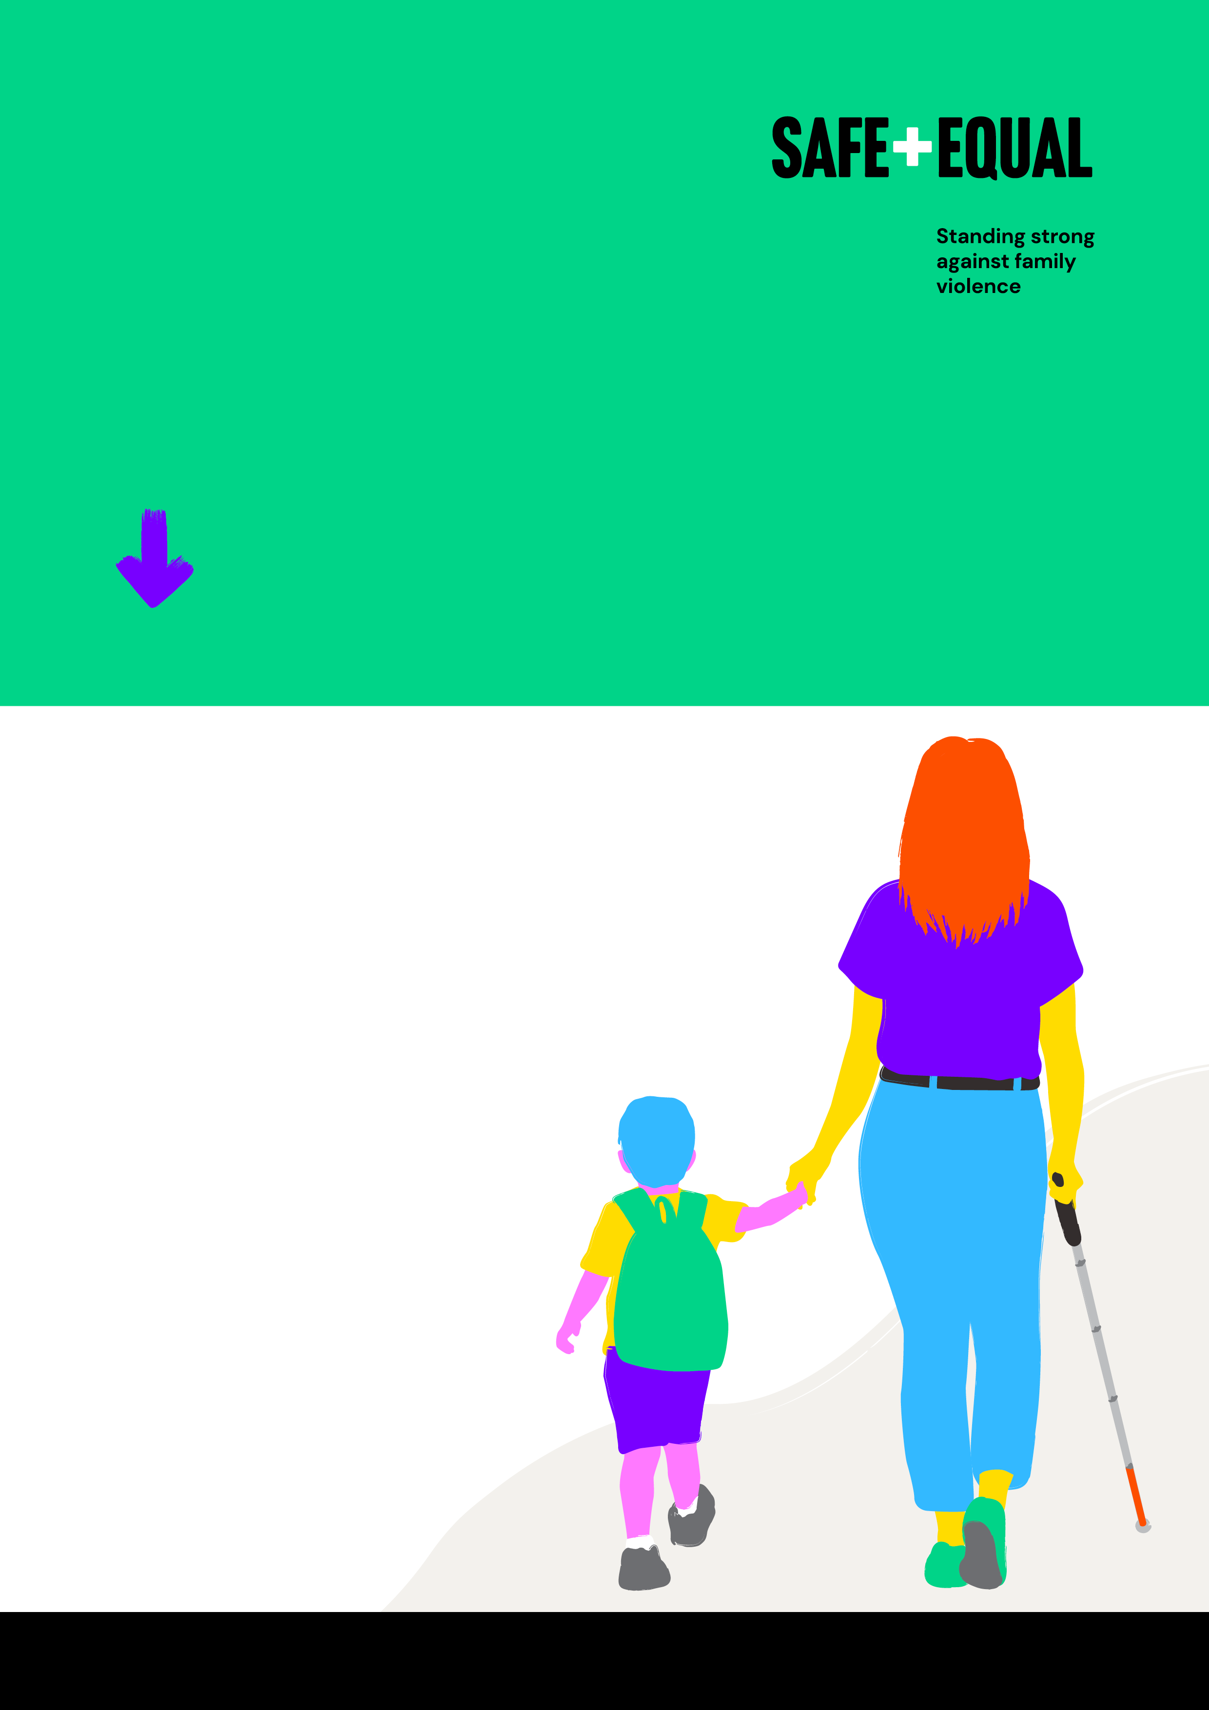

Fast Facts   
on family and   
gender-based violence

A guide for prevention practitioners

Safe and Equal acknowledges Aboriginal and Torres Strait Islander peoples as the traditional and ongoing custodians of the lands on which we live and work. We pay respects to Elders past and present. Sovereignty has never been ceded.

**Content**

Introduction 3

Prevalence 4

Prevalence and intersectionality 6

Impacts of family and gender-based violence 8

Attitudes to violence against women and gender equality 10

Gender equality 14

Endnotes 16

# Introduction

Statistics can be a powerful way to convince people about a social problem, and particularly to argue for the prioritisation of government policy and investment. Numbers that quantify how many people experience family and gendered violence are critical for gaining attention and arguing the need for change. Meanwhile, numbers that tell us about attitudes towards violence are important for tracking progress in changing attitudes that drive violence, and helping us prevent it in the future. But statistics only tell part of the story.

Statistics are often used to portray how significant or serious that something is in order to get attention. It is important to present this within a story that explains what drives violence against women and other forms of family and gender-based violence, as well as what we can do to change this. Overusing or relying too heavily on statistics can present a negative picture, and sometimes this can make the current situation seem inevitable and even accidentally reinforce the ideas we are trying to change.

To shift people towards change, statistics about violence need to be placed within a story that starts with a positive vision for the future and ends with suggestions for action and practical solutions everyone can get behind.

For more on how to use statistics, and their limitations, see our online resource [*How to Use Statistics in Primary Prevention*](https://safeandequal.org.au/resources/how-to-use-statistics-in-primary-prevention/)

# Prevalence

We all deserve a world where we can live and love freely and fully, where families and relationships are safe and respectful, and people have everything they need to thrive.

But men’s violence against women is a significant social issue that continues to do profound harm.

## Violence perpetrated by men

**Every 9 days** a woman is killed by her current or former partner[1]

Most family and gender-based violence is perpetrated by cisgender men, and this impacts women, children and young people, LGBTIQ+ communities, as well as other men.

**95% of men** and **94% of women** who experienced violence since the age of 15 did so at the hands of a **male perpetrator**[2]

We need to break down harmful gender stereotypes, and challenge ideas about masculinity that emphasise aggression, dominance and control.

## Intimate partner violence

While many people experience intimate partner violence, prevalence is clearly related to gender.

Women mostly experience violence perpetrated by men, and people who are known to them, while men mostly experience violence from other men, and those they don’t know.[3]

Almost **1 in 4 women** have experienced intimate partner violence since the age of 15

Almost **1 in 14 men** have experienced intimate partner violence since the age of 15[4]

## Sexual assault

Almost **1 in 5 women** have experienced this since the age of 15

Almost **1 in 20 men** have experienced this since the age of 15[5]

## Sexual harassment

**1 in 2 women** have experienced this since the age of 15[6]

Almost **2 in 5 women** have experienced this in the last 5 years[7] at work

## Limitations of available data

National population-level surveys (i.e. the ABS’ Personal Safety Survey) are vital sources of information, but current prevalence data does not tell us enough about the experiences of a range of communities.

* Some communities under-report experiences of violence (e.g. Aboriginal and Torres Strait Islander communities and LGBTIQ+ communities) and are less likely to be open in an interview
* ABS survey methodology (household sampling and telephone interviews) can limit the inclusion of people without a fixed address or in care settings
* 2021 was the first time the PSS asked about sexual orientation. It doesn’t ask about gender diversity, and also doesn’t provide reporting of results disaggregated (separated out) by any other demographic factor other than gender

We need more data and a range of different types of research to fully understand the prevalence and perpetration of family and gender-based violence.[8]

It is critical that we acknowledge violence, build understanding and bring it out into the open. We need to work across communities, organisations and society in all places that people live, learn, work, socialise and play, to stop violence from happening in the first place.

# Prevalence and intersectionality

We all have a right to live safe, equal and fulfilling lives.

However, we know that overlapping forms of oppression influence experiences of family and gender-based violence. We must address these underlying social factors that drive violence, alongside gender.

## Aboriginal and Torres Strait Islander women

**3 in 5 Aboriginal and Torres Strait Islander women** have experienced physical or sexual violence from a male intimate partner

This violence is perpetrated by men from many cultural backgrounds, including indigenous and non-indigenous men[9]

Compared to non-Indigenous women, Aboriginal and Torres Strait Islander women experience **8 times the rate of homicide** and are **30 times more likely to be hospitalised for assault[10]**

To stop this violence, we must address the ongoing impacts of colonialism and racism, alongside gender inequality.

## Women with disabilities

Almost **2 in 5 women with disabilities** have experienced intimate partner violence since the age of 15[11]

Women with disabilities are more likely to experience violence from multiple perpetrators, including carers and family members, and over longer periods of time[12]

To stop this violence, we need to challenge ableism, and how this overlaps and interacts with gender inequality.[13]

## Refugee and migrant women

**1 in 3 refugee and migrant women** living in Australia have experienced domestic and family violence[14]

Those on temporary visas report higher levels of abuse. This is enabled by discriminatory migration policies and practices[15]

To stop this violence, we must address racism and discrimination based on myths and misconceptions about cultural differences, to create an inclusive and gender equal society.[16]

## LGBTIQ people

More than **2 in 5 LGBTIQ people** reported ever being in an intimate relationship where they were abused in some way by their partner/s

A similar proportion reported experiencing violence from a family member[17]

For bisexual women, and trans and gender diverse people (particularly trans women), rates of intimate partner violence are even higher[18]

**53.2% of trans and gender diverse people** reported experiencing sexual violence or coercion[19]

To stop this violence, we must work together to challenge rigid gender norms, alongside heteronormativity and cisnormativity.

We must work together to break down these multiple and overlapping forms of structural and systemic inequality and oppression, and build a world where everyone is celebrated for being unique.

# Impacts of family and gender-based violence

We all have the right to live free from violence, but anyone who experiences violence should be able to access support so they can be safe while they recover and go on to live happy, healthy, full and free lives.

Unfortunately, the impacts of family and gender-based violence mean this is not currently a reality for many people, and these experiences are disproportionately gendered.

The impacts of violence against women are profound, and are also felt by children in their care.

## Prevalence of witnessing parental violence

**16% of women and 11% of men witnessed parental violence** during childhood, and this was much more commonly violence towards their mother[20]

No one should have to choose between safety and their home

## Impacts of violence

Of adults **seeking homelessness services** due to family and domestic violence in 2018-19, **90% were women[21]**

Family violence is the **leading cause of homelessness** for women and children

Of women who temporarily left violent partners, and later returned, **15% returned because they had no money and nowhere to go[22]**

## Benefits of preventing violence

Violence has physical, mental, emotional and economic costs for victim-survivors. This has wide-reaching impacts in terms of opportunities and participation in education, the workforce and wider society.

Investing in prevention of violence has an economic benefit.

**Ending violence against women** and their children would have **saved** around **$22 billion** in 2015-16[23]

Most importantly, ending family and gender-based violence saves lives, and alleviates the impacts on victim-survivors, families, friends and communities.

## Factors that exacerbate the impacts of violence

Overlapping experiences of inequality and discrimination can worsen the impact of family and gender-based violence, including impacts on income, health, mental health and housing security.

Some communities face additional barriers to accessing services, which can exacerbate the impacts of violence.

We need to address the impacts of violence through a range of sustainably-funded, safe and inclusive services for victim-survivors, and we need to work together to prevent this violence from happening in the future.

# Attitudes to violence against women and gender equality

We all deserve to experience and express healthy and equitable attitudes towards gender, and feel supported to just be ourselves.

## Research into community attitudes

The gendered drivers of men’s violence against women are well-described in Change the Story (Our Watch, 2021), and national population-level research has been conducted into attitudes connected to these drivers for over 30 years.

The National Community Attitudes to Violence Against Women Survey includes analysis specific to a range of communities (e.g. Aboriginal and Torres Strait Islander communities). In 2021, it also included new questions about recognition of particular forms of violence targeted at people because of their migrant or disability status, gender experience, sexuality or religion.

However, we need more research into attitudes related to the overlapping drivers of violence experienced by all women, and by LGBTIQ+ communities.

## Findings from research

* Rigid and binary ideas about gender drive violence by pushing people into roles and behaviours that limit their lives and their potential, and risk them hurting both themselves and others.
* Condoning violence, or denying what the weight of evidence tells us about men’s perpetration of violence against women, only makes things worse.
* Violence against trans and gender diverse people, and trans women in particular, is inextricably linked to these attitudes.
* **Understanding and attitudes regarding violence against women and gender inequality have improved slowly but significantly over time.**
* However, in 2021, fewer people recognised that men are more likely to commit domestic violence, and that women are more likely to experience physical harm from domestic violence.[24]
* **We need to challenge false ideas that violence is experienced equally – when prevalence, severity and impacts are clearly gendered.**

Most people recognised that experiences of family and gender-based violence can be different for different people, and that it isn’t always physical.

* **84%** agreed that **harassment** via repeated emails, text messages was always or usually **a form of violence**
* **82%** agreed that **controlling a partner by denying them money** is always **or usually a form of abuse and domestic violence**
* **89%** recognised **in person stalking** as always or usually **a form of violence**
* **78%** agreed that **repeatedly criticising a partner** to make them feel bad or useless is always or usually **a form of domestic violence[25]**

To end family and gender-based violence, we must challenge ideas that limit women’s independence and autonomy and continue to build understanding that healthy and respectful relationships are not based on control.

## Attitudes are changing

Many problematic attitudes are shifting in positive directions:

* **87% strongly disagreed** with the statement **“men should take control in relationships and be head of the household”** compared to **79%** in 2009
* **81% strongly disagreed** with the statement **“women find it flattering to be persistently pursued, even if they are not interested”** compared to **68%** in 2017[26]

This shows that change is possible. But some attitudes are slower to change, and many problematic attitudes remain amongst a sizeable minority.

**35% agreed that women are exaggerating** about how unequally they are treated in Australia[27]

More needs to be done to improve these attitudes.

## Myths around sexual assault

Creating communities that are safer for women requires dismantling myths and fallacies around sexual assault.

There are many reasons why the vast majority of sexual assaults are not reported to police, and it is very rare that reports are found to be untrue.

**But**

**14%** of respondents **agreed** that women make **false allegations**

**And**

**35% agreed** that sexual assault allegations are commonly used as a way of **getting back at men[28]**

Sexual assault and harassment are serious and unacceptable actions that persist because of problematic norms that deny women’s autonomy, their rights to their own bodies and their right to refuse sex.

Preventing sexual violence also means acknowledging both the overlapping and specific drivers of unacceptably high rates of sexual violence experienced by trans and gender diverse people.

We must increase a range of inclusive education programs around consent and shift attitudes so that everyone can engage with sex enthusiastically and happily, if they want, with a partner who feels respected and is just as keen.

We know what needs to change in order to create a better future. We need people to reject violence and inequality, and be ready to step forward and be part of a movement for change. This means recognising the gendered nature and reality of violence. Changing attitudes will mean greater safety and freedom for all women, for all trans and gender diverse people, and for men as well.

# Gender equality

Achieving gender equality across all facets of our society is necessary for preventing and ending family and gender-based violence.

## Australia’s declining ranking

Unfortunately, **Australia’s global ranking** for gender equality **has declined** over the past several years:

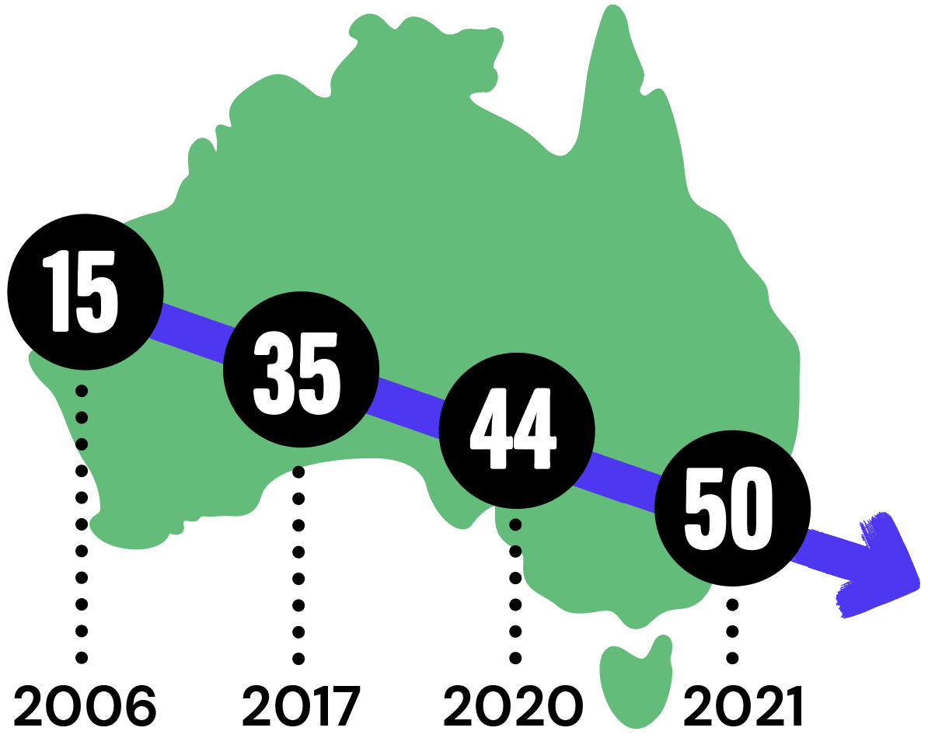

* 2006: Australia ranked No. 15
* 2017: Australia ranked No. 35
* 2020: Australia ranked No. 44
* 2021: Australia ranked No. 50[29]

But change is possible with the right action. Just look at our neighbours: New Zealand is ranked No. 4 in 2021 and is among the world’s most gender equitable countries.

Women are paid less on average than men for the same full-time role across every industry and occupation in Australia.[30]

We need to increase pay in undervalued industries, and end pay discrimination.

## Tackling gender inequality and discrimination

There is increasing attention being paid to improving gender equality within workplaces.

**But**

**Women remain under-represented** in key-decision making roles across **almost all industries in the workforce**[31]

This is even more so for Aboriginal and Torres Strait Islander women, and women from multicultural backgrounds.[32]

**85%** of ‘culturally and racially marginalised’ women **felt they had to work twice as hard** as other employees to get the same treatment or evaluation[33]

During Covid-19, more women lost their jobs, had hours reduced or shouldered the burden of unpaid caring responsibilities.[34]

This also impacted on mental health: **Women** report **higher rates of mental health issues**, suicidality and self-harm compared to men[35]

We need to tackle the multiple forms of discrimination so that people of all genders can equally participate in leadership and decision-making roles.

Gender inequality creates the environment for violence against women, and it also makes the impacts of violence worse.

Together, we can and must create a gender equal society that is truly inclusive. We need long-term efforts to shift gender-based oppression and discrimination. This must go hand-in-hand with efforts specifically targeted at the prevention of violence against women, and all forms of family and gender-based violence.

# Endnotes

1. Australian Institute of Health and Welfare (2019) Family, domestic and sexual violence in Australia: Continuing the national story 2019
2. Diemer, K. (2015) Australian Bureau of Statistics Personal Safety Survey: Additional analysis on relationship and sex of perpetrator
3. Australian Bureau of Statistics (2023) Personal Safety Survey, Australia, 2021-22
4. Australian Bureau of Statistics (2023) Personal Safety Survey, Australia, 2021-22
5. Australian Bureau of Statistics (2023) Personal Safety Survey, Australia, 2021-22
6. Australian Bureau of Statistics (2023) Personal Safety Survey, Australia, 2021-22
7. Australian Human Rights Commission (2022) Time for Respect: Fifth national survey on sexual harassment in Australian workplaces
8. Safe and Equal (2023) How to use statistics
9. Our Watch (2018) Changing the picture
10. Kripps, K. (2023) Indigenous women and intimate partner homicide in Australia: confronting the impunity of policing failures
11. Centre of Research Excellence in Disability and Health (2021) Nature and extent of violence, abuse, neglect and exploitation against people with disability in Australia
12. Centre of Research Excellence in Disability and Health (2021) Nature and extent of violence, abuse, neglect and exploitation against people with disability in Australia
13. Our Watch (2022) Changing the Landscape
14. Segrave, M., Wickes, R. and Keel, C. (2021) Migrant and refugee women in Australia: The safety and security study
15. Segrave, M., Wickes, R. and Keel, C. (2021) Migrant and refugee women in Australia: The safety and security study
16. Multicultural Centre for Women’s Health (2017) Intersectionality matters
17. Australian Research Centre in Sex, Health and Society (2020)   
    Private Lives 3: The health and wellbeing of LGBTIQ people in Australia
18. Rainbow Health Australia (2020) Pride in Prevention
19. Kirby Institute (2018) Australian Trans and Gender Diverse Sexual Health Survey
20. Australian Bureau of Statistics (2023) Personal Safety Survey, Australia, 2021-22
21. Australian Institute of Health and Welfare (2019) Specialist homelessness services annual report 2018–19
22. Summers, A. (2023) The Choice: violence or poverty: A report into domestic violence and its consequences in Australia today
23. KPMG (2016) The cost of violence against women and their children in Australia
24. ANROWS (2023) 2021 National Community Attitudes Towards Violence Against Women Survey
25. ANROWS (2023) 2021 National Community Attitudes Towards Violence Against Women Survey
26. ANROWS (2023) 2021 National Community Attitudes Towards Violence Against Women Survey
27. ANROWS (2023) 2021 National Community Attitudes Towards Violence Against Women Survey
28. ANROWS (2023) 2021 National Community Attitudes Towards Violence Against Women Survey
29. World Economic Forum (2021) Global Gender Gap Report
30. Workplace Gender Equality Agency (2021) Australian Bureau of Statistics (2023) Average weekly earnings
31. Workplace Gender Equality Agency (2021)
32. Australian Human Rights Commission (2018) Leading for Change: A blueprint for cultural diversity and inclusive leadership revisited
33. Diversity Council of Australia (2023) Culturally and racially marginalised women in leadership
34. Victorian Equal Opportunity and Human Rights Commission (2020) Affected communities: Workplace gender equality
35. ABS (2022) National Study of Mental Health and Wellbeing