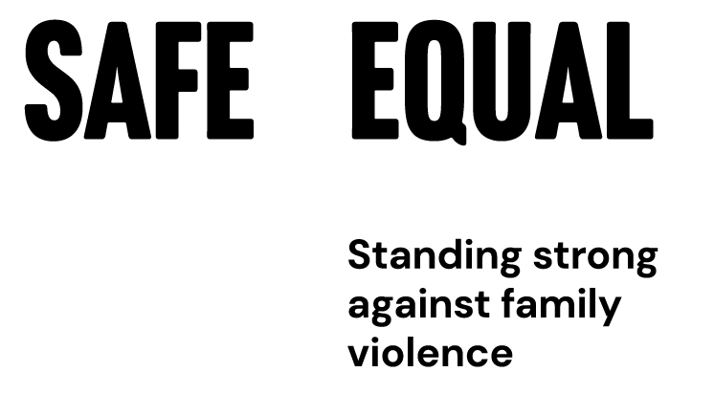

How to use statistics in primary prevention

Understanding their importance, uses and limitations

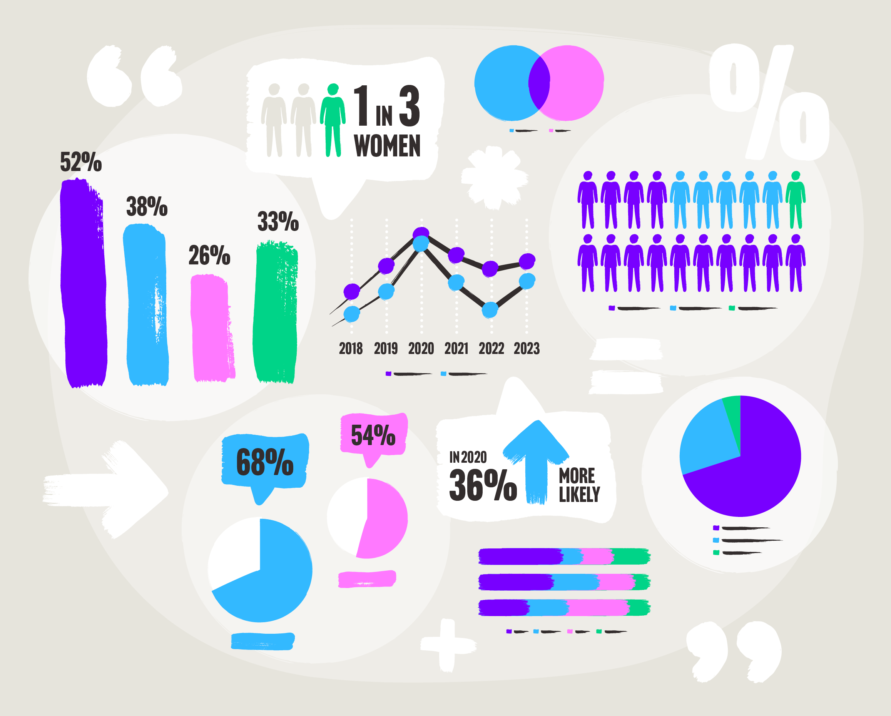

Safe and Equal acknowledges Aboriginal and Torres Strait Islander peoples as the traditional and ongoing custodians of the lands on which we live and work. We pay respects to Elders past and present. Sovereignty has never been ceded.

**Contents**

Introduction 3

Where do statistics come from? 4

Population-level research and its limitations 5

A broad national research agenda 6

Quoting statistics 7

Telling a story 8

Author: Marina Carman

# How to use statistics in primary prevention

## Introduction

Statistics can be a powerful way to convince people about a social problem, and particularly to argue for the prioritisation of government policy and investment. Numbers that quantify how many people experience family and gender-based violence are critical for gaining attention and arguing the need for change. Meanwhile, numbers that tell us about attitudes towards violence are important in tracking progress in changing attitudes that drive violence, and helping us prevent it in the future. But statistics only tell part of the story.

This resource aims to support greater understanding of statistics, how best to use them, and their limitations as well.

Example infographic

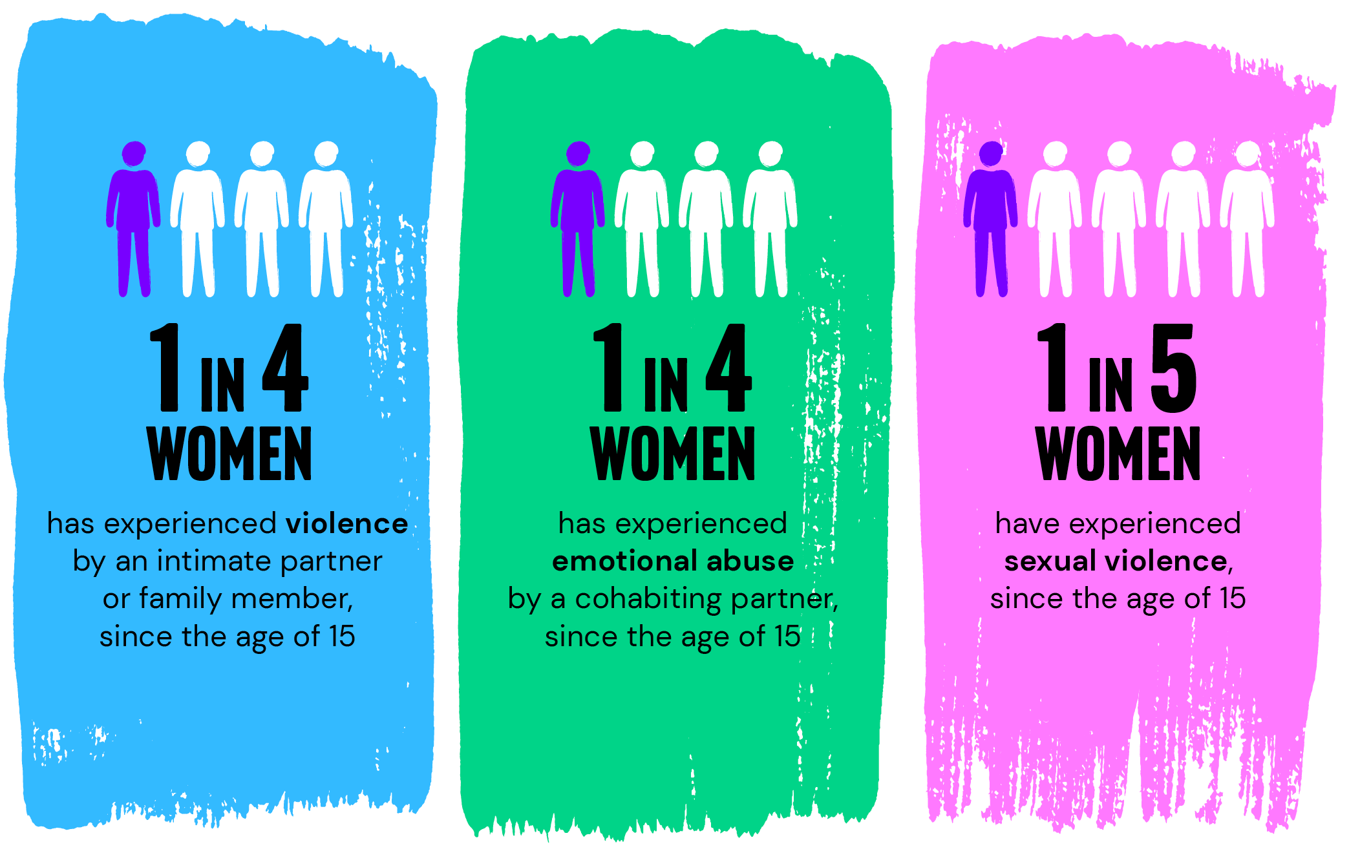

The above image presents the following data as an infographic:

* **1 in 4 women** has experienced violence by an intimate partner or family member, since the age of 15
* **1 in 4 women** has experienced emotional abuse by a cohabiting partner, since the age of 15
* **1 in 5 women** have experienced sexual violence, since the age of 15

Source: Personal Safety Survey, Australian Bureau of Statistics, 2023.

## Where do statistics come from?

Statistics come from large-scale surveys of lots of people. These are called ‘quantitative’ studies, and they generate statistics that tell us about things like prevalence (how many people experience family and gendered violence). Quantitative studies can also tell us about patterns (who is more or less likely to experience violence), attitudes (how people think about violence), or trends over time (if the surveys are repeated). Sometimes these studies also include questions about the impact of violence on people’s lives, and their experiences when accessing services or other support.

When using and quoting statistics, the best available data will be the most ‘representative’ data. In particular, this is used to explain the prevalence of experiences of violence. A key distinction here is the difference between ‘population-level data’ and data that comes from surveys using other non-random or ‘convenience’ samples.

* ***Population-level*** data is produced using research methods that aim for samples to be representative of a population as a whole. The strongest population-level data is produced when everyone in a population is included in the sample. The national census, for instance, includes every household in Australia. Other methods used by population-level studies include collecting data from large random samples (either households or individuals), which are most likely to be representative of the population as a whole.
* ***Non-random*** or ***convenience sampling*** can be used in national surveys focussed on particular groups or particular experiences. These produce results that are important in understanding experiences and needs, but are not considered ‘representative’. These samples can be made more representative by aligning them with census data (a process known as weighting) or results can be analysed in comparison to population-level data for other groups.

Population-level data is the most robust data, but is also resource-intensive and expensive to collect. In terms of violence against women, there are two key sources of national population-level data:

* The [Personal Safety Survey](https://www.abs.gov.au/statistics/people/crime-and-justice/personal-safety-australia/latest-release) (PSS) is conducted by the Australian Bureau of Statistics. It is based on earlier surveys focussed on women, but has been conducted population-wide in 2005, 2012, 2016 and in 2021-22. A total of 11,905 people completed the latest survey, drawn from a random sample of households. The survey includes people aged 18 and over, with questions about the nature and extent of violence experienced since the age of 15. This included experiences of violence, emotional abuse and economic abuse, sexual harassment, stalking, abuse and witnessing parental violence during childhood, as well as feelings of general safety.
* The [National Community Attitudes towards Violence against Women Survey](https://www.ncas.au/) (NCAS) is conducted by ANROWS. It began in 1987, and is conducted every four years. The 2021 survey included responses from 19,100 people aged 16 and over, through a random selection of phone numbers. The survey includes questions about how participants understand violence against women, their attitudes towards it, what influences their attitudes, as well as attitudes to gender equality and preparedness to intervene when witnessing violence or its precursors.

Both these surveys are conducted periodically (every four years), and use the same questions each time. These are called ‘cross-sectional’ studies, which are based on recruiting a fresh sample each time. This provides a snapshot at a point in time, and also allows for tracking of broad societal level changes over time. These surveys provide key data that is used to inform reporting against indicators in the [National Plan to End Violence Against Women and Children](https://www.dss.gov.au/ending-violence) 2022-2032.

## Population-level research and its limitations

Population-level research is powerful and convincing in defining a problem, and we need this sort of research for measuring and tracking prevalence and attitudes. However, it doesn’t and can’t answer every question.

### Sampling and methodology

A number of issues in the methodology used in population-level surveys can impact who gets included and how representative the results end up being.

For instance, sampling through households limits the inclusion of people without a fixed address, or those in other types of living and care settings (which limits participation for older people and people with a disability). Sampling through telephone or even internet surveys can limit the participation of people with disabilities and those who do not speak English as a primary language.

In some cases, participants may be less likely to be fully open about sensitive issues if being interviewed by someone, compared to filling out an anonymous survey. This has particularly been identified as a barrier for lesbian, gay, bisexual, trans and gender diverse, and intersex (LGBTIQ+) communities.

The pandemic has also had an impact. In the explanatory notes on the methodology for the latest Personal Safety Survey results released in 2023, the ABS acknowledges the impact of the pandemic on data collection. This has resulted in reduced sample sizes due to a range of factors (including the introduction of some features to ensure the safety of participants). However, the sample is still large and representative.

### What questions get included

Questions in surveys have to be prioritised, otherwise they would be too long and participants would never agree to do them. These decisions are practical but also political.

For instance, the Personal Safety Survey did not ask about about sexual orientation until 2020, and does not currently ask information about gender diversity. It also doesn’t provide reporting of results disaggregated (separated out) by any other demographic factor other than gender. This means there is insufficient data to allow an analysis of prevalence according to ethnic identity, country of origin, cultural or linguistic background, migration status and religion.

There is also no single, robust and reliable source of national data on prevalence for Aboriginal and Torres Strait Islander women. However, [Changing the Picture](https://www.ourwatch.org.au/resource/changing-the-picture/) outlines a range of population-specific research that indicates it is very high.

Some communities have been found to under-report their experiences of violence, like Aboriginal and Torres Strait Islander communities and LGBTIQ+ communities. There is evidence that asking one question about whether someone has experienced violence or abuse, is not as effective as asking a number of questions about experiences that signify violence and abuse. Some [population-specific research with LGBTIQ+ communities](https://www.latrobe.edu.au/arcshs/work/private-lives-3) has yielded important insights in doing so.

The PSS is also based on asking people whether they have experienced violence. There is no similar robust data set asking about perpetration. This limits the understanding of violence and its dynamics.

The 2021 NCAS implemented the [2020 ABS Standard for Sex, Gender, Variations of Sex Characteristics and Sexual Orientation Variables](https://www.abs.gov.au/statistics/standards/standard-sex-gender-variations-sex-characteristics-and-sexual-orientation-variables/latest-release), and provided data from non-binary and gender diverse participants for the first time. Separate reports will also be provided on understanding and attitudes reported by participants by age, Aboriginal and Torres Strait Islander and people born in a ‘non-main English-speaking country’. It also included analysis across a range of demographic factors, and introduced a number of questions about recognition of particular forms of violence targeted at people because of their migrant or disability status, gender experience, sexuality or religion.

## A broad national research agenda

Population-level and other quantitative studies provide vital information about prevalence, patterns, attitudes and behaviours (who and what), as well as changes over time (when). But, they aren’t going to be able to answer questions about how or why. A broad national research agenda is needed to fill in the gaps, and build on existing work that has addressed these questions.

For instance, ‘qualitative’ studies involve things like interviewing smaller numbers of people in more detail. Studies like this are more in-depth and can tell us more about people’s experiences and understandings of family and intimate partner violence, why this might be the case, and what helped people to recover and to change.

‘Longitudinal’ studies involve following the same sample of people over time. These are more useful for tracking changes at an individual level. One example of insights that can be drawn from this sort of research comes from the [Australian Longitudinal Study on Women’s Health](https://plan4womenssafety.dss.gov.au/wp-content/uploads/2018/07/Measuring-Domestic-Violence-in-Longitudinal-Research.pdf), which involves understanding differences in how women reported their experiences of violence at different points in their lives.

There is also a range of conceptual and theoretical work that goes into identifying and defining the social drivers of violence against women, and other forms of family violence. Evaluations of interventions to prevent and respond to violence are also important for understanding more about what works and why.

Put together, all of these sorts of research and analysis make up the evidence base that informs our work across family violence prevention and response.

## Quoting statistics

The key thing when quoting statistics is to say where they came from, and be as accurate as possible about what they mean. Attention to these details helps to establish that the statistics are based on actual research, and to acknowledge both the strengths and limitations of existing data.

### Top tips

* It is better to quote the original source, rather than another document that quoted the statistics. This can be as simple as a note like: ABS, Personal Safety Survey, 2023.
* It can be more powerful to represent statistics numerically rather than as a percentage, e.g. one in four rather than 25%. This helps people to visualise how common something is, but it works a lot better if the percentage is high.
* Some studies ask about experiences before or after a certain age, over the last 12 months, or about experiences over a lifetime. It is important to include these qualifiers, as the statistics can be really different depending on the measure being used.
* It is generally better to say ‘X survey found that x numbers of women experience x’ rather than ‘x numbers of women experience x’. This becomes much more important where population-level data doesn’t exist. For instance, where the experiences of some communities are absent from population-level data but are available through surveys of those specific communities, these surveys should be clearly referenced and promoted.
* Where data doesn’t exist, this should be mentioned, alongside advocacy for more inclusive data collection that captures the experiences and needs of marginalised communities.
* It is important to be specific when quoting comparisons – i.e. ‘x group are x times more likely to experience x than x’ rather than ‘x group are more at risk’. Sometimes comparisons can be between two groups (e.g. women and men) or between one group and everyone else (e.g. general population). If the categories or definitions of categories used in the research have limitations, it’s better to quote the research directly, and then explain the limitations.

Statistics can tell us who is more or less likely to experience or report violence, or what factors occurred alongside these experiences. But in interpreting and using statistics it is important to understand the distinction between causality and ‘association’. So, for instance, statistics will tell us that some people with a particular life experience are also at increased risk of experiencing violence, but that is very different from saying that this experience caused the violence.

Nevertheless, associations can tell us a lot about things like which people and groups might need more attention, things that increase or decrease risk, or how particular attitudes and behaviours may be related. Associations can point the way to informing interventions, and improve our understanding of the range of changes required in order to prevent or respond to violence.

## Telling a story

A final point on using statistics is that they are often used to portray how significant or serious that something is in order to get attention. It is important to present this within a story that explains what drives violence against women and other forms of family violence, as well as what we can do to change this.

Overusing or relying too heavily on statistics can present a negative picture, and sometimes this can make the current situation seem inevitable and even accidentally reinforce the ideas we are trying to change.

To shift people towards change, statistics about violence need to be placed within a story that starts with a positive vision for the future and ends with suggestions for action and practical solutions everyone can get behind.

For more on statistics you can use in your work, refer to Safe and Equal’s [Fast Facts 2022](https://safeandequal.org.au/resources/fast-facts-2022/).



Safe and Equal acknowledges the support of the Victorian Government.