**Slide 1:**

Learning from the 16 Days of Activism: Post-Campaign workshop

Tuesday 14 December 2021

Image: Respect Victoria, Preventing Family Violence Logo, Respect Women Call it Out state-wide campaign logo, Safe and Equal organisation logo

**Slide 2:**

**Acknowledgement of Country**

*****

Image: The Australian Aboriginal flag and the Torres Strait Islander Flag

We wish to acknowledge the custodians of this land, The Wurundjeri people, their Elders past and present, and any Aboriginal or Torres Strait Islander people here today. I also want to express my gratitude that we share this land today, my sorrow for the costs of that sharing, and my hope and belief that we can move to a place of equity, justice, and partnership together.​

**Slide 3:**

**Agenda and Housekeeping**

This webinar is being recorded and will be available following the session on the 16 Days section of our website.​

​

There will be a Q and A session at the end of this event where you will be able to connect with the team and ask questions about your campaign.​

​

We would like this space to be respectful and safe for all attendees and speakers, so please consider this as you ask questions and interact in the chat box.

**Slide 4:**

*Natasha Darrigan*

*Senior Campaigns Advisor*

*Respect Victoria*

Image: Respect Victoria, Preventing Family Violence Logo, Safe and Equal organisation logo

The white and orange Respect Victoria logo, which includes the text 'Preventing Family Violence' in a smaller square speech bubble. Next to this is the Safe and Equal organisation logo in bold black text with a white plus symbol depicting the 'and'. Below the logo is the text 'Standing strong against family violence' in a smaller black font.

**Slide 5:**

16 Days of Activism Against Gender-Based Violence (’16 Days’) Statewide Campaign 2021

Luke Butler, Manager, Campaigns

Natasha Darrigan, Senior Adviser, Campaigns

Grantee Wrap Up Session

Tuesday 14 December 2021.

Image: A bright orange slide with bold white text which reads '16 Days of Activism Against Gender-Based Violence ('16 Days') Statewide Campaign 2021. In the bottom right hand corner is the black, white and orange version of the Respect Victoria logo within a white square speech bubble.

**Slide 6:**

**Acknowledgement of Country – Natasha Darrigan**

I acknowledge the Traditional Owners of the various lands on which we meet today.

We pay our respects to the Elders past and present, for they hold the memories, the traditions, the culture and hopes of Aboriginal and Torres Strait Islander peoples across Australia.

**Slide 7:**

Grassroots Initiative – 2021 (Partnering with Safe and Equal)

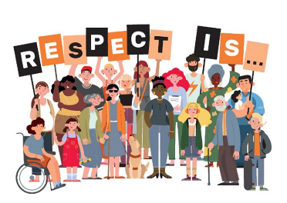

Image: 16 Days campaign illustration, which depicts colourful illustrations of diverse people of all ages, ethnicities and abilities on a white background. People are holding black-, white- and peach-coloured placards each with an individual letter on them that spell out 'RESPECT IS...'

**Slide 8:**

Grassroots Initiative – 2021 (Partnering with Safe and Equal)

* In June 2021, following a tender process, Respect Victoria awarded funding to Safe and Equal to run grassroots activity.
* Safe and Equal partnered with the Municipal Association of Victoria (MAV), the Victorian Council of Social Services (VCOSS), No To Violence (NTV) and the Women’s Health Services Council (WHSC) to leverage their respective membership bases and expertise.
* Small grants were delivered and a campaign toolkit, supporting assets, email support, webinar events.
* The initiative will be independently evaluated in the new year.
* A total of 113 applications were received: 94 membership orgs, 68 councils, 30 community organisations.

**Slide 9:**

Walk Against Family Violence (WAFV) – 2021 (Partnering with Safe Steps)

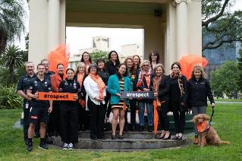

Image: A group photo of people standing in front of a concrete marquee in the middle of Treasury Gardens in Victoria, wearing orange and black and holding '#respect' placards.

**Slide 10:**

State-Wide Campaign – 2021 (Respect Women/Respect Is…)

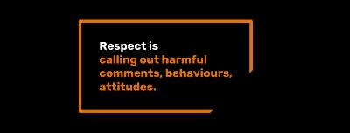

Image: Image shows a black rectangle, and in the centre is an orange outlined box that says 'Respect is calling out harmful comments, behaviours, attitudes'

**Slide 11:**

State-Wide Campaign – 2021 (Respect Women/Respect Is…)

* Respect Victoria ran it’s bystander focused campaign, Respect Women: ‘Call It Out’ (Respect Is) from 21 November to 12 December 2021 across channels like regional TV, YouTube, digital banners, social media, radio, Spotify.
* Respect Victoria will be evaluating impact in the coming months but initial results show engagement has been high through digital channels.
* This year, Respect Victoria engaged with Victim Survivor Advisory Council (VSAC) members in a photoshoot and captured their stories of what respect means to them for organic social media.
* Additionally, we worked with 16 Days Ambassadors Rosie Batty, Cam Nguyen, Kristy Dickinson, Luke and Daniel Mancuso (YiaYia Next Door), and Nyadol Nyuon and captured their stories of what respect means for organic social media.

**Slide 12:**

State-Wide Campaign – 2021 (Respect Women/Respect Is…) – VSAC Partnership

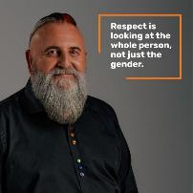

Image: Photo of a middle-aged man with white skin, wearing a black button-up shirt with rainbow colored buttons. He has a long grey beard and a kind smile. In the top right hand corner is a text box that says 'Respect is looking at the whole person, not just the gender'.

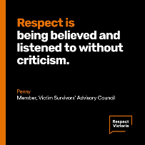

Image: Black textbox with thin orange stripe down the left hand side. Text inside the box says 'Respect is being believed and listened to without criticism' and in smaller text below this it says 'Penny, Member, Victim Survivors' Advisory Council', with the Respect Victoria logo in the bottom right hand corner.

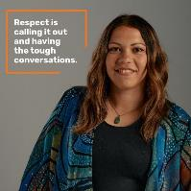

Image: A photo of a woman with tan skin, wearing a green stone necklace, a black tank top and a printed teal, blue and green draped jacket over top. She has copper-brown hair and is smiling at the camera. In the top left hand corner is a text box which says 'Respect is calling it out and having the tough conversations.'

**Slide 13:**

State-Wide Campaign – 2021 (Respect Women/Respect Is…) – Ambassadors

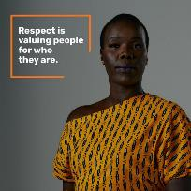

Image: Photo of Nyadol Nyuon, a black woman with short cropped black hair, wearing a mustard and black block-print, off-shoulder top. She is looking directly at the camera and smiling slightly. In the top left hand corner is a text box that says 'Respect is valuing people for who they are'.

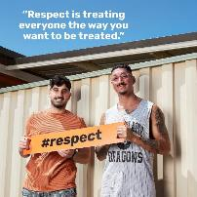

Image: A photo of Luke and Daniel Mancuso, standing in front of a cream coloured, aluminium fence. One of the brothers is wearing a dark peach coloured t-shirt, and the other is wearing a gray basketball tank top. They are holding an orange banner that says '#respect'. In the top left-hand side is white text that says 'Respect is treating everyone the way you want to be treated'.

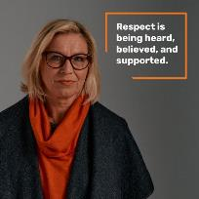

Image: A photo of Rosie Batty, wearing a dark orange cowl-neck top underneath a charcoal colored jacket. She has black-rimmed glasses on, and mid-length blond cropped hair. She is looking directly at the camera. In the top right hand corner is a text box that says 'Respect is being heard, believed, and supported.'

**Slide 14:**

Thank you for your involvement in the 16 Days and your time today.

**Slide 15**

*Claire Bower*

*Health Promotion Officer*

*Gippsland Women’s Health*

Image: A bright orange slide with bold white text which reads '16 Days of Activism Against Gender-Based Violence ('16 Days') Statewide Campaign 2021. In the bottom right hand corner is the black, white and orange version of the Respect Victoria logo within a white square speech bubble.

**Slide 16:**

16 Days of Activism 2021

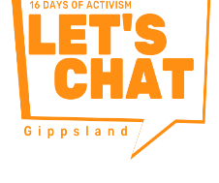

Image: The Gippsland Women's Health campaign logo which is an orange angular speech box that says 'LET'S CHAT' in big, bold orange text, with smaller text above that says '16 DAYSOF ACTIVISM' and 'Gippsland' at the bottom outside of the text box.

**Slide 17:**

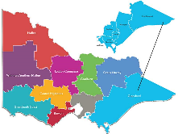

Image: A map of Victoria, with all the regions highlighted in a different colour. There is a zoom-in on the Gippsland region to identify the separate local council areas within.

**Slide 18:**

Support

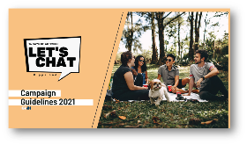

Image: Screenshot of a rectangle, peach coloured brochure for the 'Let's Chat' campaign guidelines for supporters and participants. The brochure is divided in half horizontally by a diagonal line, and to the right of the line is a photo of four young adults sitting on a picnic blanket in a park smiling at each other, with a small white dog in the foreground.

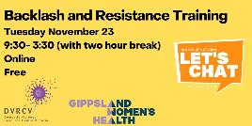

Image: A pale yellow event banner for 'Backlash and Resistance Training' which has the Let's Chat logo and the DVRCV and Gippsland Women's Health logos at the bottom.

**Slide 19:**

Virtual Collateral

Images: Various images of virtual campaign collateral that are available to campaign participants. This includes a Zoom background with a peach, orange, and green squiggly motif, and the Let's Chat and Respect Victoria logos. It also includes instagram post template, phone backgrounds and social media profile picture borders.

**Slide 20:**

Social Media Performance

Facebook:

* 25 posts
* 11625 impressions
* 873 interactions
* (reactions, comments, shares, link clicks)

Instagram:

* 22 posts
* 2872 impressions
* 3199 interactions

LinkedIn:

* 12 posts
* 1491 impressions
* 1604 interactions

Campaign Hashtags:

* #Let’s Chat Gippsland
* #16 Days Of Activism
* #Respect Is

**Slide 21:**

Website

As of 7th December:

1399 website visits by 487 visitors, including 252 visits to the Resources page

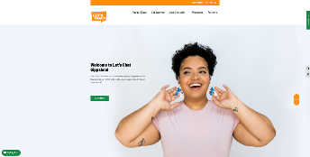

Image: Screenshot of the Gippsland Women's Health 'Let's Chat' campaign website.

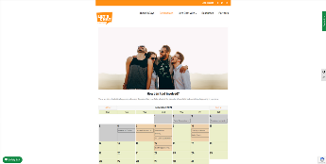

Image: Screenshot of the virtual 'Let's Chat' calendar of events

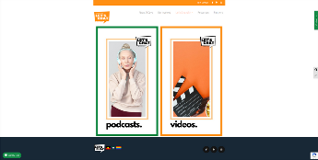

Image: Screenshot of example campaign collateral available for downloading

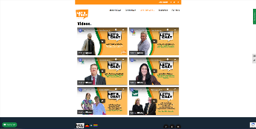

Image: Screenshot of one of the website pages which shows embedded video's featuring people talking about the campaign.

**Slide 22:**

Visual Presence

Images: Various images of a giant 2m by 2m ‘Let’s Chat’ campaign posted in different locations around the Gippsland area.

**Slide 23:**

Media Coverage

Images: Various images of print and online newspaper articles promoting the Gippsland campaign activities.

**Slide 24:**

Who got involved?

Images: Various images of podcast cover images, posters and Instagram posts promoting events that were organised during the 16 Days campaign.

**Slide 25:**

Successes

* Region-wide collaborative approach
* Increase in region's confidence
* Seeing partners tie their events into the Let’s Chat theme
* Regional leader's support
* Localised social media content
* Campaign website
* Partnership with local newspapers and print media outlets
* Significant reach across social media platforms
* Strong brand presence across digital media and in-person events

**Slide 26:**

Learnings

* Refine and review your audience
* Allow time, money and resources for extensive promotion
* Partner with local media outlets
* Embed diversity

**Slide 27:**

Thank you



Image: A thank you slide which includes the Respect Victoria and 'Let's Chat' campaign logos in the corners. The main image is a photo of a woman with tan skin and short, curly black hair. She is wearing a pale pink t-shirt and is looking to the left of the camera. She has a big smile and is holding her hands behind her bright blue and white, triangle-shaped dangly earrings.

**Slide 28:**

*Sally Reiffel*

*Manager, Family Safety and Healing Programs*

*Bendigo and District Aboriginal Cooperative*

Image: A bright orange slide with bold white text which reads '16 Days of Activism Against Gender-Based Violence ('16 Days') Statewide Campaign 2021. In the bottom right-hand corner is the black, white and orange version of the Respect Victoria logo within a white square speech bubble.

**Slide 29:**

The Clothesline Project

Image: A bright orange slide with bold white text which reads '16 Days of Activism Against Gender-Based Violence ('16 Days') Statewide Campaign 2021. In the bottom right-hand corner is the black, white and orange version of the Respect Victoria logo within a white square speech bubble.

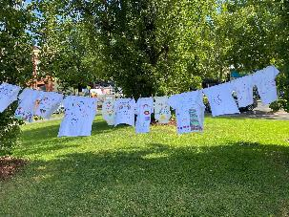

Image: A photo of a clothesline on which there hangs a dozen white t shirts of various adults and children's sizes. The garments have been brightly decorated with what respect means using fabric makers. The photo has been taken on a sunny day, and in the background is lush green grass and lots of trees.

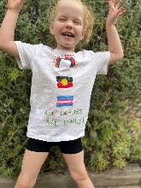

Image: A photo of a female child with white skin and pale strawberry-blonde hair. She is standing with her legs out and arms up in a joyful pose and is laughing at the camera. She is wearing black shorts and a white t-shirt that she has decorated using fabric markers with a rainbow, the Aboriginal flag and the Transgender flag, aligned vertically. At the bottom is green text that says 'All Families are deadly' in green.

**Slide 30:**

*Anita Bhandari*

*Community Engagement Worker*

*Didi Bahini Samaj*

Image: A bright orange slide with bold white text which reads '16 Days of Activism Against Gender-Based Violence ('16 Days') Statewide Campaign 2021. In the bottom right-hand corner is the black, white and orange version of the Respect Victoria logo within a white square speech bubble.

**Slide 31:**

16 Days of Activism Against Family Violence: DIDI BAHINI SAMAJ VICTORIA (DBSV) APPROACHES



Image: A picture of the 'Didi Bahini Samaj Victoria' organisational logo, which is pink and orange.

**Slide 32:**

Acknowledgment of Country

I would like to acknowledge Aboriginal and Torres Strait Islander people as the first peoples and traditional owners and custodians of this land.

I pay respects to the ancestors of this country, elders, knowledge holders and leaders, past, present and emerging and extend my respect to all Aboriginal and Torres Strait Islander people.



Image: The Australian Flag



Image: The Aboriginal Flag

**Slide 33:**

DIDI BAHINI SAMAJ VICTORIA (DBSV)

Didi Bahini Samaj Victoria (DBSV); Nepalese women-led organisation in Australia

* Committed to gender equality and women empowerment to ascertain women’s quality of life.
* Engaged to promote women’s participation by doing various activities concerning to:
  + women capacity and confidence building, health and wellbeing;
  + Prevention of family violence and raising awareness against violence
  + recently actively engaging COVID vaccination education, prevention and preparedness, supporting newly arrived young international students in COVID crisis.
* Committees: 17 COMMITTEES (1 Executive Committee, 1 ADVISORY Committee and 15 UNIT COMMITTEES)

**Slide 34:**

Main Area of Involvement

* Creative cultural celebration
* The primary forum for discussion and information sharing
* Innovative women’s health and wellbeing programs
* Women’s capacity and confidence-building programs
* Prevention of Family violence – making family violence issue is everyone’s business across the Nepalese communities
* Self-care and self-empowerment activities
* Support groups and support systems
* Networking and advocacy
* Community engagement and social connection
* Supporting women in Nepal
* Supporting international students

**Slide 35:**

DBSVs 16 days of activism campaign approaches

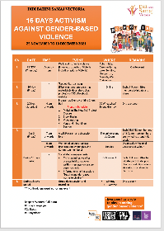

Image: A screenshot of an events calendar, with various events organised across the 16 Days of Activism. At the bottom of the calendar are the Respect Victoria logos and the Domestic Violence Victoria and Domestic Violence Resource Centre Victoria logos.

**Slide 36:**

Walking campaign

Walk against family violence

Joined walking campaign led by Safe Steps

25 NOV (Thursday) 2021

* DBSV Unit Committees initiated a walking program for the prevention of family violence wearing an orange t-shirts, dresses / clothes and mask
* Major event happened in Coburg, Werribee, Craigieburn, Bendigo, Shepperton, Melton.

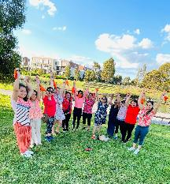

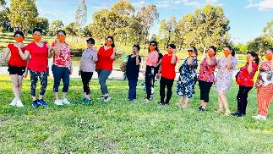

Image: Various photos of Didi Bahini Samaj staff wearing orange clothing and orange facemasks, standing outside in large green park.

**Slide 37:**

This year, DBSV supported Respect Victoria’s ‘Respect Is…’ campaign by featuring messages ‘What respect means…to our community members, leaders and DBSV Team’

Displayed videos, short clips, photos via our social media platforms : DBSV Facebook, website, YouTube

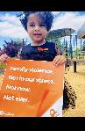

Image: small child holding a campaign poster

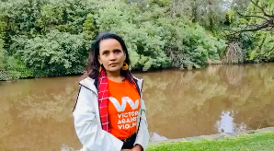

Image: Video still of a woman wearing an orange Victoria Against Violence t-shirt and orange earrings, with a light blue jacket, staring directly at the camera. She is standing on grass in front of water.

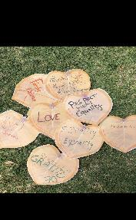

Image: Paper cut-out hearts featuring written messages of what respect means

**Slide 38:**

Clothesline Project

* Initiated by DBSV Glenroy Unit Committee
* Around 15 participants joined the project in Coburg Lake Park, Coburg
* The painted cloth was displayed via the organisation’s Facebook and was used for further campaign activities.
* Some of the glimpses of our clothesline project:

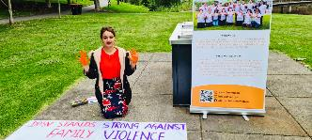

Images: Various photos of women wearing orange garments and making orange hand-prints on a giant poster to mark their solidarity with victim-survivors of family violence.

**Slide 39:**

KNITTING:   
THE NEW ME PROJECT’  
A part of the WWV campaign is exhibiting and story sharing for 16 days of activism called “Knitting: The New Me” Breaking the Social Isolation and Promoting Connection.  
['Knitting: The New Me' - Video Link](https://www.youtube.com/watch?v=hmLmADTtTFA)

Images: Various photos of a bright orange knitted blanket being held by different groups of people in a big wooden hall.

**Slide 40:**

Story Sharing

* Story of Nepalese Migrants Women
* Story of Resilience
* Story of Empowerment
* Story of Connection

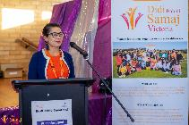

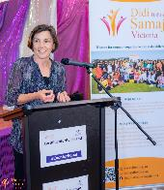

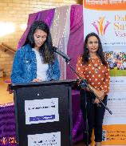

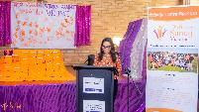

Images: Various photos of female speakers of different ages and skin-tones, standing in front of a podium with a microphone and speaking to an audience. In the background is a purple fabric banner, and the Didi Bahini Samaj logo.

**Slide 41:**

DBSV Supporting Family Violence Victim-survivors in Nepal

* Virtual Teej 2021 (Nepalese Women Festival): September 9th
* Supporting victim survivor of Family violence - fund raised and $ 5000 handed over to AAWAJ (local non-governmental organization in Nepal)
* By now we supported more than 90 women in last 6 years

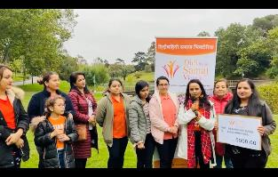

Image: Photo of group of women of various ages and skin-tones standing together in front of a large campaign banner in a grassy park

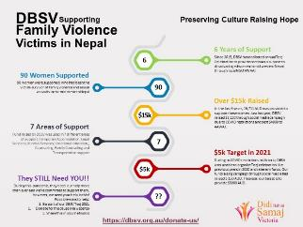

Image: Screenshot of an infographic on how DBSV supports family violence victims in Nepal, including how to show support, and what is needed.

**Slide 42:**

Vigil Candle Lighting

* 𝗔 𝗩𝗶𝗿𝘁𝘂𝗮𝗹 𝗩𝗶𝗴𝗶𝗹 𝗖𝗮𝗻𝗱𝗹𝗲 𝗹𝗶𝗴𝗵𝘁 was organised via Zoom on the very last day of 16 days of activism against family violence : 10th December 2021
* 𝘁𝗼 𝗿𝗲𝗺𝗲𝗺𝗯𝗲𝗿 those 𝘄𝗵𝗼 𝗵𝗮𝘃𝗲 𝗹𝗼𝘀𝘁 𝘁𝗵𝗲𝗶𝗿 𝗹𝗶𝘃𝗲𝘀 𝗱𝘂𝗲 𝘁𝗼 𝗱𝗼𝗺𝗲𝘀𝘁𝗶𝗰 𝗮𝗻𝗱 𝗳𝗮𝗺𝗶𝗹𝘆 𝘃𝗶𝗼𝗹𝗲𝗻𝗰𝗲!!
* Around 25 DBSV team members participated the session

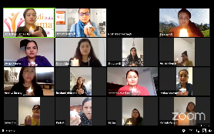

Image: Screenshot of zoom meeting in progress with all participants holding a lighted candle

**Slide 43:**

Our Key Message

We believe we have a strong role to play.

We acknowledge our roles and commitments in ending gender-based violence, raising awareness and advocating against gender-based violence.

* 𝗗𝗕𝗦𝗩 𝘀𝘁𝗮𝗻𝗱𝘀 𝘀𝘁𝗿𝗼𝗻𝗴 𝗮𝗴𝗮𝗶𝗻𝘀𝘁 𝘃𝗶𝗼𝗹𝗲𝗻𝗰𝗲
* We stand with those who are victim-survivors of violence
* A𝗻𝗱 𝘀𝗮𝘆 ‘𝗘𝗻𝗼𝘂𝗴𝗵 𝗶𝘀 𝗘𝗻𝗼𝘂𝗴𝗵’
* ‘𝗩𝗶𝗼𝗹𝗲𝗻𝗰𝗲 𝗶𝘀 𝗻𝗲𝘃𝗲𝗿 𝗼𝗸’
* ‘𝗦𝘁𝗼𝗽 𝗩𝗶𝗼𝗹𝗲𝗻𝗰𝗲’
* ‘𝗥𝗲𝘀𝗽𝗲𝗰𝘁 𝗪𝗼𝗺𝗲𝗻: 𝗖𝗮𝗹𝗹 𝗶𝘁 𝗼𝘂𝘁”

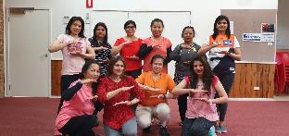

Image: Photo of group of women in two rows looking directly at the camera with their arms and forearms held in an '=' sign.

Image: A photo of a group of women all wearing orange face masks, some of whom are wearing orange garments. Some of the women have their arms up and are holding hands. They are standing in front of the Didi Bahini Samaj campaign banner in a park in front of a large tree.

**Slide 44:**

Thank you

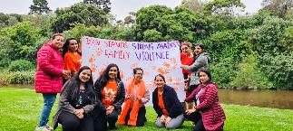

Image: A group of women, some of which are holding up a large banner with orange painted hand prints that says 'DBSV Stands Strong Against Family Violence'. Five women are sitting or kneeling on the grass in front of the banner. The group are on a grass bank in front of a river and trees.

**Slide 45:**

*Jason Rodwell*

*Community Development Project Manager*

*Frankston City Council*

Image: A bright orange slide with bold white text which reads '16 Days of Activism Against Gender-Based Violence ('16 Days') Statewide Campaign 2021. In the bottom right-hand corner is the black, white and orange version of the Respect Victoria logo within a white square speech bubble.

**Slide 46:**

Acknowledgement of Country

Frankston City Council acknowledges the Traditional Custodians of the land on which we are meeting (virtually) today, the Bunurong People of the Kulin Nation, and pay my respect to Elders past, present and future.

I would like to extend that respect to Elders of other communities who may be here with us today.

**Slide 47:**

Strengths focused buy-in for optimal engagement

* Previous participation from Council was lead solely by four staff ‘champions’ who worked well beyond the scope of their roles and responsibilities leaving them overburdened
* This year’s campaign was outsourced to Council departments and partner agencies to participate (rather than individual staff) to apply a ‘16DoA lens’
* Departments & agencies played to their strengths (by applying a 16DoA lens to their everyday business / deliverables) resulting in increased buy-in, confidence, engagement and campaign exposure
* Departments & agencies with limited capacity encouraged to team up with other business units to provide secondary support or resourcing

**Slide 48:**

Author Talks *‘See What You Made Me Do’* - Jess Hill

* Libraries booked Jess Hill and Paul Kennedy to talk about her recent book ‘See What You Made Me Do’ and the concept of coercive control.
* Event had 182 attendees, however had to be stopped prematurely   
  due to online trolls.
* Council received large outpouring of support from the public, who also challenged the negative behaviour.
* Good news is that Jess Hill and Paul Kennedy will re-record their talk   
  for all to view :)

Images: Video carousel of photos showing a headshot of Paul Kennedy, a white man with dark grey hair, wearing a blue shirt with red dots, smiling at the camera and standing on a beach in front of a pier. Another photo shows a headshot of author Jess Hill, a white woman with curly dark brown hair, which is tied up in a high bun. She is wearing a black turtleneck, and red lipstick and is looking directly at the camera. The last photo shows the cover of Jess Hills' book, 'See what you made me do', which is about power, control and domestic abuse.

**Slide 49:**

Arts & Culture Dept.   
*‘Respect Is…’* projections at Frankston Arts Centre

* Frankston Arts Centre is a heavily booked venue (18 months in advance) so they were unable to host an event
* Arts & Culture worked with Media & Comms Dept. to project ‘Respect Is..’ messages on the Arts Centre in the Frankston CBD as an alternate engagement strategy
* The projections can be viewed well beyond the CBD into the municipality!

Image: Gif of the Frankston Arts Centre at night, showing the projected 'Respect Is' banner on the front of the building, which is visible across the CBD.

**Slide 50:**

City Futures & Comms Dept.  
*‘Local Business Champions’* Promotional Kit

* Our City Futures team also worked with the Comms Dept. to develop free promo tool kits for local businesses to help champion and spread awareness of 16DoA
* Promo kits included coffee stamps and sprinkle stencils, QR code window stickers, R.V. collateral and support-resource companion cards
* This year we recruited 9 local cafes and the PCLC Street Law Coffee Van as champions!

Image: Video carousel of photos of various people holding disposable coffee cups with the 'Respect Women' campaign logo printed on them.

**Slide 51:**

Neighbourhood Houses & Youth Services Dept.  
Community Workshops

* Youth Services Dept. teamed up with Neighbourhood Houses to host a series of community workshops
* Community groups and young people participated in cooking and crafting workshops to raise awareness of 16DoA across all youth centres and neighbourhood houses
* *“Orange is the color of safety and a future that's bright and free from violence” -* Participant quote

Image: Video carousel of photos of various campaign activities organised by neighbourhood houses and youth services dept. including orange-coloured envelopes with campaign messages, craft workshops and orange posters.

**Slide 52:**

Positive Ageing Dept. & Respecting Seniors Network   
‘16Ks In 16 Days’ walking event

* In partnership with the Respecting Seniors Network, Frankston City and Mornington Peninsula Shire Councils collectively planned a walking event that counts steps against elder abuse
* Selfie stands have been installed among 15 popular walking routes in both regions with a QR code to an online community pedometer + instagram selfie filter

Image: Video carousel of photos showing campaign participants of difference genders, colours and ages posing with an A1-sized cardboard frame with a cut-out in the shape of a footprint, with the heading 'Steps for Respect: 16 K's in 16 Days'. Most photos have been taken on the beach on the Mornington Peninsula.

**Slide 53:**

Recreation Dept. & Sports Clubs  
‘16 Days of Activism’ dedicated fixture rounds

* Recreation supported local clubs to host a dedicated fixtured rounds to raise awareness about 16DoA
* Recreation put together personalised club packs that included campaign information, social media kit, orange wristbands and armbands and R.V. resources
* 10 clubs participated in the campaign and received great feedback from the community

Image: Video carousel of photos showing campaign participants of difference genders, colours and ages, as well as various campaign event posters and Facebook posts promoting the 16 Days campaign and the key messages.

**Slide 54:**

Community Development Dept. & WHISE  
‘*Respect Is.. L2P Program*’ active bystander training

* Frankston’s L2P program pairs their volunteer mentor drivers with disadvantaged learners for the duration of their mandatory hours
* This unique relationship provided a opportunity to upskill mentors with active bystander training to develop their understanding of gender-based violence to better support young people
* WHISE has developed a specialised L2P active bystander training model exclusive to Frankston City Council

Image: Video carousel of photos showing campaign participants of difference genders, colours, abilities and ages taking part in the L2P program. Most photos show individuals standing in front of, or inside, a white instructor hatchback car, holding either a red 'P' plate or a yellow 'L' plate.

**Slide 55:**

Reflections & Learnings

* Shifting from an individual to a departmental/organisational approach by applying a 16DoA lens to ‘everyday business’ greatly increases buy-in, confidence, capacity and community engagement all round.   
  (particularly for those that don’t work within community services)
* Reach out to your local councils early (around July) for partnership opportunities to enhance collaborative engagement strategies, funding and resourcing (resource planning meetings are very helpful)
* Build upon the existing strengths of Council, staff, partnerships, agencies and existing resources (work smarter, not harder)
* Plan for small ideas and scale up if capacity is available; examples of this are the ‘local business champions’ and sports clubs ‘fixture rounds’

**Slide 56:**

Thanks for listening!  
Any questions, feel free to email:  
jason.rodwell@frankston.vic.gov.au

**Slide 57:**

Breakout Rooms

* What were the highlights – are there any exciting stories or outcomes to share?
* What did you learn – about violence, prevention or your work?
* What would you do again next year, what would you do differently?
* What do you think the statewide campaign should do again, or do differently next year?

Image: The white and orange Respect Victoria logo, which includes the text 'Preventing Family Violence' in a smaller square speech bubble. Next to this is the Safe and Equal organisation logo in bold black text with a white plus symbol depicting the 'and'. Below the logo is the text 'Standing strong against family violence' in a smaller black font.

**Slide 58:**

Questions?

Please pop any questions you might have into the chat box.

Image: The white and orange Respect Victoria logo, which includes the text 'Preventing Family Violence' in a smaller square speech bubble. Next to this is the Safe and Equal organisation logo in bold black text with a white plus symbol depicting the 'and'. Below the logo is the text 'Standing strong against family violence' in a smaller black font.

**Slide 59:**

Thank you

​For your time and contributions to the Q&A session.​

Have a wonderful holiday season, and we look forward to seeing you all next year!

Image: The white and orange Respect Victoria logo, which includes the text 'Preventing Family Violence' in a smaller square speech bubble. Next to this is the Safe and Equal organisation logo in bold black text with a white plus symbol depicting the 'and'. Below the logo is the text 'Standing strong against family violence' in a smaller black font.