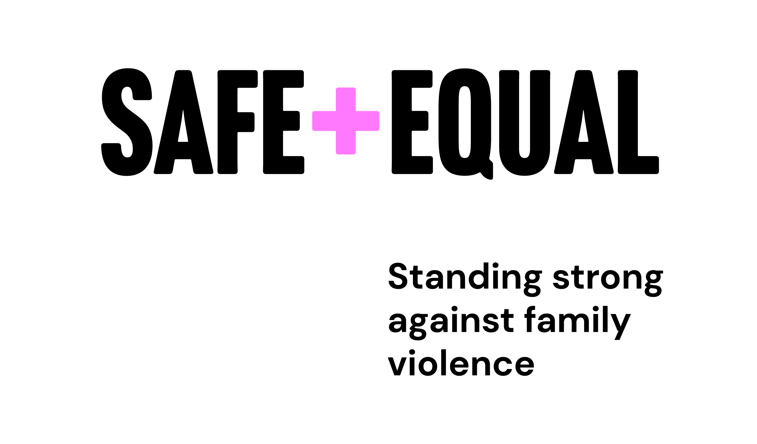­­

­

16 Days of Activism: Grassroots Initiative

**2022 Grants Application Guide**

# Acknowledgement of Traditional Owners

**Acknowledgement of Aboriginal and Torres Strait Islander peoples**

Safe and Equal acknowledges Aboriginal and Torres Strait Islander peoples as the traditional and ongoing custodians of the lands on which we live and work. We pay respects to Elders past and present. We acknowledge that sovereignty has never been ceded and recognise First Nations peoples’ rights to self-determination and continuing connections to land, waters, community and culture.

© 2022 Safe and Equal

# About Safe and Equal

Safe and Equal is the peak body for specialist family violence services that provide support to victim survivors in Victoria. The interests of people experiencing, recovering from, or at risk of, family violence is at the heart of everything we do. Our vision is a world beyond family and gender-based violence, where women, children and people from marginalised communities are safe, thriving, and respected. We recognise the gendered nature of violence in our society, and the multiple intersecting forms of power and oppression which can compound the impacts of violence and limit people’s access to services, support, and safety. We work closely and collaboratively with other organisations and support the leadership of victim survivors to amplify their voices and create change.

**We develop family violence practice and support workforces** to ensure that victim survivors are safe, their rights are upheld, and their needs are met. The prevalence and impact of family and gender-based violence will be reduced because we are building a strong and effective workforce responding to victim survivors that can meet the needs of the community we serve, while also having a growing and impactful workforce working to prevent violence.

**We work to strengthen and connect organisations, sectors, and systems** to achieve safe and just outcomes for victim survivors irrespective of entry point, jurisdiction and individual circumstances. Joining efforts across prevention, response, and recovery we work to ensure the family violence system is informed and supported by a well-resourced and sustainable specialist sector. Our contributions to primary prevention workforces, initiatives and alliances contribute to social change for a safer and more respectful community.

**We are building momentum for social change** that drives meaningful action across institutions, settings, and systems for a safer and more equal society. Our workforce and practice development efforts are coupled with a partnership approach that builds community awareness and commitment to change. Our expertise and efforts enable citizens across the community to recognise and respond to family and gendered violence, hold perpetrators to account and support the ongoing recovery and empowerment of victim survivors.

**We are a strong peak organisation** providing sustainable and influential leadership to achieve our vision. The work we do and the way we work are integrated and align with our values. This is achieved through inclusive culture, and a safe and accessible workplace supported by robust systems and processes.

Contents

Acknowledgement of Traditional Owners 2

About Safe and Equal 3

Background and Context 5

Grants Guidelines 6

Key Dates 6

Types of Grants Available 6

Aim of Grassroots Fund 6

Eligibility 7

Assessment Criteria 8

Funding Acknowledgements 10

# Background and Context

The United Nation’s international campaign – 16 Days of Activism Against Gender Based Violence – takes place each year from 25 November (International Day for the Elimination of Violence Against Women) until 10 December (International Human Rights Day). In 2019 and 2020, Respect Victoria delivered the Respect Women: Call It Out initiative across the 16 Days for the first time, using the reach of local government and community networks via the Municipal Association of Victoria (MAV). The MAV, in partnership with the Domestic Violence Resource Centre Victoria (DVRCV) and Respect Victoria, developed a range of communication materials and other resources to support delivery of the campaign.

In 2021, Respect Victoria funded Safe and Equal[1] to facilitate the delivery of the Respect Women: Call It Out (Respect Is) 16 Days of Activism initiative in 2021 and 2022. This includes administering small one-off grants to encourage Victorian councils, selected non-government organisations including women’s health services and specialist family violence services to participate in the 16 Days initiative; and providing ongoing support to participating organisations (those funded and not).

**The purpose of this document** is to act as a guide for the grants process for the 2022 campaign.

# Grants Guidelines

## Key Dates

* Grant applications open **Wednesday 6 July 2022**
* Grant applications close **Wednesday 3 August 2022**
* Applicants will be notified on the outcome of applications in mid-August 2022
* Successful applicants will receive their grant in late August – early September 2022

## Types of Grants Available

In 2022 there will be a **two-tiered grants structure**.

* **Individual organisations** will be eligible for a one-off grant of $1,500 and approximately 80 of these grants will be offered.
* **Consortia of two or more organisations** planning joint activities or projects that extend their reach will be eligible for a one-off grant of $5,000. Approximately 8 consortium grants will be offered.

The aim of the two-tiered approach is to promote partnership between organisations to capitalise on synergies, leverage resources, and avoid duplication of efforts. This approach also aims to increase the reach of the grants programme, by allowing organisations to make strategic connections in communities.

## Aim of Grassroots Fund

The aims of the grants are to support organisations and councils to:

* Work in partnership with their organisations and communities, including local stakeholders to build awareness and spread community conversations around campaign messaging,
* Develop a range of activities to promote conversations around respect and the broader campaign messages in the community,
* Identify and work with particular population cohorts and settings where campaign activities will be undertaken,
* Utilise online vehicles and other resources for connecting the campaign with the breadth and diversity of local communities,
* Consider and report on opportunities for ongoing work that engages the community around preventing violence against women and all forms of family violence beyond the 2022 Campaign period,
* Contribute to Campaign evaluation by reporting against quantitative and qualitative data indicators.

## Eligibility

Applications will be open to all community organisations, not-for-profits, and councils.

In order to be eligible for assessment, applications must be completed and submitted prior to the advertised deadline and meet **all** eligibility criteria. **Applications that are late, incomplete, or ineligible will not be assessed.**

Applications must:

|  |
| --- |
| **Individual Grants** |
| * Be for an activity/project that is related to Respect Victoria’s 16 Days of Activism Against Gender-Based Violence messaging, Respect Women: ‘Call it Out’ (Respect Is) * Be for an activity/project that will be implemented between 1st September – 10th December 2022 * Be submitted on or before the advertised deadline * Have all sections completed * Have successfully acquitted any previous funding under the 16 Days Grants Program * Provide a valid ABN in the Applicant organisation’s name * Not request funding for any of the ineligible activities listed below:   + Activities/projects that contradict Safe and Equal and/or Respect Victoria’s values   + Activities/projects that have already been completed (i.e. retroactive funding for work already undertaken)   + Operational or ongoing activities normally funded through other arrangements   + Profit-making activities, where any profit generated will not be reinvested into the organisation’s community-focused activities |
| **Consortium Grants** |
| Applications must meet all the above Individual Grant criteria, AND:   * List two or more organisations that will participate in the consortium, including organisations’ ABNs * Demonstrate meaningful partnership between consortium members, with clear roles and responsibilities for each |

## Assessment Criteria

The 16 Days Grants Program assessment process is competitive, merit-based, and guided by the weighted Assessment Criteria. As part of our commitment to a transparent, accountable, and equitable process, in 2022, grants will not be awarded on a rolling basis. In 2022, **all eligible applications will be assessed competitively against one another** after the application window has closed. The strongest and most relevant applications (against the eligibility & assessment criteria) will be awarded the grants.

Eligible applications will be assessed by a panel of Safe and Equal staff who will independently score the applications. Those with the highest cumulative scores will be shortlisted for assessment and funding decisions which will be made jointly by Safe and Equal and Respect Victoria.

Applications will be assessed against three weighted categories: Reach (50%), Approach (30%) and Experience (20%). Grants will be assessed against the criteria listed below:

|  |  |  |
| --- | --- | --- |
| Reach (50% weighting) | Approach (30% weighting) | Experience (20% weighting) |
| **Individual Grants** | | |
| * Promotes community conversations that align with Respect Victoria campaign messages during the 16 Days of Activism (Respect Women: ‘Call It Out’ (Respect Is)). * Demonstrates work in partnership with membership base/ relevant stakeholders to build awareness and promote community conversations utilising campaign messaging, focusing on Respect Women: ‘Call It Out’ (Respect Is). * Organisation represents, or can demonstrate work with, diverse and/or at-risk communities – particularly multicultural and faith-based communities, Aboriginal communities, LGBTIQA+ communities, people with disabilities, young people, and older Victorians. | * Activities are well considered, contain fresh ideas, and are achievable within the timeline and the budget. * Demonstrates consultation with membership base/ relevant stakeholders which informs the approach, or a clear plan as to how consultation will take place. * Demonstrates understanding of who stakeholders/ beneficiaries are, and messages are tailored accordingly. | * Demonstration that the project team have the appropriate skills and capacity to deliver the activities. * Organisations is committed to participating in the collection of outputs and data to feed into the campaign evaluation conducted by Respect Victoria at the end of the campaign. |
| **Consortium Grants**  *Application must meet of the above Individual Grant criteria, AND:* | | |
| * Demonstrates strategic understanding of how consortium grant will increase the potential reach (breadth or depth) of campaign messages in the community. | * Demonstration that one or more consortium members represents or works directly with communities of interest. | * Clear articulation of meaningful partnership between consortium members with clear roles and responsibilities for each. |

## Funding Acknowledgements

The following statements will be used to explain the partnership between Respect Victoria and Safe and Equal in any externally facing content:

In 2022, Respect Victoria and Safe and Equal are partnering to deliver and support local community engagement with the 16 Days of Activism against Gender-Based Violence state-wide campaign. [Organisation] has been funded under Respect Victoria’s 16 Days of Activism grassroots initiative.

Any written statements in published or printed materials associated with the project, including media releases, reports and evaluations should acknowledge funding by Respect Victoria.

Any initiative materials or resources developed by the project and used as part of the 16 days initiative should include the Respect Women: Call it Out logo.

Logos to be used on any new assets/resources created: 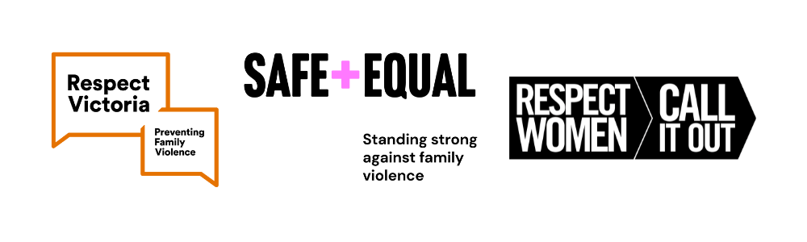

Funder logos can be downloaded here:

<https://safeandequal.org.au/16-days-of-activism/#resources>

1. In 2021, Domestic Violence Victoria (DV Vic) and Domestic Violence Resource Centre Victoria (DVRCV) merged to form Safe and Equal