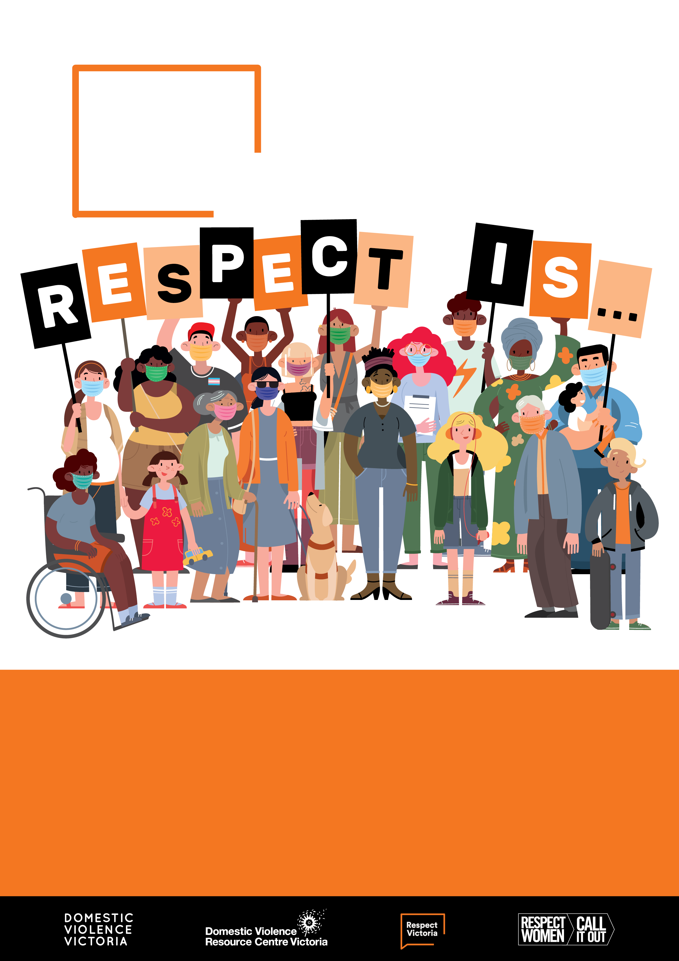

16 Days of Activism  
toolkit

Respect   
Women:   
‘Call It Out’

This toolkit has been created to assist organisations   
to participate in Respect Victoria’s **Respect Women:** ‘Call It Out’ (Respect Is) 16 Days initiative   
from 25 November – 10 December.

The campaign coincides with the United Nations   
16 Days of Activism against Gender-Based Violence.

Contents

About this toolkit 4

The gendered impact of COVID-19 6

Key terms 8

About the Respect Women: ‘Call It Out’ (Respect Is) campaign 12

About the UN initiative: 16 Days of Activism against Gender-Based Violence 13

Campaign collateral 14

16 ways to get involved 18

Booklists: Children’s books 22

Booklists: Young adult books 24

Booklists: Adult fiction and non-fiction books 25

Fast facts: Prevalence 27

Fast facts: Intersectionality and gender-based violence 29

Fast facts: Impacts of Covid-19 on gender-based violence 31

Fast facts: Impacts of gender-based violence 33

Fast facts: Attitudes to gender-based violence 34

Fast facts: Gender equality in Australia 36

Tools to help ‘call it out’ 38

Conversation starters 41

Dealing with resistance and backlash 42

Responding to disclosures 47

Beyond the 16 Days 50

Support services 52

If you or someone you know is experiencing family violence,   
help is available.

If you believe someone is in immediate danger call Triple Zero (000) and ask for the police.

**Safe Steps (1800 015 188)**  
[safesteps.org.au](https://www.safesteps.org.au/)

Safe Steps is Victoria’s 24/7 family violence support service.

For a more comprehensive list of support services see Support services on **page 52** of this toolkit.

Acknowledgements

 

We acknowledge the traditional custodians of the land on which we work and we pay our respects to their Elders, past and present. We acknowledge that sovereignty of this land was never ceded and we are committed to honouring Australian Aboriginal and Torres Strait Islander peoples in our work.

Domestic Violence Victoria and the Domestic Violence Resource Centre Victoria has been funded by Respect Victoria to work with councils and community organisations across Victoria to participate in the Respect Women: ‘Call It Out’ (Respect Is) 2021 initiative, which coincides with the United Nations’ 16 Days of Activism against Gender-Based Violence. This resource is an updated version of the toolkit developed by the Municipal Association of Victoria (MAV) in 2020 in partnership with DVVic/DVRCV and Respect Victoria. DV Vic/DVRCV acknowledge the contributions of our Project Advisory Group members, MAV, Victorian Council of Social Services (VCOSS), No To Violence (NTV) and Women’s Health Services Council (WHSC).

# About this toolkit

This toolkit provides information about the Respect Women: ‘Call It Out’ (Respect Is) initiative coinciding with the United Nations (UN) 16 Days of Activism against Gender-Based Violence (16 Days of Activism).

The toolkit features information and resources for organisations to use during the 16 Days of Activism and beyond as well as ‘conversation starters’ to stimulate community discussion about the prevention of family and gender-based violence.

Many sections within this toolkit can be used on their own, as posters or pull-out resources.

The resources within this toolkit have been designed so that they are suitable for use in Victoria in response to the coronavirus (COVID-19) pandemic and changing restrictions.

Respect Victoria is an independent Statutory Authority dedicated to the primary prevention of all forms of family violence and violence against women.

Respect Victoria’s Respect Women: ‘Call It Out’ campaign encourages individuals, communities, and organisations to ‘call it out’ and intervene when safe to do so when they witness sexism and gender inequality – drivers that can lead to family violence and violence against women.

The UN’s 16 Days of Activism against Gender-Based Violence is a global campaign that takes place annually between 25 November and 10 December.

In Australia, on average, 1 woman is murdered by a current or former partner each week, and 1 in 2 women has experienced sexual harassment. Violence against women and their children costs Australia $22 billion each year, however, the way women are treated is arguably more important than the dollar cost to the economy. It is everyone’s responsibility to be an active part of addressing gender inequality in Australia, because women and girls deserve to be treated as equals.

Source: KPMG (2016) The cost of violence against women and their children in Australia.

“Everyone has a role to play in ending gender-based violence”

## A note on language

‘Gender-based violence’ includes all forms of violence against people based on their gender, or violence that affects people of a particular gender disproportionately. It is most frequently used to describe men’s violence against women.

Throughout this toolkit, the term ‘gender-based violence’ will refer to men’s violence against women. Violence in this domain is where the strongest evidence base exists and is consistent with the historic and current focus of the UN’s global campaign.

Gender-based violence causes severe harm to families and communities. Campaigns like the 16 Days of Activism highlight the need for us to prevent all forms of family and gender-based violence experienced within our society.

Importantly, members of LGBTIQ+ communities face discrimination and violence on the basis of sex, sexuality and/or gender identity at alarming rates.

## Applying an intersectional lens to this campaign

It is vital that this campaign and others like it are inclusive of the diversity that exists within our communities. As such, we encourage you to collaborate with representatives from LGBTIQA+ communities as you prepare for your 16 Days of Activism. To find out more visit the [Research & Resources page](https://www.rainbowhealthvic.org.au/research-resources) on Rainbow Health Victoria’s website.

Two specific primary prevention documents of focus would be the [Pride in Prevention Evidence Guide](https://opal.latrobe.edu.au/ndownloader/files/29088549) and the [Pride in Prevention Messaging Guide](https://opal.latrobe.edu.au/ndownloader/files/29080026).

The International Day of People with Disabilities is recognised on 3 December, which coincides with the 16 Days of Activism. We strongly encourage you to collaborate with organisations led by people with disabilities to ensure your activities are inclusive and raise awareness of the rights and agency of people with disabilities. For helpful information, visit the [Women with Disabilities Victoria website](https://www.wdv.org.au/about-us/).

This campaign should seek to address systemic and structural discrimination, through working with and listening to Aboriginal and Torres Strait Islander peoples and culturally diverse communities, including refugee and migrant communities, using community language and culture as part of a strengths-based approach to addressing gender-based violence.

For helpful information, please visit the [Prevention of Family Violence page on Djirra’s website](https://djirra.org.au/what-we-do/) and the Resources page on [Multicultural Centre for Women’s Health website](https://www.mcwh.com.au/publications/).

“It is vital that this campaign is inclusive and celebrates the diversity of our community”

# The gendered impact of COVID-19

The COVID-19 pandemic has exacerbated gender inequality and increased the risk of gender-based violence.

Read on to find out what your organisation can do to address gender inequality in response and recovery to family and gender-based violence.

The COVID-19 pandemic has changed how we live. The impact of restrictions and physical distancing on individuals, families, and communities, while varied, has been profound. There is no doubt, that the impact of the pandemic is highly gendered.

## Evidence on the impact of COVID-19

Data shows that both worldwide and in Australia, women have endured the greatest cost with higher unemployment rates, greater risk of exposure to the virus in lower paid jobs, greater caring responsibilities and significantly poorer mental health outcomes than men.

Family violence services have also reported increased demand during the pandemic. Intimate partner and family violence increase during disaster and emergencies, both in prevalence and severity (Parkinson 2014).[1] Data released by the Crime Statistics Agency in September 2021 shows that Victoria is facing its highest reported rates of family violence in history, with a 11.3% increase in family violence related offences in the year ending 31 March 2021.[2]

The reported increase in violence has been compounded by reduced access to services and support during social isolation. To see further information please refer to the Crime Statistics Agency [COVID-19 Family Violence Database.](https://files.crimestatistics.vic.gov.au/Family+violence+data.html)

For more data on the gendered impact of COVID-19, see Fast facts: Impacts of Covid-19 on gender-based violence on page 31.

## Addressing gender inequality, response and recovery

Violence doesn’t happen because we’re staying at home. Family violence and gender-based violence are driven by gender inequality, discrimination and marginalisation. That means that response to and recovery from the pandemic must address gender inequality and other forms of discrimination.

In aiding and strengthening the recovery from the gendered impacts of COVID-19, we must commit to deconstructing the systemic inequalities that lead to and exacerbate family violence and gender-based violence. By “building back better” a more inclusive and equal Victoria, we can help everyone live free from violence.

## What your organisation can do

Your organisation can help “build back better” by implementing a COVID-19 recovery plan that addresses the disproportionate impact of the pandemic on women. There are a range of resources and tools to help you do this, including:

* [Guiding principles for primary prevention in the context of COVID-19](https://www.respectvictoria.vic.gov.au/coronavirus-covid-19#guiding-principles-for-primary-prevention-of-family-violence-and-violence-against-women-in-the-coronavirus-covid-19-pandemicnbsp)   
  (Respect Victoria)
* [Addressing systemic and structural discrimination for primary prevention of family violence in the context of COVID-19: A resource for advocacy](https://www.respectvictoria.vic.gov.au/coronavirus-covid-19#advocacy-on-structural-and-systemic-discrimination)   
  (Respect Victoria)
* [Applying a Gender Lens to COVID-19 Response and Recovery](https://www.whin.org.au/wp-content/uploads/sites/2/2021/03/Applying-a-Gender-Lens-to-COVID-19-Response-and-Recovery_v4FINAL26_10_20.pdf)   
  (Women’s Health in the North)
* [Towards a Gender-Equal Recovery: COVID-19 Fact sheets](https://www.genvic.org.au/resources/covid-19-resources/)   
  (Gender Equity Victoria)
* [Left Behind: Migrant and Refugee Women’s Experiences of COVID-19](https://www.genvic.org.au/focus-areas/genderequalhealth/left-behind-migrant-and-refugee-womens-experiences-of-covid-19/)   
  (Gender Equity Victoria)

As practitioners and contributor workers in the primary prevention family violence sectors, which is a predominantly feminised workforce, it is important to remember that we too have experienced significant impacts as a result of the pandemic. We encourage practitioners and organisations to prioritise self and collective care and retain a healthy work-life balance as you undertake your 16 Days of Activism campaign.

## Complying with restrictions

Ensure you comply with the current Victorian Government Chief Health Officer’s directions when organising activities or events for the 16 Days of Activism. Please note, the restrictions could be different between regional Victoria and metropolitan Melbourne.

Visit the [Department of Health and Human Services (DHHS) website](https://www.dhhs.vic.gov.au/coronavirus) for the most up-to-date information on the COVID-19 pandemic in Victoria.

# Key terms

These terms are used throughout this toolkit, with definitions listed below.

## Active bystanding

Refers to the act of ‘calling out’ sexist and/or disrespectful language or behaviour, either in the moment or following an incident.

## Backlash

Describes extreme, aggressive, or organised forms of resistance to preventing gendered violence. Resistance can range from denial to passive attempts to maintain the status quo. Examples include men’s rights groups inciting misogyny or online trolls abusing social commentators.

## Bystander

Describes a person who is present or witnesses an event or incident but is not actively involved in it.

## Bystander action

Refers to ‘how’ a bystander calls out, or engages others in responding to incidents of violence, sexism, harassment, or discrimination. It also refers to action to address the attitudes, behaviours, norms, polices and structures that contribute to violence against women.

Examples include calling out inappropriate behaviour, changing the topic, eye rolling, enlisting support, referring to organisational policies, or changing discriminatory workplace policies and practices. These actions can be taken in the moment or following an incident.

## Disclosure

Occurs when someone tells another person about violence they have experienced, perpetrated, or witnessed. Undertaking prevention of violence against women activities can lead to an increase in disclosures as people learn more about harmful attitudes and behaviours and think about their own lives.

In some cases, it is because the activity has created a safe space for people to discuss their experiences.

## Domestic violence

Is sometimes interchanged with ‘family violence’. Victorian legislation and policy documentation use the term ‘family violence’ as it is more inclusive of diverse family units and kinship networks. As noted below ‘family violence’ encompasses more than just violence occurring in a domestic situation.

## Family violence

Involves patterns of coercive, controlling, and abusive behaviours inflicted on victim survivors resulting in fear for their own or someone else’s safety and wellbeing. Family violence can take many forms including coercive control, physical, sexual, psychological, emotional, and spiritual violence. It also includes financial/economic abuse and technology facilitated abuse.

Family violence can occur within a diverse range of family units including:

* Intimate partners (current or former): married or de facto couples with or without children
* Other family members; including siblings, stepparents, extended kinship connections
* Adolescent or adult children and their parents
* Older people and their adult children, relatives, or carers
* People with disabilities and their relatives or carers.

## Gender-based violence

Describes violence rooted in gender-based power, inequality, and discrimination.

Gender-based violence causes or can cause physical, sexual, psychological, or financial harm. It can occur in the home, at work, online or in public. People of all genders can experience gender-based violence, including transgender and/or non-binary people.

Gender-based violence is sometimes used interchangeably with ‘violence against women’ because of the disproportionate number of women and girls who experience violence ([UN Women](https://www.unwomen.org/en/what-we-do/ending-violence-against-women/facts-and-figures)).

## Gender equality

Is the outcome reached through addressing gender inequality. Achieving gender equality is not about erasing gender differences, but protecting and upholding people’s rights, responsibilities, and opportunities, and ensuring that access to these is not dependent on their gender or the sex they were assigned at birth. Gender equality provides the necessary conditions for addressing the [underlying causes](https://www.youtube.com/watch?v=fLUVWZvVZXw&t=1s) that drive or predict violence to help achieve long-term change. Find out more about the underlying drivers of violence against women in [Change the Story](https://media-cdn.ourwatch.org.au/wp-content/uploads/sites/2/2019/05/21025429/Change-the-story-framework-prevent-violence-women-children-AA-new.pdf), Australia’s national framework for the primary prevention of violence against women and their children.

## Victorian Gender Equality Act 2020

The Victorian Gender Equality Act came into effect in March 2021 and sets out a series of mandatory reporting obligations for public entities, including councils and universities. The reporting obligations under the Act are focused on encouraging organisations to define, plan, and implement targeted actions, report on specific gender equality metrics in the workplace, and conduct gender impact assessments on policies, programs and services that directly affect the public. Understanding the connection between broader gender equality and primary prevention is essential for achieving long-term change.

The Gender Equality Act signifies a growing commitment to achieving change, and importantly, creates the enabling environment required for effectively addressing the underlying causes and reinforcing factors of gender-based violence. Ultimately, progressing gender equality at all levels of society provides the necessary levers for reducing and ending family and gender-based violence.

## Intersectionality

Refers to the interconnected nature of different dimensions of diversity, including for example, gender, ethnicity, disability, socio-economic status, and Aboriginality. Effective and inclusive actions aimed at improving gender equality and primary prevention must recognise that experiences of gender inequality, discrimination and gender-based violence are compounded by the intersection of gender with a multitude of other dimensions of diversity. This includes taking into consideration how and what types of data is captured, whether family violence services are inclusive and accessible, whether resources refer to gender and primary prevention beyond binary and western norms, what different barriers to equality might look like for different diverse groups, and what is most impactful.

## Perpetrator

Is the term most used in Victoria to describe people –mainly men–who choose to use family violence or commit sexual violence against women. ‘Offender’ or ‘sexual violence offender’ are used to describe perpetrators of violence in clinical or legal contexts.

## Primary prevention

Is a public health approach that addresses the underlying causes of a problem to prevent it from occurring in the first place. It is geared towards education, upskilling individuals, communities and organisations to identify the issue, and generating systems and practices to stifle the issue’s ‘progress’.

## Prevention of/preventing violence against women (PVAW)

Often used interchangeably and are generally understood to mean the primary prevention of violence against women.

While there is an established evidence base around the drivers of violence against women, our understanding of what drives other forms of family violence is still emerging.

## Resistance

Is an active pushing back against initiatives that aim to prevent violence against women and promote gender equality. Examples include denial of the problem, refusing to make a change or dismantling a change initiative. Learn more about responding to resistance and backlash in VicHealth’s [(En)countering Resistance](https://www.vichealth.vic.gov.au/-/media/ResourceCentre/PublicationsandResources/PVAW/Encountering-Resistance-Gender-Equality.pdf), which provides strategies for responding to resistance to gender equality initiatives.

## Respect

Understanding and appreciating every person for who they are. All people deserve to be treated with respect, as a basic human right.

## Sexism

Is a form of discrimination and refers to the language, attitudes, behaviours and conditions that create, support or reinforce gender inequality. Sexism can take many forms from inappropriate jokes or comments and discrimination to sexual harassment and assault. Sexism can occur in a range of settings either at the hands of an individual perpetrator or embedded within organisations that reinforce sexist behaviour through organisational culture and hierarchy.

## Sexual harassment

Refers to unwelcome sexual behaviour that could make a person feel offended, humiliated, or intimidated. Sexual harassment can be a single incident or repeated behaviour. It can be physical, verbal or written. It doesn’t matter what the intention is: sexual harassment is against the law. The Equal Opportunity Act 2010 makes sexual harassment illegal in certain areas of public life including at work, school and in shops. For more information, please visit the [Victorian Equal Opportunity & Human Rights Commission website](https://www.humanrights.vic.gov.au/for-individuals/sexual-harassment/).

## Victim survivor

Describes people, including children and young people, who have experienced or are experiencing family or gender-based violence. The term acknowledges the strength and resilience shown by people who lived, or are currently living with, violence. People who have experienced violence have different preferences about how they would like to be identified and may choose to use victim or survivor separately, or another term altogether.

## Violence against women

Is any act of gender-based violence that causes or could cause physical, sexual, psychological, or financial harm or suffering to women. This includes threat of harm or coercion and can occur in public or in private life.

While violence against women often occurs in a family or relationship context, violence against women is broader than what is covered by the term family violence as it includes, for example, harassment at work or sexual assault by a stranger, colleague, or acquaintance.

# About the Respect Women: ‘Call It Out’ (Respect Is) campaign

**Respect Victoria’s Respect Women: ‘Call It Out’ (Respect Is) campaign encourages Victorians to call out sexism, sexual harassment and disrespect towards women.**

This campaign aims to support the Victorian community in understanding what respect means, what it looks like, and how to put it into practice in their everyday lives. We have an opportunity to support our communities to understand what gender equality looks like and how striving for equality can prevent violence against women. When gender equality exists, we all benefit.

Gender inequality involves devaluing or disrespecting women or women’s contributions. Research has consistently found that these forms of disrespect increase the likelihood of violence against women.

Respect Victoria wants to inspire action and to encourage members of the public to embrace the types of behaviours and actions that represent and personify ‘respect’.

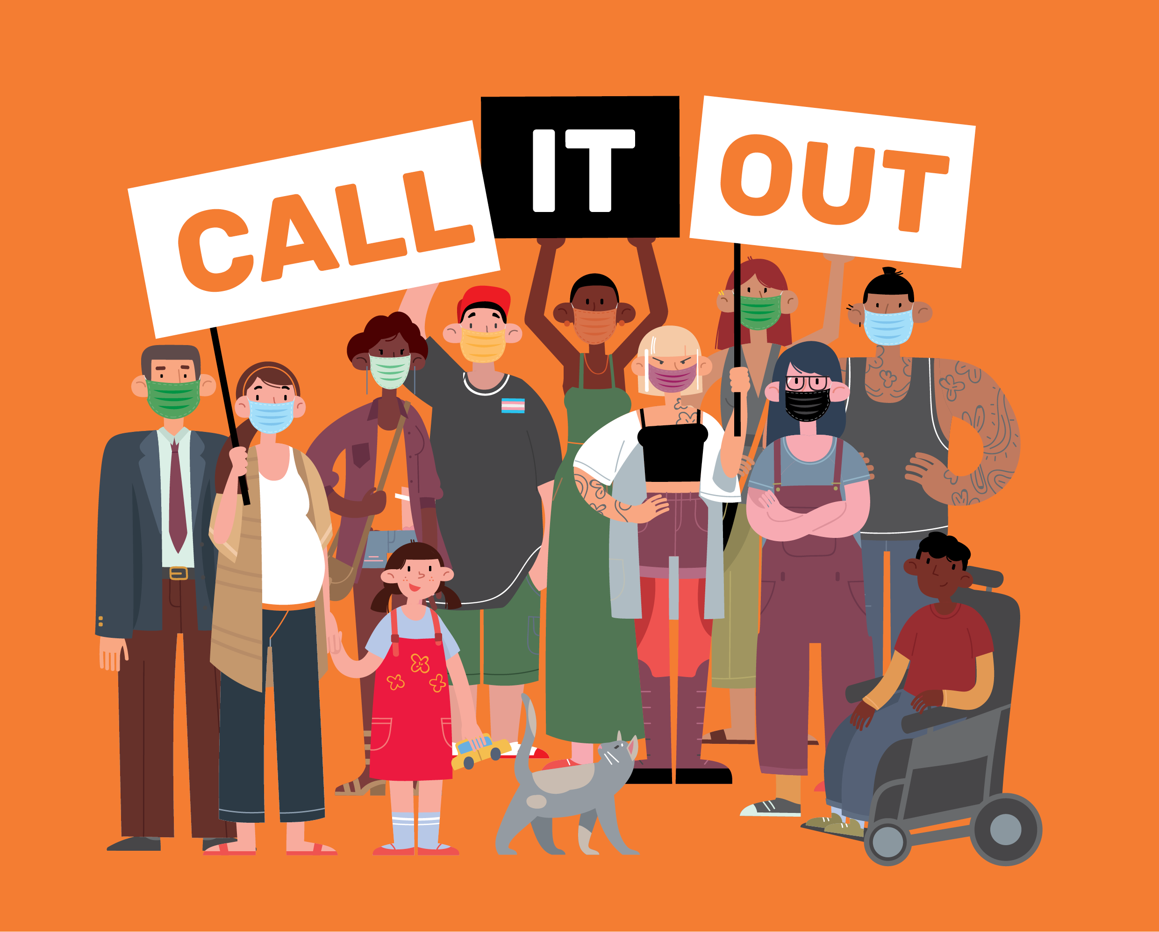

# About the UN initiative: 16 Days of Activism against Gender-Based Violence

**The 16 Days of Activism against Gender-Based Violence originated from a petition that was circulated during the 1991 United Nations World Conference on Human Rights.**

This petition called on the conference committee to comprehensively address women’s human rights and recognise gender-based violence as a human rights issue. Almost three decades on, the 16 Days of Activism against Gender-Based Violence is a widely recognised global campaign that signifies action towards ending violence against women and girls around the world.

The 16 Days of Activism begins on the [International Day for the Elimination of Violence Against Women](https://www.un.org/en/events/endviolenceday/) (25 November) and ends on [International Human Rights Day](https://www.un.org/en/observances/human-rights-day) (10 December). The dates for the campaign were chosen to link violence against women and human rights. During this time, organisations and individuals from around the world raise awareness about women’s rights being human rights, and that violence against women is a fundamental violation of those human rights.

Respect Victoria’s Respect Women: ‘Call It Out’ (Respect Is) campaign seeks to align with the timing of 16 Days of Activism as recognition that this is an important period of the year to be actively focusing on violence against women.

[More details on the activist origins of the 16 Days of Activism](https://www.unwomen.org/en/what-we-do/ending-violence-against-women/take-action/16-days-of-activism)

The 16 Days of Activism against Gender-Based Violence is a global initiative galvanising individuals, communities, and organisations to address gender inequalities and eradicate violence against women and girls around the world.

# Campaign collateral

**A selection of campaign collateral and materials has been developed for councils and organisations to use during the 16 Days of Activism initiative and beyond (as appropriate).**

Below is a list of digital collateral. On each item, there is a blank space for you to drop in your organisational logo(s) in Adobe Photoshop or Canva.

Additional information that is specific to the Respect Women: ‘Call It Out’ (Respect Is) campaign messaging will be provided by Respect Victoria at a later date. This will include social media tiles and posters.

## Logos

Please note: the **Respect Women: Call It Out** logo is current and should still be used in 2021, along with the Respect Victoria logo. In terms of hierarchy, your council/organisation’s logo should come first, then Respect Victoria’s logo, then your partner organisation’s logo.

## Respect Women: Call It Out logo

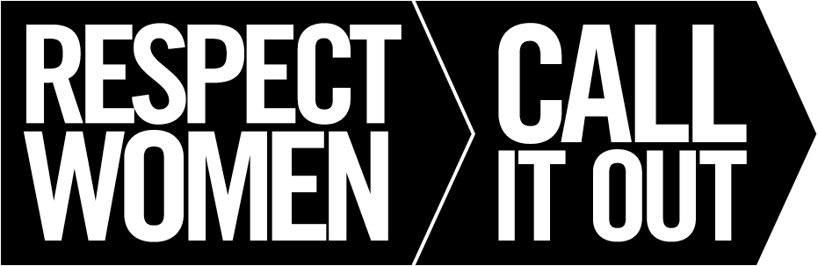

## Respect Victoria logo

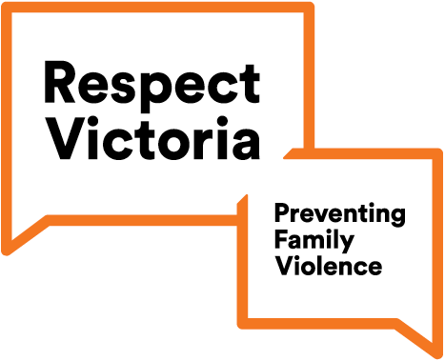 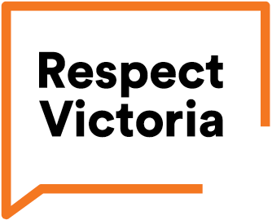

## Sticker

This is designed to be printed as 7cm wide x 9cm high.

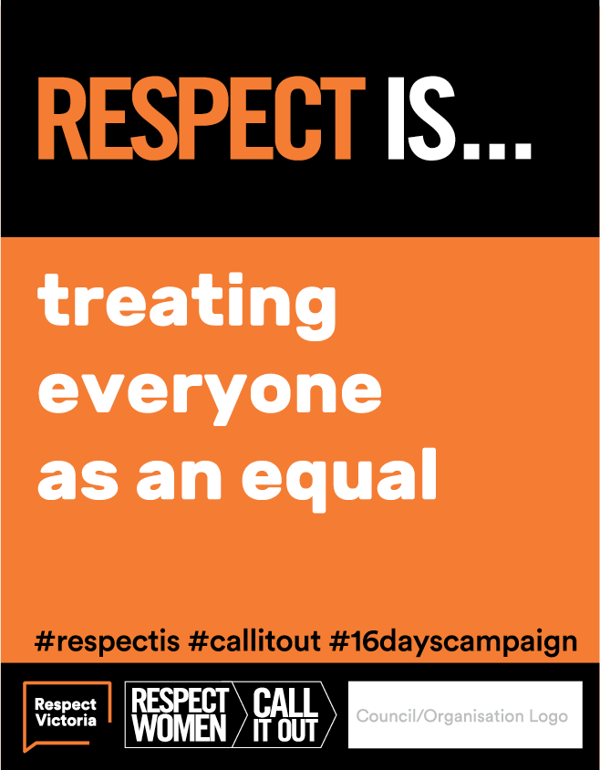

## Bookmark

This is designed to be printed as 4.5cm wide x 15cm high.

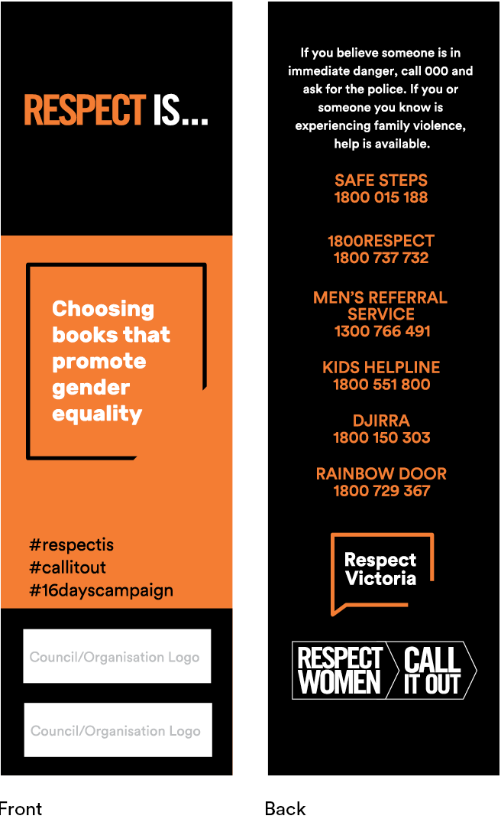

## Selfie Frame

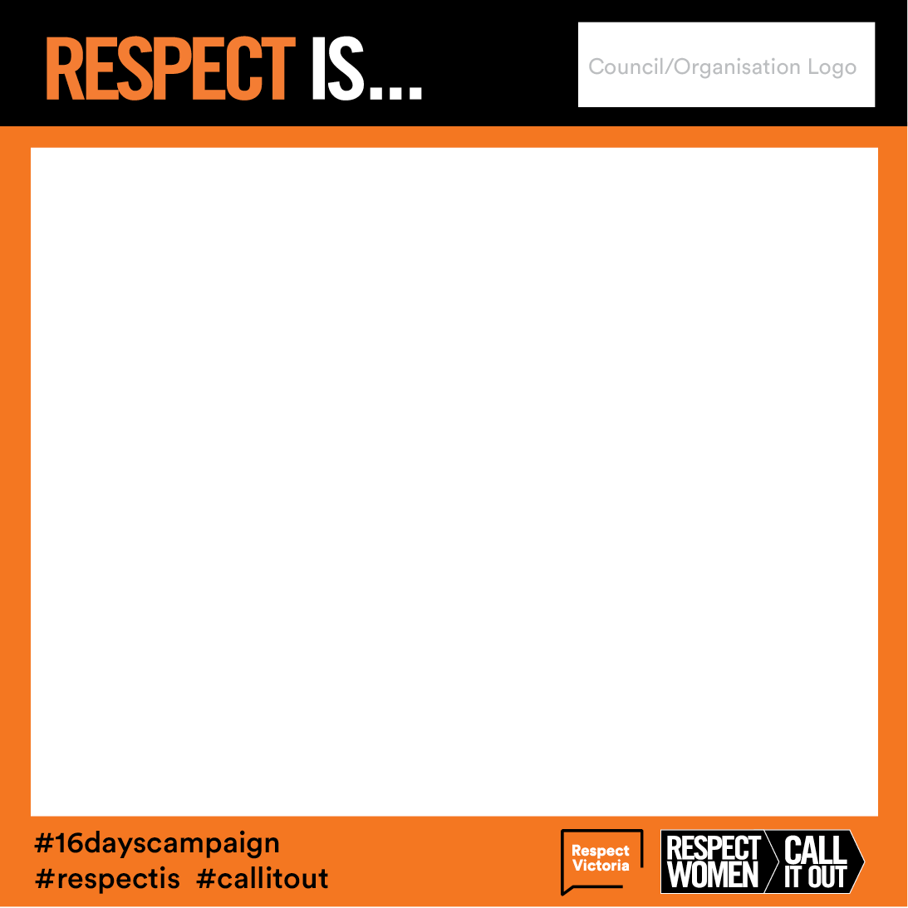

This is a virtual selfie frame. It is designed for you to drop an image (photo) of you/someone/people into the frame and share on social media or online.

## Virtual Background

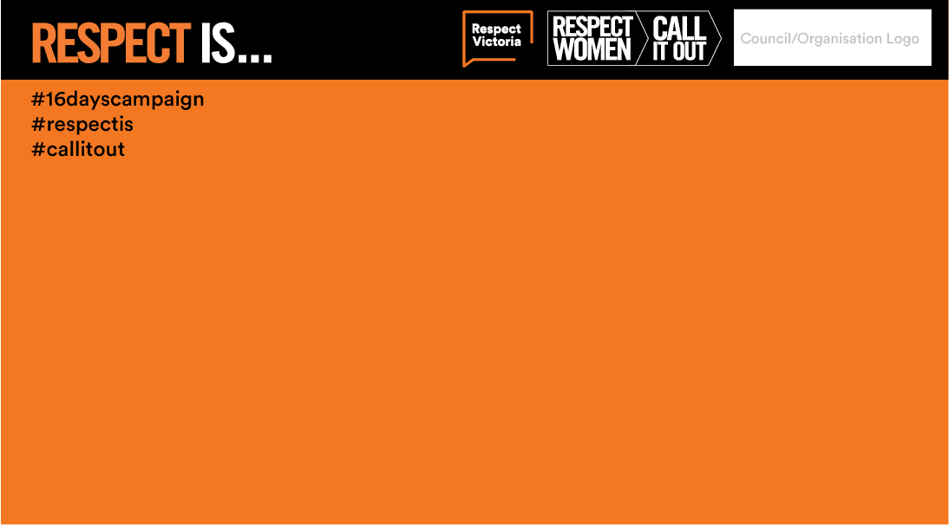

This is designed to be used as a virtual background on Zoom and other online meeting platforms.

## Email Signature Banner

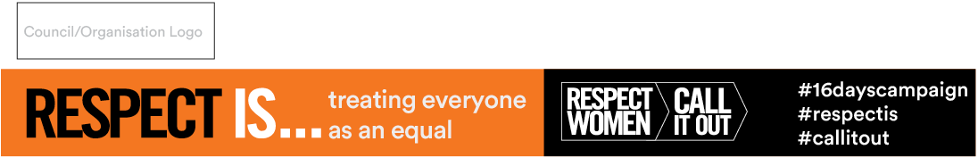

This is designed to be used by your organisation in your email signatures.

## Respect Is...Cards

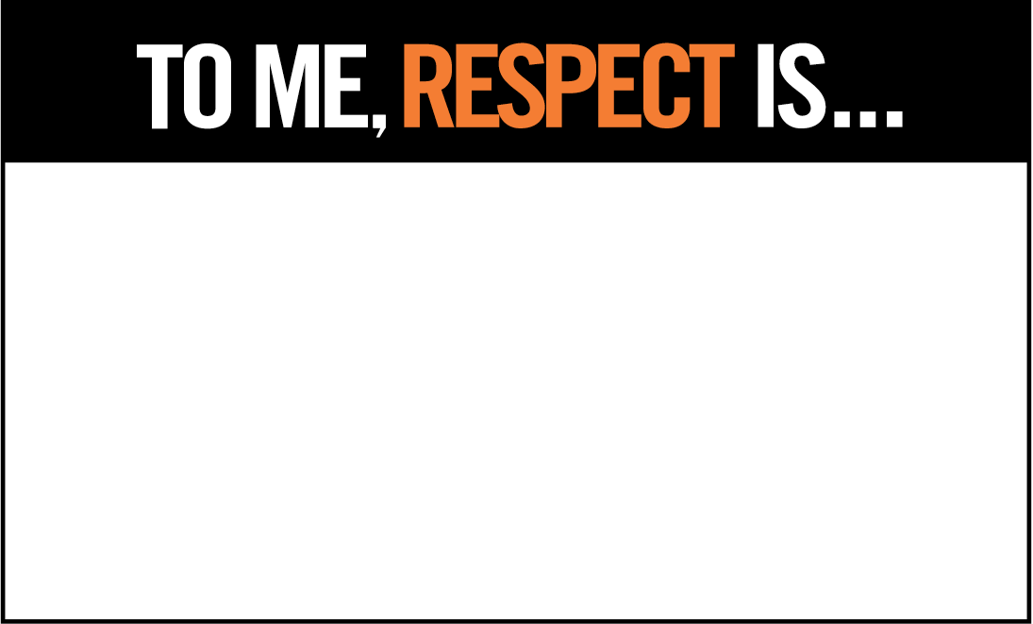

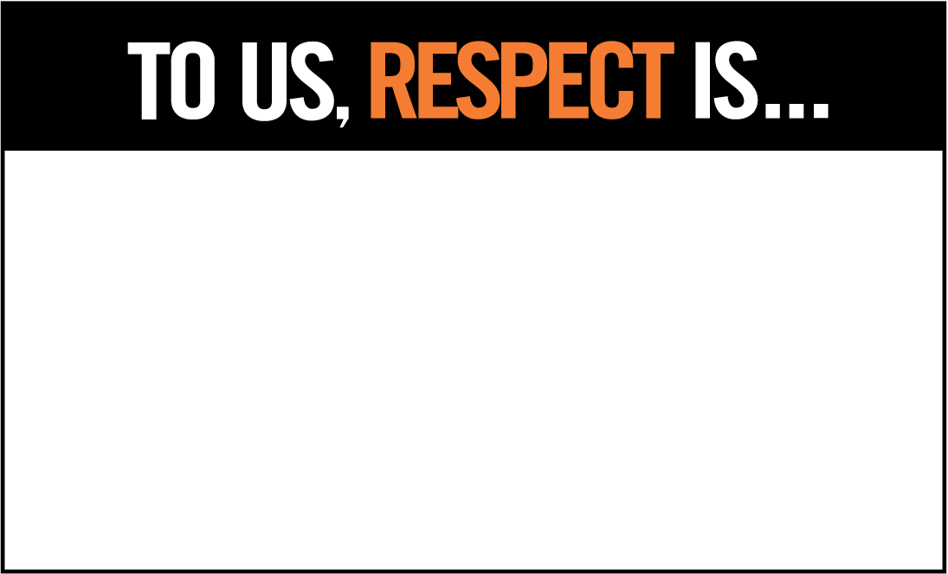

You may wish to use the ‘TO ME / TO US, RESPECT IS...’ cards to hold up in your photos, describing what respect is to you/them (in your/their own words). Words can be either handwritten or typed in using Adobe Photoshop. e.g. “To me, respect is... listening to what other people have to say.”

If you are developing your own ‘Respect Is...’ key messages (as opposed to personal statements), please email these to [prevention@dvvic.org.au](mailto:prevention@dvvic.org.au?subject=16%20Days%20Grassroots%20Initiative%20Helpdesk) prior to distribution.

Please note this is not for approval purposes but so DVVic/DVRCV can keep a register of these key messages along with any collateral developed by participating organisations.

## Hashtags include

#respectis

#callitout

#16dayscampaign

# 16 ways to get involved

**Here are just a few ideas. Many of these ideas can also be used beyond the 16 Days of Activism to encourage year-round action for gender equality and prevention of gender-based violence.**

## 1. Sign up to the virtual Walk Against Family Violence (WAFV) before 25 November hosted by Safe Steps with support from Respect Victoria

The inaugural **‘Walk Against Violence’** was held in 2008, on the first day of the 16 Days of Activism initiative. The Walk Against Family Violence is supported by Respect Victoria, and organised by Safe Steps in coordination with the City of Melbourne, Djirra, Victorian Aboriginal Child Care Agency, DVVic/DVRCV, InTouch Multicultural Centre, Emerge, City of Melbourne, Women with Disabilities Victoria, No To Violence, and the Victim Survivor Advisory Committee.

For more than a decade this major event has taken place in Melbourne’s CBD. Each year, the walk has gained momentum, drawing larger crowds and increased interest from the community.

The walk launches the **16 Days of Activism** suite of activities and community initiatives, encouraging Victorians to stand up and speak out against family violence.

As with 2020, the WAFV will be encouraging Victorians to stage their own ‘neighbourhood walk’ by themselves or in small groups adhering to government approved gathering sizes. Walkers will be encouraged to [register for the walk](https://walk.safesteps.org.au/cms/register) (as an individual or as part of a team) and wear orange to raise awareness of family violence. Additional resources available at the [Walk against family violence website](https://walk.safesteps.org.au/).

## 2. Host an online event: start conversations about preventing gender-based violence

Organise an online morning tea, panel discussion, book club or exhibition. Use the conversation starter kit on page 41 of the toolkit to support a conversation about respect, gender-based violence, everyday sexism and how to call it out. Use VicHealth’s [Framing Gender Equality Messaging Guide](https://www.vichealth.vic.gov.au/-/media/ResourceCentre/PublicationsandResources/Mental-health/Framing-gender-equality---Message-guide.pdf?la=en&hash=AF111835871BFA3092C1F9DD98B3C8AA0E493295) to help inform your messaging.

## 3. Get active on social media

Social media can be used to drive behaviour change. During the pandemic, its popularity has skyrocketed, with people using this technology to stay connected. We encourage individuals and organisations to share the social media tiles to promote respect and bystander action. Use Fast facts: Attitudes to gender-based violence on page 34 to support your messages. See Dealing with resistance and backlash online on page 44for tips on dealing with online resistance and backlash. Ask your Councillors, Presidents or Chairs to support the initiative through social media. Use the selfie frame provided in this toolkit.

## 4. Invite faith and diverse community leaders to actively participate

Faith-based and multicultural community leaders can play a vital role in bringing about change. Invite your local leaders to work on a joint activity and use resources in community languages.

## 5. Share books that challenge traditional gender stereotypes

Record people reading books, or parts of books, aloud and share the videos. Use Booklists: Children’s books on page 22, Booklists: Young adult books on page 24, and Booklists: Adult fiction and non-fiction books on page 25 to create library displays, promote to book clubs and distribute among colleagues, family and friends.

Print the bookmark template included in this toolkit and distribute to local libraries.

## 6. Elevate the voices of Aboriginal and Torres Strait Islander, refugee and migrant women

Invite Aboriginal and Torres Strait Islander, refugee and migrant women, to share their stories, achievements and initiatives in print, video and on social media.

Two helpful resources include Victorian Aboriginal Child Care Agency’s (VACCA) [#SafeKooriFamilies – There Is Another Way](https://www.vacca.org/page/stories/educational-resources) information, and resources and [social media tiles](https://intouch.org.au/new-multilingual-resources-promoting-respect-within-migrant-and-refugee-communities/) developed by InTouch Multicultural Centre Against Family Violence in partnership with Ethnic Communities’ Council of Victoria and Multicultural Centre for Women’s Health.

## 7. Share learning about gender diversity

Encourage colleagues to learn about what gender diversity means, and how to support transgender and non-binary people. The [Trans101 gender diversity crash course](https://www.trans101.org.au/) is a great place to start. Host an online workshop to discuss.

## 8. Add the Respect Women: ‘Call It Out’ logo to your email signature

Use the digital signature banner in this toolkit and the virtual background in your Zoom meetings.

## 9. Wear orange and get your colleagues to wear orange too!

[Orange symbolises](https://www.unwomen.org/en/what-we-do/ending-violence-against-women/take-action/16-days-of-activism) a brighter future and a world free from violence against women and girls. Take a photo of you and your colleagues in orange using the virtual selfie frame and share. Consider printing orange t-shirts or distribute orange face masks.

## 10. Start a conversation or run training on bystander action, including online bystander action

Use VicHealth’s [active bystander resources](https://www.vichealth.vic.gov.au/media-and-resources/publications/bystander-research-project) available on their website.

## 11. Make the link with [Masculinities and Health](https://www.vichealth.vic.gov.au/media-and-resources/publications/healthiermasculinities)

Thinking about masculinities and health requires challenging stereotypes, and encouraging equality and respect, non-violence, reflection and self-awareness, emotional expression and vulnerability, and accountability.

Use the [VicHealth Masculinities and Health](https://www.vichealth.vic.gov.au/-/media/ResourceCentre/PublicationsandResources/Health-Inequalities/VicHealth-Masculinities-and-health-framework-JUNE-2020.pdf?la=en&hash=3159E5BCCB29C72398B0EF6E592AD94881BE2277) framework to inform your initiative.

## 12. Run a competition

Organise a ‘challenging gender stereotypes’ art competition or a competition relating to what respect looks like in the context of gender equality and prevention of violence against women.

## 13. Display physical or digital posters/banners in your workspace and around your community

Display posters or banners in your workplace, on your website and social media channels and on community notice boards. Consider ways in which you can use a wide range of platforms and mediums to share the campaign messages, including online. If restrictions permit, ask to put up posters in libraries, neighbourhood houses, schools, community halls, sporting clubs and other settings within your municipality or organisation encouraging people to ‘call out’ disrespectful behaviour.

## 14. Partner with local businesses

If restrictions permit, ask local cafes to put stickers or printed sleeves on their coffee cups during the 16 Days of Activism. Ask local businesses including medical centres, supermarkets, chemists and petrol stations to display posters.

## 15. Ensure your events and materials are accessible to people with disabilities

Women with disabilities are twice as likely as women without disabilities to experience violence throughout their lives, but they are often left out of the conversation. In 2020, Women with Disabilities Victoria created a [suite of social media tiles](https://www.wdv.org.au/social-media-campaigns/2020-16-days-of-activism-against-gender-based-violence-campaign/), which could be utilised throughout the 16 Days of Activism. Find out more on the [Women with Disabilities Victoria](https://www.wdv.org.au/) website.

## 16. Learn more about gender-based violence and bystander action

Explore the [supporting resources section](https://dvvic.org.au/campaigns/16-days-of-activism-against-gender-based-violence-2021/?section=2) of the 16 Days of Activism website for additional resources such as DVVic/DVRCV A-Z of preventing violence against women posters.

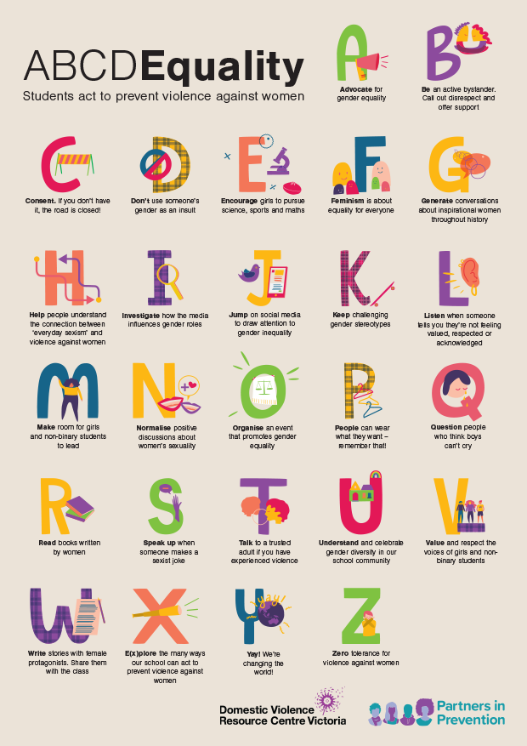 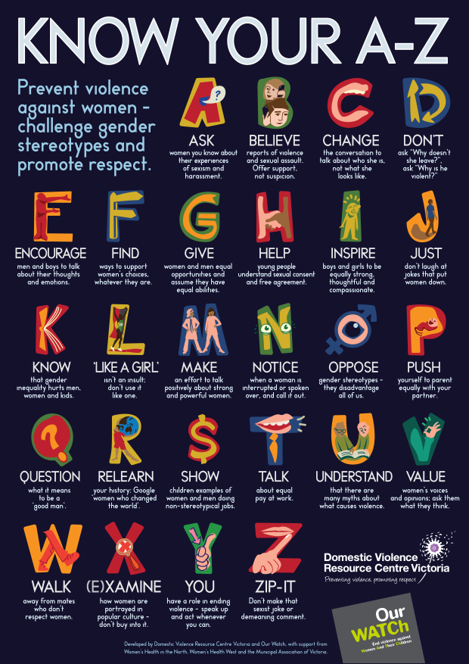

# Booklists: Children’s books

Help parents to choose books with their children that promote boys and girls as equals. Here are some great examples.

* Ada Twist by Andrea Beaty
* Amazing Babes by Eliza Sarlos and Grace Lee
* Axle Annie by Robin Pulver
* Be Who You Are by Todd Parr
* Be Your Own Man by Jessica Sanders
* Bold Australian Girl by Jess Black
* Cactus Annie by Melanie Williamson
* Crusher is Coming by Bob Graham
* Easy as Pie by Cari Best
* Fly by Jess McGeachin
* Every-day Dress-up by Selina Alko
* Giraffes Can’t Dance by Giles Andreae and Guy Parker-Rees
* Hunting for Dragons by Bruce Whatley
* I am Enough by Grace Byers
* I Could Be, You Could Be by Karen Owen
* Jacob’s New Dress by Sarah and Ian Hoffman
* Made by Raffi by Craig Pomranz
* Introducing Teddy by Jessica Walton
* My Princess Boy by Cheryl Kilodavis
* The Night Pirates by Peter Harris
* No Difference Between Us by Jayneen Saunders
* Not All Princesses Dress in Pink by Jane Yolen and Heidi Stemple
* One Busy Day by Lola Schaefer
* Pearl Fairweather Pirate Captain by Jayneen Sanders
* Piggybook by Anthony Browne
* Princess Smartypants by Babette Cole
* Roadworks & Demolition (series) by Sally Sutton
* Rosie Revere, Engineer by Andrea Beaty
* Squishy Taylor (series) by Ailsa Wild
* Ruby’s Wish by Shirin Yim Bridges
* Some Boys by Nelly Thomas
* Some Girls by Nelly Thomas
* The Different Dragon by Jennifer Bryan
* The Underwater Fancy-Dress Parade by Davina Bell
* The Paper Bag Princess by Robert Munsch
* The World Needs Who You Were Made to Be by Joanna Gaines
* Tina and Tom’s Time Travelling Toilet by Chris ‘Roy’ Taylor and James A Crabtree
* Tough Guys (Have Feelings Too) by Keith Negley
* Two Mates by Melanie Prewett
* Who Am I? I Am Me! by Jayneen Sanders
* Zephyr Takes Flight by Steve Light

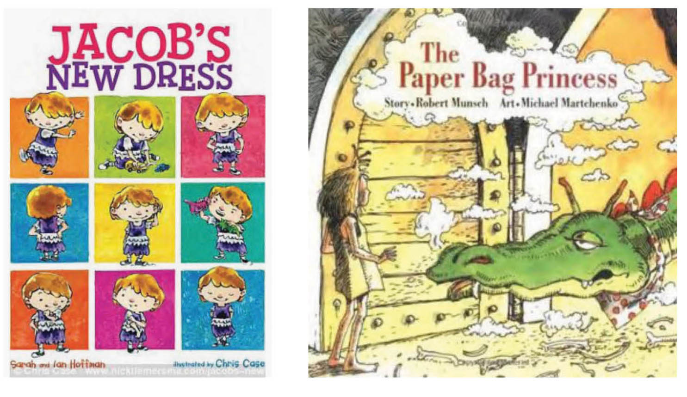

# Booklists: Young adult books

What we read has a strong influence on what we think. Provide young adults with guidance towards literature that challenges stereotypes and gives characters non-traditional roles. Here are some great examples.

* A Court of Thorns and Roses by Sarah J. Mass
* A Great and Terrible Beauty by Libba Bray
* A Thousand Nights by E.K. Johnston
* I Am J by Cris Beam
* And I Darken by Kiersten White
* Code Name Verity by Elizabeth Wein
* Gabi, a Girl in Pieces by Isabel Quintero
* Homecoming by Cynthia Voight
* How to Make Friends with the Dark by Kathleen Glasgow
* I’ll give you the sun by Jandy Nelson
* Ink and Ashes by Valynne E. Maetani
* Kindred: 12 Queer #LoveOzYA Stories by Michael Earp
* Luna by Julie Anne Peters
* Lydia by Natasha Farrant
* Not That Kind of Girl by Siobhan Vivian
* Only Ever Yours by Louise O’Neill
* Out of Darkness by Ashley Hope Pérez
* Rebel of the Sands by Alwyn Hamilton
* Remix by Non Pratt
* The Boy in the Dress by David Walliams
* The Curious Tale of the Lady of Caraboo by Catherine Johnson
* The Hunger Games Trilogy by Suzanne Collins
* The Lie Tree by Frances Hardinge
* The Love and Lies of Rukhsana Ali by Sabina Khan
* The Perks of Being a Wallflower by Stephen Chbosky
* The Ruby in the Smoke by Phillip Pullman
* The Servant by Fatima Sharafeddine
* The Sky Is Everywhere by Jandy Nelson
* The Tracey Fragments by Maureen Medved
* Unbecoming by Jenny Downham
* Wandering Son (series) by Shimura Takako

# Booklists: Adult fiction and non-fiction books

Help visitors and borrowers to choose books that will help them think about gender and gender equality differently. Here are some great examples.

* Alone atop the Hill by Alice Dunnigan
* Attack of the 50 Ft. Women: How Gender Equality Can Save The World!   
  by Catherine Mayer (2017
* A Room of One’s Own by Virginia Wolfe (1929)
* Bossypants by Tina Fey (2011)
* Brotopia: Breaking up the Boys’ Club of Silicon Valley by Emily Chang (2018)
* Carrie Pilby by Caren Lissner (2003)
* Dead Beckoning by Christina Engela (2016)
* The Argonauts by Maggie Nelson (2015)
* The Bluest Eye by Toni Morrison (1970)
* Feminism is for Everybody: Passionate Politics by Bell Hooks (2000)
* Finding Nevo by Nevo Zisin (2017)
* Girl Up by Lauren Bates (2016)
* Here Lies Arthur by Philip Reeve (2007)
* Hidden Figures by Margot Lee Shetterly (2016)
* I Am Malala: The Story of the Girl Who Stood Up for Education and Was Shot by the Taliban by Malala Yousafzai and Christina Lamb (2013)
* Invisible Women: Data Bias in a World Designed for Men by Caroline Criado Perez (2019)
* Juliet Takes a Breath by Gabby Rivera (2016)
* Kindred by Octavia E. Butler (1979)
* Men Explain Things to Me by Rebecca Solnit (2015)
* Middlesex by Jeffrey Eugenides (2002)
* Milk and Honey by Rupi Kaur (2014)
* My Life on the Road by Gloria Steinem (2015)
* Not That Bad by Roxane Gay (2018)
* Outlawed by Anna North (2021)
* Pachinko by Min Jin Lee (2017)
* Stealing the Show: How Women Are Revolutionizing Television by Joy Press (2018)
* The Argonauts by Maggie Nelson (2015)
* The Bluest Eye by Toni Morrison (1970)
* The Great Believers by Rebecca Makkai (2018)
* The Handmaid’s Tale by Margaret Atwood (1985)
* The Help by Kathryn Stockett (2009)
* The Secret Life of Bees by Sue Monk Kidd (2003)
* The Surface Breaks by Louise O’Neill (2018)
* The Testaments by Margaret Atwood (2019)
* The Time Has Come: Why Men Must Join the Gender Equality Revolution   
  by Michael Kaufman (2019)
* The Wife Drought by Annabel Crabb (2015)
* We: A Manifesto for Women Everywhere by Gillian Anderson and Jennifer Nadel (2017)
* Witness by Louise Milligan (2020)

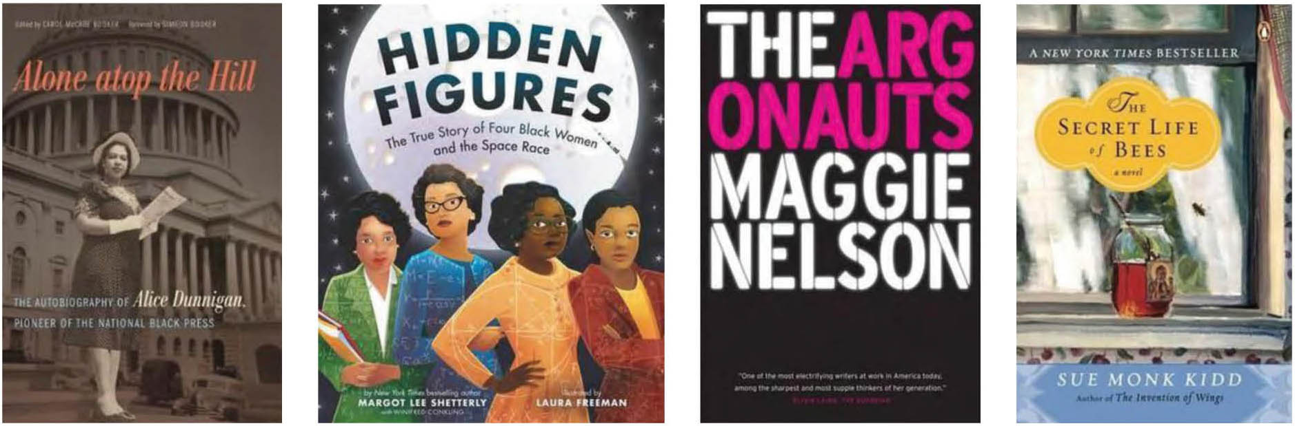

# Fast facts: Prevalence

We can create a world where everyone is equal, free and safe.

And yet violence continues to impact our communities   
in gendered ways

## Gender of perpetrators

**95%** of all victims of violence, regardless of gender, experience violence   
from a male perpetrator

Source: Diemer, K. (2015) ABS Personal Safety Survey: Additional analysis on relationship and sex of perpetrator.

## Women killed by a current or former partner

**Every 9 days**, a woman is killed by her current or former partner

Source: Australian Institute of Health and Welfare (2019) Family, domestic and sexual violence in Australia: continuing the national story 2019.

## Women’s experience of violence

**1 in 4** women have experienced violence by an intimate partner since the   
age of 15

**1 in 5** women have experienced sexual assault since the age of 15

Source: Australian Bureau of Statistics (2017) Personal safety, Australia, 2016.

**1 in 13** men have experienced violence by an intimate partner since the   
age of 15

**1 in 20** men have experienced sexual assault since the age of 15

Source: Australian Bureau of Statistics (2017) Personal safety, Australia, 2016.

## Sexual harassment

**1 in 2** women have experienced sexual harassment since the age of 15

Source: Australian Institute of Health and Welfare (2018) Family, domestic and sexual violence in Australia 2018.

**23%** of women have experienced sexual harassment at work in the last 12 months

Source: Australian Human Rights Commission (2018) Everyone’s business: Fourth national survey on sexual harassment in Australian workplaces.

Stopping gender-based violence starts with gender equality

# Fast facts: Intersectionality and gender-based violence

Gender-based violence does not impact all women   
and gender diverse people in the same way

## Aboriginal and Torres Strait Islander women

**3 in 5** Aboriginal and Torres Strait Islander women have experienced physical or sexual violence perpetrated by a male intimate partner

**To end this violence we must address colonisation and gender inequality**

Source: Our Watch (2018) Changing the picture.

## Women with disabilities

**Nearly 2 in 5** women with disabilities have experienced intimate partner violence since the age of 15

Women with disabilities are more likely to experience violence from multiple perpetrators, and over longer periods of time

**To stop this violence we must address ableism and gender inequality**

Source: Centre of Research Excellence in Disability and Health (2021) Nature and extent of violence, abuse, neglect and exploitation against people with disability in Australia.

## Refugee and migrant women

**1 in 3** refugee and migrant women living in Australia have experienced domestic and family violence

Those on temporary visas reporting much higher levels of abuse related to their migration status

**We must create a culturally inclusive and gender equal society**

Sources: Segrave, Marie; Wickes, Rebecca; Keel, Chloe (2021): Migrant and refugee women in Australia: The safety and security study.

## LGBTIQA+ people

**1 in 3** LGBTIQA+ people has experienced violence from a partner, ex-partner or family member

For intersex, transgender and gender diverse people these numbers are even higher

**To stop this violence we must address homophobia, transphobia, cisnormativity and rigid gender norms**

Source: The Australian Research Centre in Sex, Health & Society, La Trobe University (2015) A Closer Look at Private Lives 2.

All forms of inequality and discrimination are connected. We must address them all to create a safe and equal world for everyone

# Fast facts: Impacts of Covid-19 on gender-based violence

COVID-19 is a gendered problem

## Women in cohabiting relationships

**During the first 3 months of the COVID-19 pandemic 2020, a survey of 15,000 women found:**

**4.6%** of all women and **8.8%** of women in cohabiting relationships in the previous 12 months experienced physical violence by a current or former partner

**11.6%** of all women and **22.4%** of women in cohabiting relationships in the previous 12 months experienced emotional, harassing and controlling behaviour by a current or former partner

## Women who experienced violence or abuse

**Among those women who reported that they had experienced violence or abuse:**

**1 in 3** women said this was the first-time their partner had been violent towards them

**1 in 5** women said this was the first-time they had experienced emotionally abusive, harassing or controlling behaviour in their relationship

Source: Australian Institute of Criminology (2020) The prevalence of domestic violence among women during the COVID-19 pandemic.

## Reports by support practitioners

**During the March 2020 COVID-19 lockdown , support practitioners:**

**42%** reported an increase in first-time family violence reporting by women

**50%** reported an increase in the severity of violence against women

**59%** reported an increase in the frequency of violence against women

**89%** reported an increase in the complexity of women’s needs

**Practitioners also reported increased challenges:**

seeking help and providing support

undertaking effective risk assessment

carrying out safety planning during lockdown

additional barriers for temporary visa holders

Source: Pfitzner, N., Fitz-Gibbon, K. and True, J. (2020). Responding to the ‘shadow pandemic’: practitioner views on the nature of and responses to violence against women in Victoria, Australia during the COVID-19 restrictions.

Understanding how gender impacts crises like COVID-19   
is essential to improving our collective responses

# Fast facts: Impacts of gender-based violence

Women and children disproportionately   
bear the burden of family violence

## Homelessness

**In 2018-19, 90%** of adults seeking homelessness services due to family and domestic violence were women

Family violence is the leading cause of homelessness for women and children

**No one should have to choose between safety and their home**

Source: Australian Institute of Health and Welfare (2019) Specialist homelessness services annual report 2018–19.

## Cost of violence to society

The estimated cost of violence against women and their children in 2015-16 was **$22 billion per year**

**Stopping gender-based violence would save lives, and save survivors, families, friends, employers, communities and governments from bearing the costs of this violence**

Source: KPMG (2016) The cost of violence against women and their children in Australia.

# Fast facts: Attitudes to gender-based violence

While in the minority, too many Australians continue to hold problematic attitudes to gender-based violence

## Assailants

**Nearly 9 out of 10** women who have been sexually assaulted knew their assailant.

Source: ANROWS (2017) National Community Attitudes towards Violence against Women Survey

**yet**

**1 in 3** Australians are unaware that a woman is more likely to be sexually assaulted by someone she knows than by a stranger.

## Reporting to police

**9 out of 10** women who have been sexually assaulted do not report to the police, and false allegations are rare.

Source: ABS (2017) Personal Safety Survey.

**yet**

**42%** of Australians believe it is common for sexual assault accusations to be used as a way of getting back at men.

Source: ANROWS (2017) National Community Attitudes towards Violence against Women Survey.

## Leaving an abusive partner

Leaving an abusive partner can be difficult and often dangerous.

**yet**

**32%** of Australians believe that a female victim who doesn’t leave an abusive partner is partly responsible for the abuse continuing.

Source: ANROWS (2017) National Community Attitudes towards Violence against Women Survey.

We need to focus on the abusive behaviour, not women’s choices.

Improving attitudes is essential for the safety and wellbeing   
of all Australians

## Controlling behaviour

Being controlling is a key risk factor for abuse in relationships.

**yet**

**34%** of Australians think it’s natural for a man to want to appear in control of his partner in front of his male friends.

Source: ANROWS (2017) National Community Attitudes towards Violence against Women Survey

Healthy relationships are equal and respectful.

## Sharing intimate images

Sharing intimate images of a person without their consent is illegal.

**yet**

**Nearly 34%** of Australians believe that if a woman sends a nude image to her partner, then she is partly responsible if he shares it without her permission.

Source: ANROWS (2017) National Community Attitudes towards Violence against Women Survey

We all have a role to play in changing attitudes and creating a more equitable world

# Fast facts: Gender equality in Australia

Gender-balanced leadership has been proven to improve performance, productivity and profitability

Source: Cassells R and Duncan A (2020) Gender Equity Insights 2020: Delivering the Business Outcomes, BCEC|WGEA Gender Equity Series.

## Australia’s global ranking

**Australia’s global ranking for gender equality is declining:**

2006: **15**

2017: **35**

2020: **44**

2021: **50**

Source: World Economic Forum (2021) Global Gender Gap Report: Insight Report.

Greater gender equality is possible

Just look at our neighbours, New Zealand ranked #4 in 2021 and is among the world’s most gender equitable countries

## Gender pay gap

**The gender pay gap is still a problem:**

Women’s average full-time wages are lower than men’s across every industry and occupation in Australia

Women are paid on average **14% less** per week than men

This means women must work approximately **59 extra days** to earn the same income as men annually

If we continue this way, it will take **26 years** to close the total gender pay gap

Source: (2021) The Workplace Gender Equality Agency.

## Women’s representation in key decision-making roles

**Women are underrepresented in key decision-making roles across almost all industries in the workforce**

In 2019-2020, women made up:

Board Chairs: **14.6%**

CEO’s: **18.3%**

Directors: **28.1%**

Managers: **32.5%**

Source: The Workplace Gender Equality Agency 2019-20 dataset.

## Progress towards gender equality

**It is possible to achieve gender equality in Australia**

The percentage of women on ASX-listed company Boards is increasing:

2009: **8%**

2017: **26%**

2021: **34%**

This change was helped in large part by a diversity policy implemented by the ASX Corporate Governance Council in 2010.

Source: Fitzsimmons, T.W., Yates, M.S. & Callan, V.J. (2021). Towards Board Gender Parity: Lessons from the Past – Directions for the Future.

# Tools to help ‘call it out’

This section provides councils and other organisations with pointers to stimulate conversations among their workforce and communities. This information will help build capacity among all Victorians in understanding the issues and how to respond to them.

## How to “call it out”

‘Call it out’ is a broad term for responding in some way to behaviours that may be deemed sexist, disrespectful, abusive or constitute sexual harassment.

Inappropriate behaviour can be ‘called out’ by saying something or using body language to indicate disapproval in the moment. Bystanders can also say or do something later, after the incident (see 16 ways to #callitout on page 39). You should use your judgement about the best way to respond, to show that the comment or behaviour is not okay. If the behaviour is directed at a particular person, your response may be primarily to support them (see number 5 and 10 of the 16 ways to #callitout on page 39).

**‘Calling it out’ does not mean physically intervening when you witness violence and does not include hostile or aggressive responses.**

If you believe someone is in immediate danger call 000 and ask for the police. It is important that when you react to inappropriate behaviour directed toward women, you do not put yourself or the person who is being targeted at risk. Before responding, you should assess safety and risk of escalation. It is also important to stay within your comfort zone and be pragmatic about your level of skill or confidence. As with any bystander intervention, your safety is paramount.

## Different types of bystander action

**There are a range of ways you can respond to sexism, harassment, and disrespect towards women, depending on the context and your level of confidence. These can be grouped into four categories:**

* **Diffuse:** Make light-hearted comments or give disapproving looks
* **Check in:** See if the target is okay
* **Call it out:** Declare the statement or behaviour offensive and explain why it is harmful
* **Report:** Access incident reporting systems or report to management where applicable.

See VicHealth’s [Take action: Empowering bystanders to act on sexist and sexually harassing behaviours](https://www.vichealth.vic.gov.au/bystander) for more information.

## 16 ways to #callitout

**What to do when you hear or see sexist, disrespectful or sexually harassing behaviour**

1. Don’t laugh at sexist jokes.
2. Give a disapproving look to show a behaviour or statement is not okay. Shake your head or roll your eyes.
3. Leave a pointed and uncomfortable silence.
4. Make a light-hearted comment: “What century are you living in?”
5. Check in with the person affected: “I heard what he just said – are you okay?”
6. Privately let them know the behaviour is not okay: “The joke you made in yesterday’s meeting was not funny, and actually not okay.”
7. Calmly disagree and state that the comment is wrong or unacceptable: “I know you probably didn’t mean it, but I found what you said to be offensive.”
8. Speak up and educate by explaining why you disagree: “Actually evidence shows the vast majority of women do not make up false claims of sexual assault” (you could use the Key Facts in this toolkit).
9. Challenge the logic: “That’s not my experience.” or “What makes you think that?”
10. Stand up for the person affected: “Michelle was saying something, and you cut her off again.”
11. Make eye contact with the person affected – let them know you’re an ally.
12. Show your emotion: “It actually makes me sad / uncomfortable when you say that.”
13. Support others when they call it out: “I agree, that’s not funny.”
14. Appeal to their better self: “Come on, you’re better than that.”
15. Report the behaviour to management, or via incident reporting systems if available.
16. Disrupt or distract the situation to redirect focus from the incident to something else.

**For more examples of how to #callitout visit:**

* Respect Victoria [Respect Women: Call It Out campaigns](https://www.respectvictoria.vic.gov.au/campaigns)
* Our Watch [Doing Nothing Does Harm campaign](https://www.doingnothingdoesharm.org.au/)  
  Our Watch [No excuse for abuse campaign](https://noexcuseforabuse.org.au/No-Excuse/Home)
* Michael Flood [Challenging Everyday Sexism Workshop Notes](https://xyonline.net/content/challenging-everyday-sexism)

## What should be called out?

**To call out sexism and disrespect towards women, people must first be able to recognise it. Here are a few everyday examples of sexism, disrespect, and harassment that should be ‘called out’:**

* Using ‘like a girl’ as an insult: “Stop whingeing, you sound like a girl!”
* Sexist jokes at the pub: “I’d give her an 8 out of 10!”
* The stereotype that men and boys don’t cry
* Comments that transgender women are “not real women”
* Sitting back while female colleagues clean the work kitchen or get the coffees
* Stereotypes about skills: “I need a bloke’s brain for this”
* Belittling women: “Given what your husband does, do you really need to work?”
* Comments made about a person’s suitability for a role based on their gender: “I think it’s weird for a guy to be a childcare worker”
* Leering or staring
* Sharing inappropriate images with co-workers
* Fathers being congratulated for doing basic parenting tasks: “Great job babysitting the kids!”
* Sexism and racism disguised as a compliment: “She’s pretty... for an Aboriginal girl.”
* When your mate puts his partner down
* Catcalling / wolf-whistling
* Comments about women being “too emotional”
* The stereotype that Asian women are submissive and therefore make “better wives” and “know how to look after men”
* Sexually suggestive comments or jokes: “I know just what you need to release some stress!”

“come on, you’re better than that”

# Conversation starters

**Gender-based violence, sexism, harassment, and disrespect towards women can be difficult topics to bring up in conversation, especially in relationships, communities and settings where attitudes and beliefs about traditional gender roles may be strongly held.**

It is, however, important that we do start talking about these issues, or we will never be able to solve them.

Below are some questions to help you start an informal conversation with colleagues, family, friends, and community members about gender-based violence, sexism, and disrespect towards women. These conversations can be challenging and may bring up a range of difficult issues and emotions for people. Consider this before you start a conversation and make sure you feel safe, supported, and prepared.

* “What are the causes gendered violence?”
* “Why are women overwhelmingly the victims of family violence?”
* “How do men and women experience violence differently?”
* “Have you thought about who does the chores in your house? Why do you think labour is divided this way?”
* “Who are your female role models? Do you think they experienced discrimination because of their gender?”
* “Do you think the media treats women fairly? Does the media blame victims of sexual harassment?”
* “How can we get men involved to help prevent sexism and harassment towards women?”
* “Do you know what sexism is?” (Use definition and examples of sexism on page 11 in this toolkit to demonstrate).
* “Do you think there is a problem with sexism / gender inequality in our community?”
* “Have you thought about what you could do when you hear sexist comments? I know it can feel hard, but there are lots of ways to respond.” For ideas on ways to respond look at 16 ways to #callitout page 39.

**Conversations about gender inequality can lead to resistance or backlash from some people. See** Dealing with resistance and backlash **on page 42 of the toolkit for tips on how to manage this.**

“It is important that we start talking about these issues, or we will never be able to solve them”

# Dealing with resistance and backlash

**When you bring up gender equality messages, it is likely that you will face resistance or even backlash. It is an uncomfortable experience for most people when their long-held beliefs are challenged – and naturally they want to resist.**

**Preparing for potential resistance and coming up with responses in advance will help you communicate better on the spot and may help you open more conversations with the community. One way to do this is to develop a response register that can be used to guide responses in person, over the phone or online.**

## What about men experiencing violence? You’re just cherry-picking data to say that women are the victims

We acknowledge that both women and men can experience violence, but the nature of this violence differs in terms of its severity and impacts. Data comes from sources such as the [Crime Statistics Agency](https://www.crimestatistics.vic.gov.au/family-violence-data-portal/download-data-tables), the [Prevention of Family Violence Data Platform](https://files.crimestatistics.vic.gov.au/Prevention-of-Family-Violence-Data-Platform.html), and the [Personal Safety Survey](https://www.abs.gov.au/statistics/people/crime-and-justice/personal-safety-australia/latest-release) undertaken by the Australian Bureau of Statistics.

As uncomfortable as it may be, the data consistently shows that women disproportionately experience intimate partner violence and non-partner sexual assault, and are more likely to be hospitalised, injured, express fear or be killed by a current or former partner. To address the violence experienced by women, we must recognise its gendered nature. We look forward to a future with very different data that shows all forms and rates of violence being eliminated!

“Women are more likely than men to be hospitalised, injured, express fear or be killed by a current or former partner”

## Jokes are harmless – speaking disrespectfully does not mean the man is abusive

Speaking disrespectfully does not necessarily mean someone is abusive, but people who are abusive often speak disrespectfully. The [evidence](https://ncas.anrows.org.au/) tells us that the most consistent predictor for support of violence against women by men is their agreement with sexist and disrespectful attitudes towards women. Sexist jokes reflect and reinforce sexist attitudes.

There are many jokes we can make that aren’t sexist and disrespectful – why not challenge ourselves to be creative with our humour and not fall back on old stereotypes!

## Sexism and disrespect do not cause violence against women. It is caused by poverty, unemployment, and stress

Poverty, unemployment, or stress alone do not drive violence against women. Women experience poverty, stress, and unemployment at equal or often higher rates than men. However, 93% of violence is committed by men, not women. Violence against women happens regardless of income, class, or unemployment status. While we recognise those factors may increase the likelihood or severity of violence against women, they only play a role when people hold beliefs and attitudes that are sexist and disrespectful.

## Violence is only an issue within some community groups like migrant communities or Aboriginal & Torres Strait Islander communities

Family violence occurs among all types of families, regardless of income, profession, religion, ethnicity, or educational level.

## Why must one gender be more respected than the others? Respect everyone regardless of gender, not just women!

We agree – everyone should be respected regardless of their gender. Unfortunately, though, women experience casual and structural sexism daily and are not respected in the same way as many men are. To create a society where there is no disrespect and no violence, we need to look honestly at what the evidence is telling us.

## Sexism only seems to work one way these days

Sexism is prejudice or discrimination based on sex or gender. Although sexism can be directed at men, women have been and remain the predominant targets of sexism. Sexism toward women must be viewed differently to sexism toward men because it is based on systematic inequalities and historic oppression. Sexism and similarly inflexible beliefs and attitudes toward sex and gender roles (sexism) are the most consistent predictor of attitudes and behaviours that lead to violence against women.

## Why is gender equality and family violence/gender-based violence a council issue? Shouldn’t you just stick to roads, rates and rubbish?

Family violence and violence against women is a serious and prevalent issue affecting the health and wellbeing of many people living within our municipality. The role of council is to address issues that are relevant to our community and we are legislatively required to work to prevent family violence (Public Health and Wellbeing Act 2008). The reach of local government across the community is unrivalled and we are in a unique position where we can embed gender equality across multiple community settings and services. We believe that we can lead the societal change needed to achieve gender equality and subsequently prevent violence against women through the services we deliver, our organisational structure and operations, and most importantly through leadership in the community.

## What happens inside a family is their business, no one else’s

Family violence is no longer considered a private matter and is being addressed as a serious public health and criminal justice issue. If you know of someone who is being abused, express your concern, and encourage them to seek help.

**Safe Steps is Victoria’s 24/7 family violence support service.**

**Safe Steps (1800 015 188)** [safesteps.org.au](https://www.safesteps.org.au/)

## Continue to build your response register

Use the Women’s Health West, [Speaking publicly about preventing men’s violence against women: Curly questions and language considerations](https://whwest.org.au/resource/speaking-publicly-about-preventing-mens-violence-against-women/) tool and Our Watch’s Practice Guidance: [Dealing with backlash tool](https://d2bb010tdzqaq7.cloudfront.net/wp-content/uploads/sites/2/2019/02/15002447/PG_Dealing-with-backlash_UpdatedFeb2019.pdf).

For more information on how to prepare for and respond to resistance and backlash to gender equality initiatives view VicHealth’s [(En)countering resistance: Strategies to respond to resistance to gender equality initiatives](https://www.vichealth.vic.gov.au/media-and-resources/publications/13-steps-to-tackle-gender-discrimination).

Consider using the key facts and statistics provided in this tool kit to strengthen your response.

## Dealing with resistance and backlash online

To respond to destructive comments or trolling on social media, here are some ideas on how you can start your response:

* Hi (insert name), we hear you; you’re not on board with this initiative and that’s OK ...
* Hi (insert name), we’re sorry to hear you say this. From our research we know that ...
* Hi (insert name), we do appreciate other viewpoints, however, if you continue to be disrespectful to others, we will remove you from the page.
* Hi (insert name), please be clear any further de-railing of the conversation with disrespect or hatred will not be tolerated.
* Hi (insert name), thanks for sharing your feedback, we do appreciate other viewpoints however, this is a space for ... and will continue to serve that function.

It is important for social media moderators to strike a balance between allowing audiences to self-moderate and intervening when comments are offensive and de-rail constructive conversation.

Having clear moderation guidelines will support you to effectively manage resistance on online forums.

## 2020 initiative evaluation backlash and resistance info and tips

In the 2020 initiative evaluation seventy per cent (70%) of respondents reported receiving no backlash from within their community or workplace. Less than one third (29%) of all respondents experienced some level of backlash from the community or their workplace. One-third of all respondents received some level of backlash to the initiative (27 in total – 14 metropolitan and 13 rural and regional councils).

The main ‘backlash’ identified themes included:

* ‘What about men or men’s experience of violence?’ (75%) and
* ‘Councils should focus on roads, rates and rubbish – not gender equality or prevention of violence against women’ (25%).

The respondents that had received backlash reported on their approaches to preparing for, and responding to, backlash. Preparation included:

* Training and briefing for staff, including training delivered by external specialists
* Briefing communications staff/teams
* Reminders and refreshers on your organisations’ policies around social media, backlash
* Draft responses for potential backlash topics and suggestions for when to delete or block
* Use and distribution of resources and references in the 16 Days toolkit (Dealing with resistance and backlash; resources from Our Watch, VicHealth, Women’s Health West)
* The officer responsible for the initiative working collaboratively with the communications team throughout the 16 Days.

Respondents also indicated that their communications teams were experienced, competent, had worked on the campaign in previous years and were able to manage responses to community backlash. The approaches described by respondents were consistent, with several respondents indicating they ‘usually allow it to play out on social media’ and that ‘community members responded to backlash on social media in ways that were encouraging and respectful.’

Other approaches included:

* Blocking or removing offensive comments on social media; not responding to less offensive comments; providing a standard response explaining the rationale for 16 Days
* Complaints via letter or email: prepared responses with manager
* Phone call or in person: acknowledging comments, allow to vent, reply
* Engaging multiple managers to take the lead in providing responses to their departments.

The instances reported of backlash, or resistance from staff members arose during staff meetings or training sessions. In contrast to social media discussions, in person social settings allow for these issues to be explored with discussions reported to be generally constructive. One council for example reported that ‘These conversations during training sessions allowed for discussion of issues/statistics and experiences, and as such allowed for some engagement around the issues. A positive thing/learning opportunity.’ Others also provided examples of issues raised during panel discussions, to which panel members responded well.

## Ideas for responding to backlash

‘One of our internal GE advocates in our Customer Experience team is the main contact for backlash. The Comms team has done this campaign a few times and has the tools to deal with backlash on social media, including the Our Watch resource for responding to backlash.’

Yarra Ranges Shire Council

‘Due to our campaign being online this year we pinned this comment on all posts:

‘The 16 days of Activism Against Gender Based Violence is a State Government funded community awareness campaign being promoted through local councils. We understand that people are interested in and support this cause. We acknowledge that there will be some however who have differing views. Talking about violence against women doesn’t preclude us from talking about other forms of violence. If we don’t understand the specific drivers of violence as a community, we won’t stop them. We ask that you engage on this post in a respectful way, respecting each other as we all have differing views.’

****Latrobe Regional City Council****

‘Learnings around backlash from 2019 were incorporated into our approach for this year. Debriefings were held after each dance class, the launch of the art exhibition and the 16 days event. Support people were available at the dance classes and at the 16 Days events.’

Mount Alexander Shire Council

# Responding to disclosures

**When you open up conversations about gender equality, respectful relationships and violence against women, there’s a good chance that someone may disclose that they have experienced or witnessed violence.**

**For this reason, it is important you know how to respond. This section provides information to support you to respond to disclosures effectively.**

## Do

* Listen, without interruption or judgement, giving the victim survivor time to share their experience
* Believe what the victim/survivor is saying to you
* Affirm the victim/survivor has done the right thing in disclosing their experience
* Affirm the victim/survivor is brave in being able to come forward
* Emphasise that they are not to blame for their experience
* Respect the victim/survivor’s decisions – even if you don’t agree with them
* Be honest and open about your skills and knowledge and the types of support you can provide
* Provide information about specialist support services (see Support services on **page 52**) in a way that is safe for them to receive. Encourage them to seek out additional personal and professional support
* Keep the conversation confidential. The only exception is if you believe the person’s safety is at immediate risk (call 000), or you become aware that a child’s safety is at risk. In some cases, for example if you are a professional such as a teacher or doctor, it may be mandatory for you to report this to relevant authorities.

“What has happened is not okay and is not your fault”

## Don’t

* Try to find out details
* Try to fix the situation for them
* Suggest the situation is somewhat their fault – don’t ask questions like ‘why do you put up with it?’ or ‘how can you still stay with him?’
* Give advice or tell them what to do – it will reduce their confidence to make their own decisions
* Judge or criticise their choice – even if you don’t agree with it
* Criticise the perpetrator – it may only make the victim/survivor want to defend the perpetrator. Focus on criticising the abusive behaviour and let them know that no one should abuse them
* Provide counselling – if you are not a counsellor or do not have specialist training in responding to family violence, be honest and open about that. Instead, you can provide information about referral pathways which are listed at Support services on **page 52** of this toolkit.

## Examples of things you could say

**These are some ideas. It is important you only say what you believe and use your own words:**

* What has happened is not okay and is not your fault
* I’m glad you have told me
* No one should have to experience what you have been through
* Do you feel safe at the moment?
* I don’t have specialist knowledge in helping people with experiences like yours, but I can give you the contact details of people who do
* It’s up to you to choose what to do with this information, but I can give you the contact details of a specialist whom you can talk to if you need.

## Self-Care

**Self-care is a priority and necessity – not a luxury. If you find yourself feeling down, depleted, or irritable you may need to take some time out. There are lots of ways you can do this.**

* **Reach out to someone.** This could be a family member, trusted friend or colleague, your manager, a counsellor or another support person. You could also speak to your GP about seeing a counsellor or, if available to you, access your employee assistance program (EAP). For after-hours support, Safe Steps, Victoria’s family violence support service, is available 24 hours a day for professionals to discuss the personal impact of working with people who have experienced violence
* **Find a way to escape physically and/or mentally** e.g. reading, days off, holidays, walks, seeing friends
* **Rest** – have some time with no goals e.g. taking naps, watching clouds, lying on the beach
* **Play** – have fun and do things that make you laugh e.g. playing with children and pets, creative activities, watching a favourite comedy.

## The three most important things you can do when responding to disclosure

1. **Listen** without interruption or judgement
2. **Believe** and validate their experience
3. **Provide information** about referral pathways

# Beyond the 16 Days

Efforts to prevent violence against women, such as this year’s 16 Days initiative, are more likely to be effective and to achieve lasting change when they are part of a broader suite of activities to promote gender equality and prevent violence against women.

**To increase the likelihood that you will achieve positive and lasting change, consider the following:**

## Get leadership on board

Leadership involvement and support is essential for getting traction on gender equality initiatives. When leadership is on board, bystander action can more easily be embedded into organisational policies, code of conduct and performance management. Having strong leadership on preventing violence against women helps to create an authorising environment in which bystander action is encouraged and supported. Our Watch has advice on [how to secure support from leadership](https://workplace.ourwatch.org.au/tools-and-resources/engaging-leaders-and-securing-commitment/).

## Make sure your organisation has an effective reporting and resolution process. If not, develop one!

Having an effective reporting and resolution process supports people to take action easily and safely against sexism, disrespect and sexual harassment. [VicHealth](https://www.vichealth.vic.gov.au/media-and-resources/publications/equal-footing-toolkit) and [Our Watch](https://workplace.ourwatch.org.au/tools-and-resources/workplace-response-to-violence-and-harassment/) have useful suggestions to support your workplace to respond appropriately to violence against women and sexual harassment.

## Ensure your organisation has an equal opportunity, sexual harassment, or gender equity policy

Policies provide a blueprint for the kind of workplace culture you want to achieve. To encourage bystander action, you will need policies that let staff and other stakeholders know what behaviours are inappropriate, what action can be taken, and how privacy will be protected. This information does not have to be contained in a standalone bystander action policy, but can be included in other policies aimed at building a safe and respectful workplace, such as an equal opportunity or sexual harassment policy. Policies should be accessible, accompanied by complaint and grievance procedures, and communicated to all staff. Take a look at the [promising practice portal](https://www.mav.asn.au/what-we-do/policy-advocacy/social-community/gender-equality/promising-practice-portal) and [council produced resources](http://www.mav.asn.au/what-we-do/policy-advocacy/social-community/gender-equality/council-produced-resources) on the MAV website.

## Attend, deliver or organise gender equality or bystander action trainings/workshops.

For information on a range of gender equality training and professional development workshops for individuals and workplaces visit:

* The [Domestic Violence Resource Centre Victoria](https://training.dvrcv.org.au/our-courses/)
* Subscribe to receive the [MAV gender equality and prevention of violence against women](http://www.mav.asn.au/what-we-do/policy-advocacy/social-community/gender-equality/e-news-updates-pvaw-and-gender-equality) fortnightly e-news update
* Sign up to the [Partners in Prevention Network](https://www.partnersinprevention.org.au/)
* [Women’s Health Victoria](https://whv.org.au/our-focus/prevention-of-violence-against-women)
* [No To Violence](https://ntv.org.au/sector-resources/training/)
* Your regional Women’s Health Service.

## Roll out light touch messaging about bystander action throughout the year

Consider doing this through a series of simple emails. These emails should:

* Be clear about what constitutes sexism, harassment and disrespect
* Provide suggestions on how bystanders could respond.

For more information on how to do this view VicHealth’s, [Take action: Empowering bystanders to act on sexist and sexually harassing behaviours in universities](https://www.vichealth.vic.gov.au/-/media/ResourceCentre/PublicationsandResources/PVAW/Bystander/Bystander_Final-ReportPhase2Trials.pdf?la=en&hash=252829B0D9FFD147690D7FC9FD9907B8D79E3B2D).

## Develop a code of conduct

A code of conduct is an important guide for employees when thinking about how they are expected to behave in the workplace.

## Use of tools and resources beyond the 16 Days

The tools and resources provided in this toolkit have been deliberately designed to be useful beyond the 16 Days of Activism against Gender-Based Violence 2021. We encourage councils, organisations, and community members to continue to use these resources to support bystander action, prevent violence against women and promote gender equality.

# Support services

During the 16 Days:  
Ensure support services are visible

**Ensure the following support services are visible when running the Respect Women: ‘Call It Out’ 16 Days initiative.**

**At a minimum, the Safe Steps phone number should be included, and where possible add the following sentence “If you believe someone is in immediate danger, call 000 and ask for the police. If you or someone you know is experiencing family violence, help is available.”**

If you or someone you know is experiencing family violence,   
help is available.

## Safe Steps

**1800 015 188**

A confidential and supportive family violence response line for Victoria. Phone services available 24/7. [Safe Steps website](https://www.safesteps.org.au/): safesteps.org.au

## Orange Door

Family violence support and safety hubs. To find your nearest location, visit the website: [Orange Door website](http://orangedoor.vic.gov.au/): orangedoor.vic.gov.au

## Djirra

Djirra is a culturally safe place where culture is celebrated, and practical support is available. Call 1800 105 303 or visit the [Djirra Aboriginal Family Violence Prevention and Legal Services website](https://djirra.org.au/): djirra.org.au

## InTouch Multicultural Centre Against Family Violence

A specialist family violence service that works with multicultural women, their families, and their communities. Call 1800 755 988 or visit the [InTouch website](https://intouch.org.au/): intouch.org.au

## 1800 RESPECT

**1800 737 732**

The national sexual assault, domestic and family violence counselling service. Phone and online services available 24/7. [1800 RESPECT website](https://www.1800respect.org.au/): 1800respect.org.au

## Kids Helpline

**1800 55 1800**

Kids Helpline is a counselling service for Australian children and young people aged between 5 and 25 years. Phone and online services available 24/7. [Kids Helpline website](https://www.kidshelpline.com.au/): kidshelpline.com.au

## Rainbow Door

Rainbow Door is a free specialist LGBTIQ+ helpline providing information, support, and referral to all LGBTIQ+ Victorians, their friends and family during the COVID-19 pandemic and beyond. Call 1800 729 367 or visit the [Rainbow Door website](https://www.rainbowdoor.org.au/): rainbowdoor.org.au

## Men’s Referral Service

**1300 766 491**

Men’s Referral Service provides anonymous and confidential telephone counselling, information, and referrals to men, to help them take action to stop using violent and controlling behaviour. [No to Violence website](https://ntv.org.au/): ntv.org.au

## Mens Line

**1300 78 99 78**

Professional support and information service for Australian men. Phone and online services available 24/7. [Mens Line website](https://www.mensline.org.au/): mensline.org.au

## Seniors Rights Victoria

**1300 368 821**

Seniors Rights Victoria (SRV) provides information and advice to help prevent elder abuse and safeguard the rights of older people. [Senior Rights Victoria website](https://seniorsrights.org.au/): seniorsrights.org.au

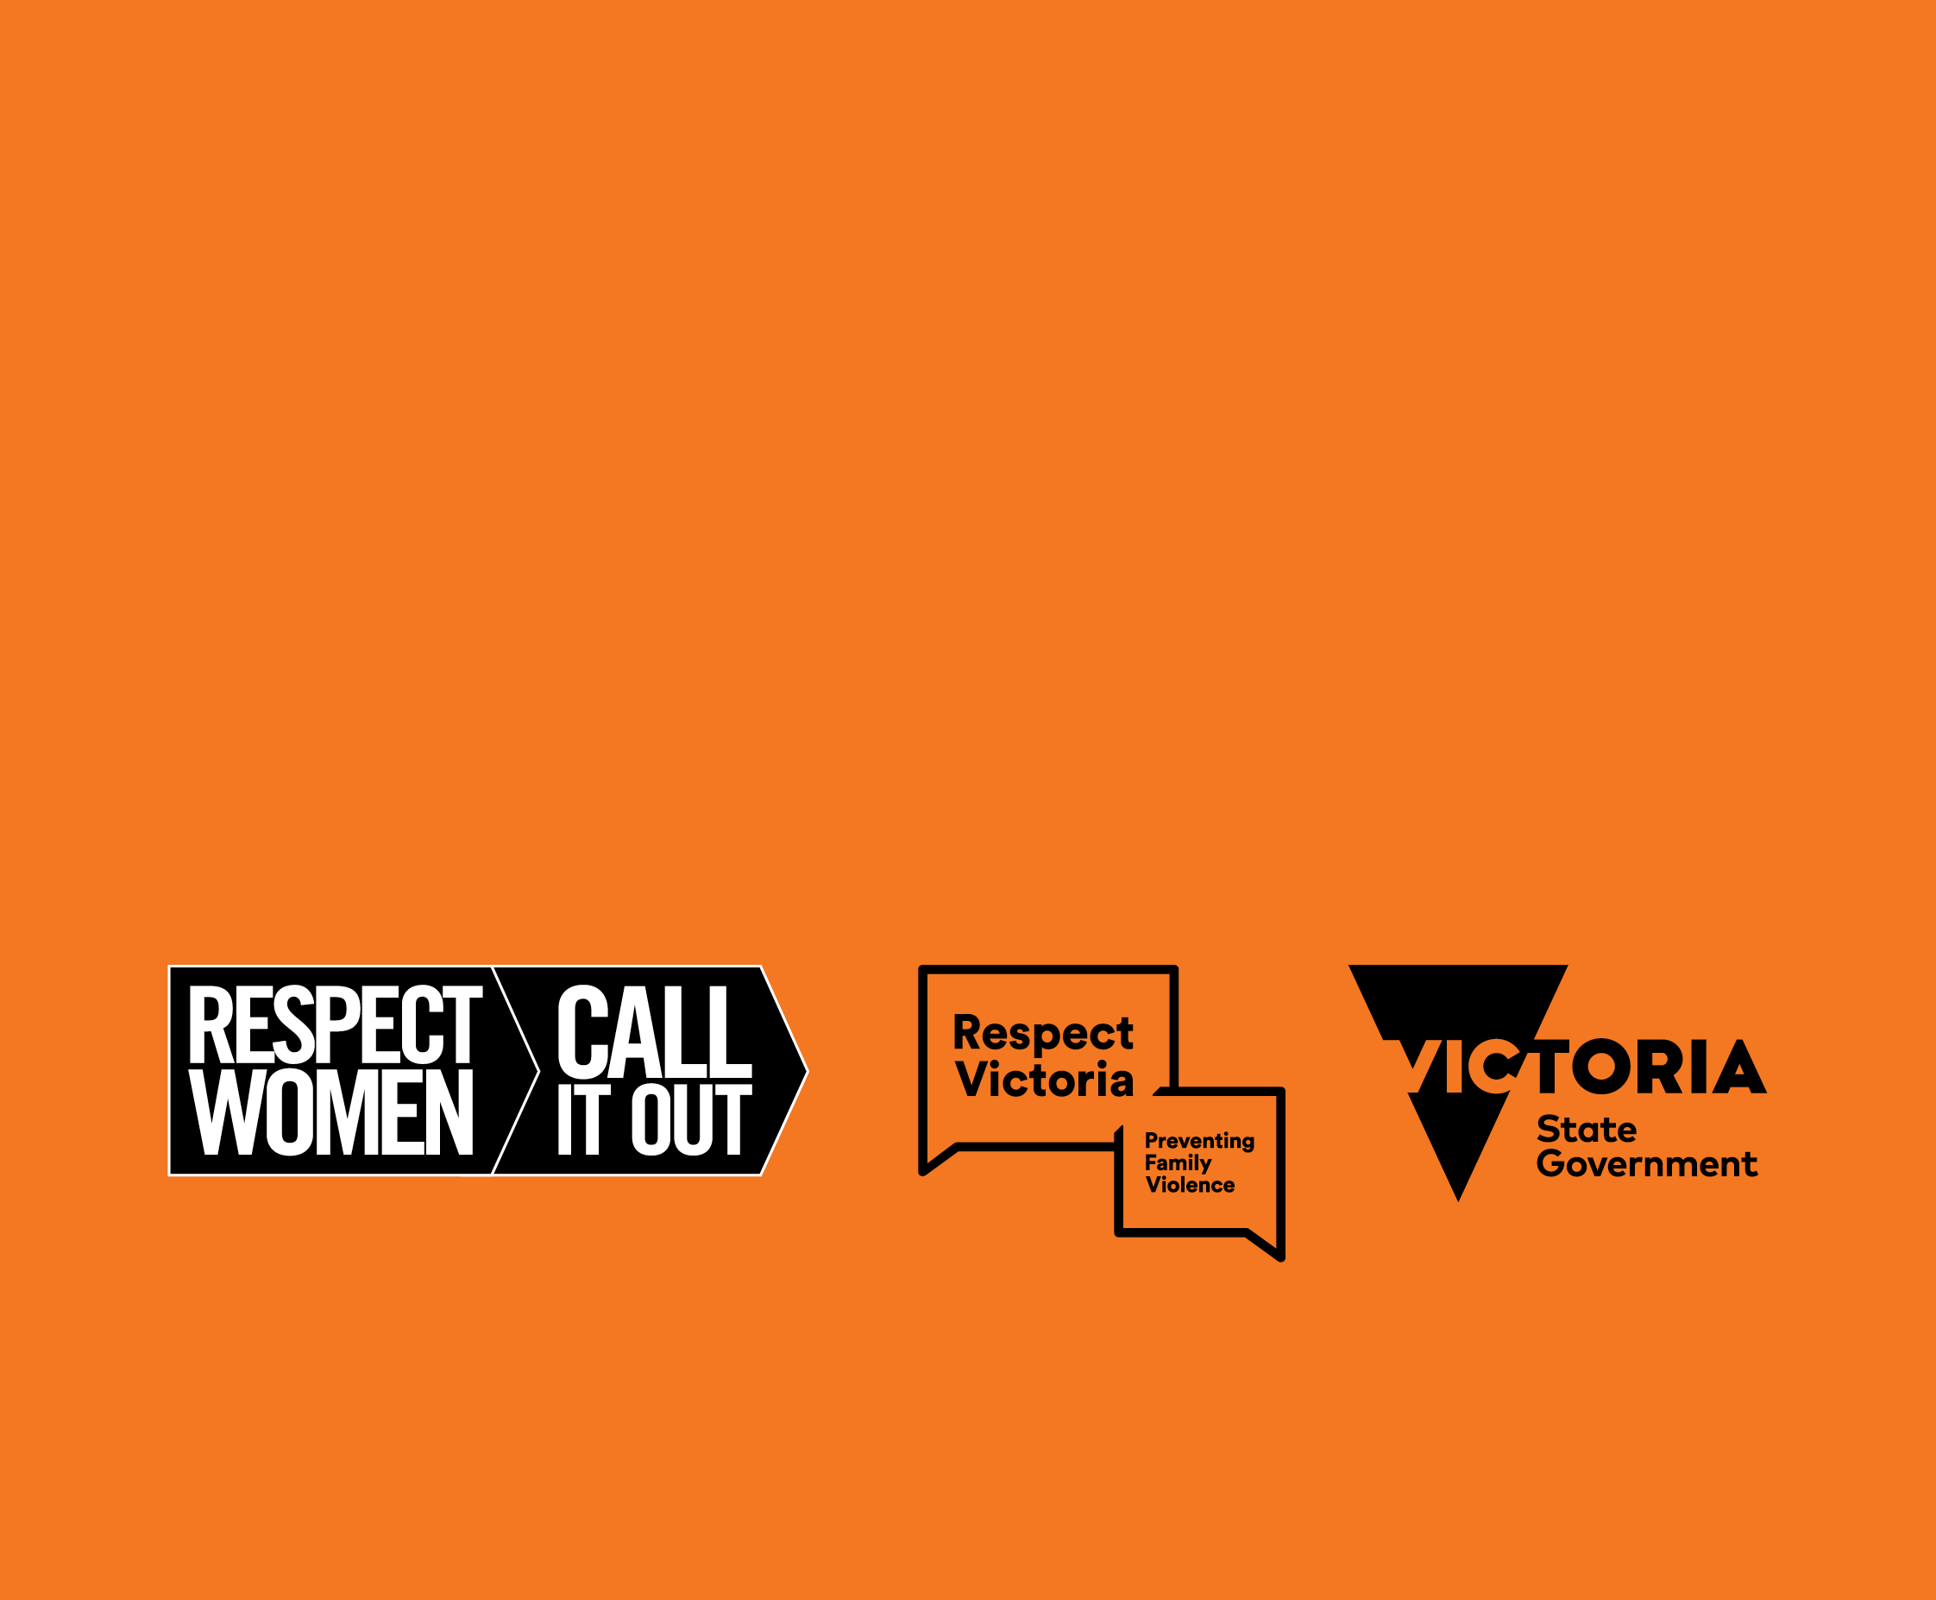

**For more information relating to this toolkit,   
contact DV Vic/DVRCV by emailing**[prevention@dvvic.org.au](mailto:prevention@dvvic.org.au?subject=16%20Days%20Grassroots%20Initiative%20Helpdesk)

**Victorian Government departments   
can contact Respect Victoria by emailing**[contact@respectvictoria.vic.gov.au](mailto:contact@respectvictoria.vic.gov.au?subject=16%20Days%20Grassroots%20Initiative%20)

1. Parkinson, D. (2014). Women’s experience of violence in the aftermath of the Black Saturday bushfires (doctoral dissertation, Monash University)
2. [Media Release: 1 in 5 criminal offences in Victoria were family violence-related in the year ending 31 March 2021](https://www.crimestatistics.vic.gov.au/media-centre/news/media-release-1-in-5-criminal-offences-in-victoria-were-family-violence-related)